Agenda Date: October 28, 2010
Item Number: B3

Docket: TG-101542
Company Name: Mason County Garbage Co., Inc. d/b/a Mason County Garbage G-88

Staff: David Gomez, Deputy Assistant Director – Water and Transportation

Recommendation
Staff recommends that the commission:
- Allow the proposed recycling commodity adjustments filed by the company on September 15, 2010, in Docket TG-101542 to become effective November 1, 2010, by operation of law.
- Grant the company’s request to retain thirty percent of the revenue received from the sale of recyclable commodities subject to conditions set forth staff’s memo.
Background
On September 15, 2010, Mason County Garbage Co., Inc. d/b/a Mason County Garbage (Mason County Garbage or company) filed with the Utilities and Transportation Commission (commission):
- Revisions to its currently effective Tariff No. 13, designated as Tariff pages 1, 21 and 21A with a stated effective date is November 1, 2010;
- A request to retain thirty percent of the revenue Mason County Garbage receives from the sale of recyclable materials that it collects in its residential recycling collection service;
- A copy of the Company's 2010-2011 recycling and revenue sharing plan titled; "Company Recycling Plan: Single-Stream Recycling Program"; and
- A letter dated September 14, 2010, signed by David Baker, Solid Waste Manager, Mason County Utilities and Waste Management.
Mason County Garbage proposes to increase the amount that it pays to single-family customers for the value of the recyclable materials that Mason County Garbage collects in its residential recycling collection service. The monthly credit for single-family customers is proposed to increase from $1.15 to $1.75.
RCW 81.77.185 states that the commission shall allow a solid waste collection company collecting recyclable materials from single-family customers to retain “up to fifty percent of the revenue paid” to the company for the material if the company submits a plan to the commission that is certified by the appropriate local government authority as being consistent with the local government solid waste plan and that demonstrates how the revenues will be used to increase recycling. The remaining revenue must be passed through to single-family customers.
Mason County Garbage's 2010-2011 recycling and revenue sharing plan titled; "Company Recycling Plan: Single-Stream Recycling Program" sets forth specific actions that Mason County Garbage will take to increase recycling using recyclable commodity revenues retained by the company. The 2010-2011 plan is identical to the one submitted by the company in commission Docket TG-090899. The plan submitted in TG-090899, represents the initial agreement between the company and Mason County (county) when single stream recycling was introduced through Mason County's Ordinance #147-08, which is adopted in the County Code as chapter 13.30.90. The 2010-2011 plan calls for thirty percent of the retained recyclable commodity revenue to be awarded to the company on the basis of:
- Meeting or exceeding data monitoring and reporting requirements - 10 percent award;
- Achieving and demonstrating an increase in recycling per household per month, year-over-year - 10 percent award; and
- Assisting the County in providing and operating a glass recycling box at county transfer stations – 10 percent award.
The letter signed by David Baker, Solid Waste Manager, Mason County Utilities and Waste Management stated that the company's performance from 2009 to 2010 had achieved the goals and objectives identified in the County's Solid Waste Management Plan and ordinance, and Mason County Garbage is therefore entitled to retain thirty percent of recyclable commodity revenues it withheld from customers.
In its Order 02, Docket TG-090899, the commission authorized Mason County Garbage to retain thirty percent of the revenue it receives from the sale of recyclable materials until its next deferred accounting commodity filing, which would become effective on November 1, 2010. The company was ordered to make its commodity adjustment effective November 1, 2010, and report to the commission no later than September 15, 2010, the amount of revenue it retained, the amount of money it spent on the activities identified in the company's recycling plan, and the effect the activities had on increasing recycling.
Staff provided technical assistance to help the company comply with commission orders by sending two separate reminders of the requirements specified in Order 02, TG-090899 and including an example report provided by another company in a recent filing with the commission. The first reminder, with an example report, was sent to the company on July 19, 2010, and the second reminder was sent on August 20, 2010.
On October 22, 2010, the company provided staff with a list of expenditures related to the previous year's plan (Table 1 below). Staff compared these expenditures against the plan filed by the company for the 2009-2010 period and has submitted a data request to fully understand the nature of these expenses and how they relate to the revenue sharing plan.
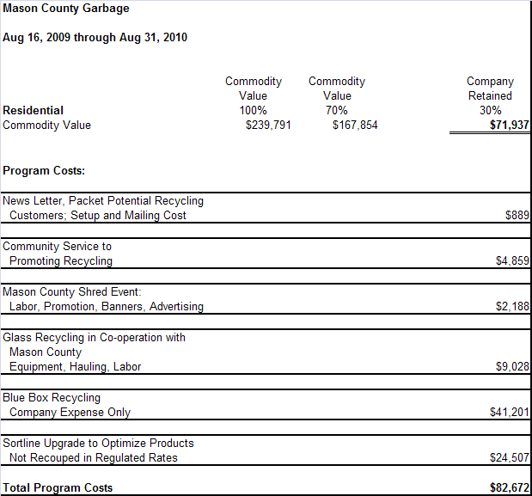
Table 1; 2009-2010 Mason County Garbage Revenue Retained and Expenditures
Staff recommends that the commission accept the County’s recommendation that Mason County Garbage retain thirty percent of the revenue it will receive from the sale of recyclable materials and require the company to report to the commission the amount of revenue it retained, the amount of money it spent on the activities identified in Mason County Garbage’s recycling and revenue sharing plan and the effect the activities had on increasing recycling. Staff also recommends that the commission require the company to meet the performance requirements set forth in the plan, and consider whether to reduce the revenue share the company retained if the company fails to meet those performance requirements. Finally, staff recommends that the commission require revenues from this plan period that are not spent to be carried over to the following year, unless the commission orders some other treatment.

Conclusion
Staff recommends that the commission:
- Allow the proposed recycling commodity adjustments filed by the company on September 15, 2010, in Docket TG-101542 to become effective November 1, 2010, by operation of law.
- Grant the company’s request to retain thirty percent of the revenue received from the sale of recyclable commodities subject to conditions set forth staff’s memo.

