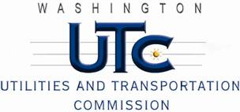

Memorandum
September 30, 2010

To: TR-091659 - File

From: Kathy Hunter, Deputy Assistant Director Transportation Safety

Subject: TR-091659 Pend Oreille Valley Railroad
Grade Crossing Protective Fund (GCPF) Project at the Intersection of
SR-31 and Pend Oreille Valley Railroad’s Tracks in Pend Oreille County, Washington

On October 27, 2009, the Washington Utilities and Transportation Commission (Commission) awarded a GCPF grant totaling $9,812.23 to replace obsolete incandescent lights with LED type lights, replace system batteries, chargers, and cross-bucks at the
SR-31 crossing in Pend Oreille County. The USDOT number assigned to this crossing is 399656B.

On September 28, 2010, the applicant, Pend Oreille Valley Railroad submitted a request for reimbursement pursuant to Commission order. On June 21, 2010, Commission staff conducted a site visit and verified that the project is completed according to the specifications outlined in the order approving the grant.

Please close this docket.

