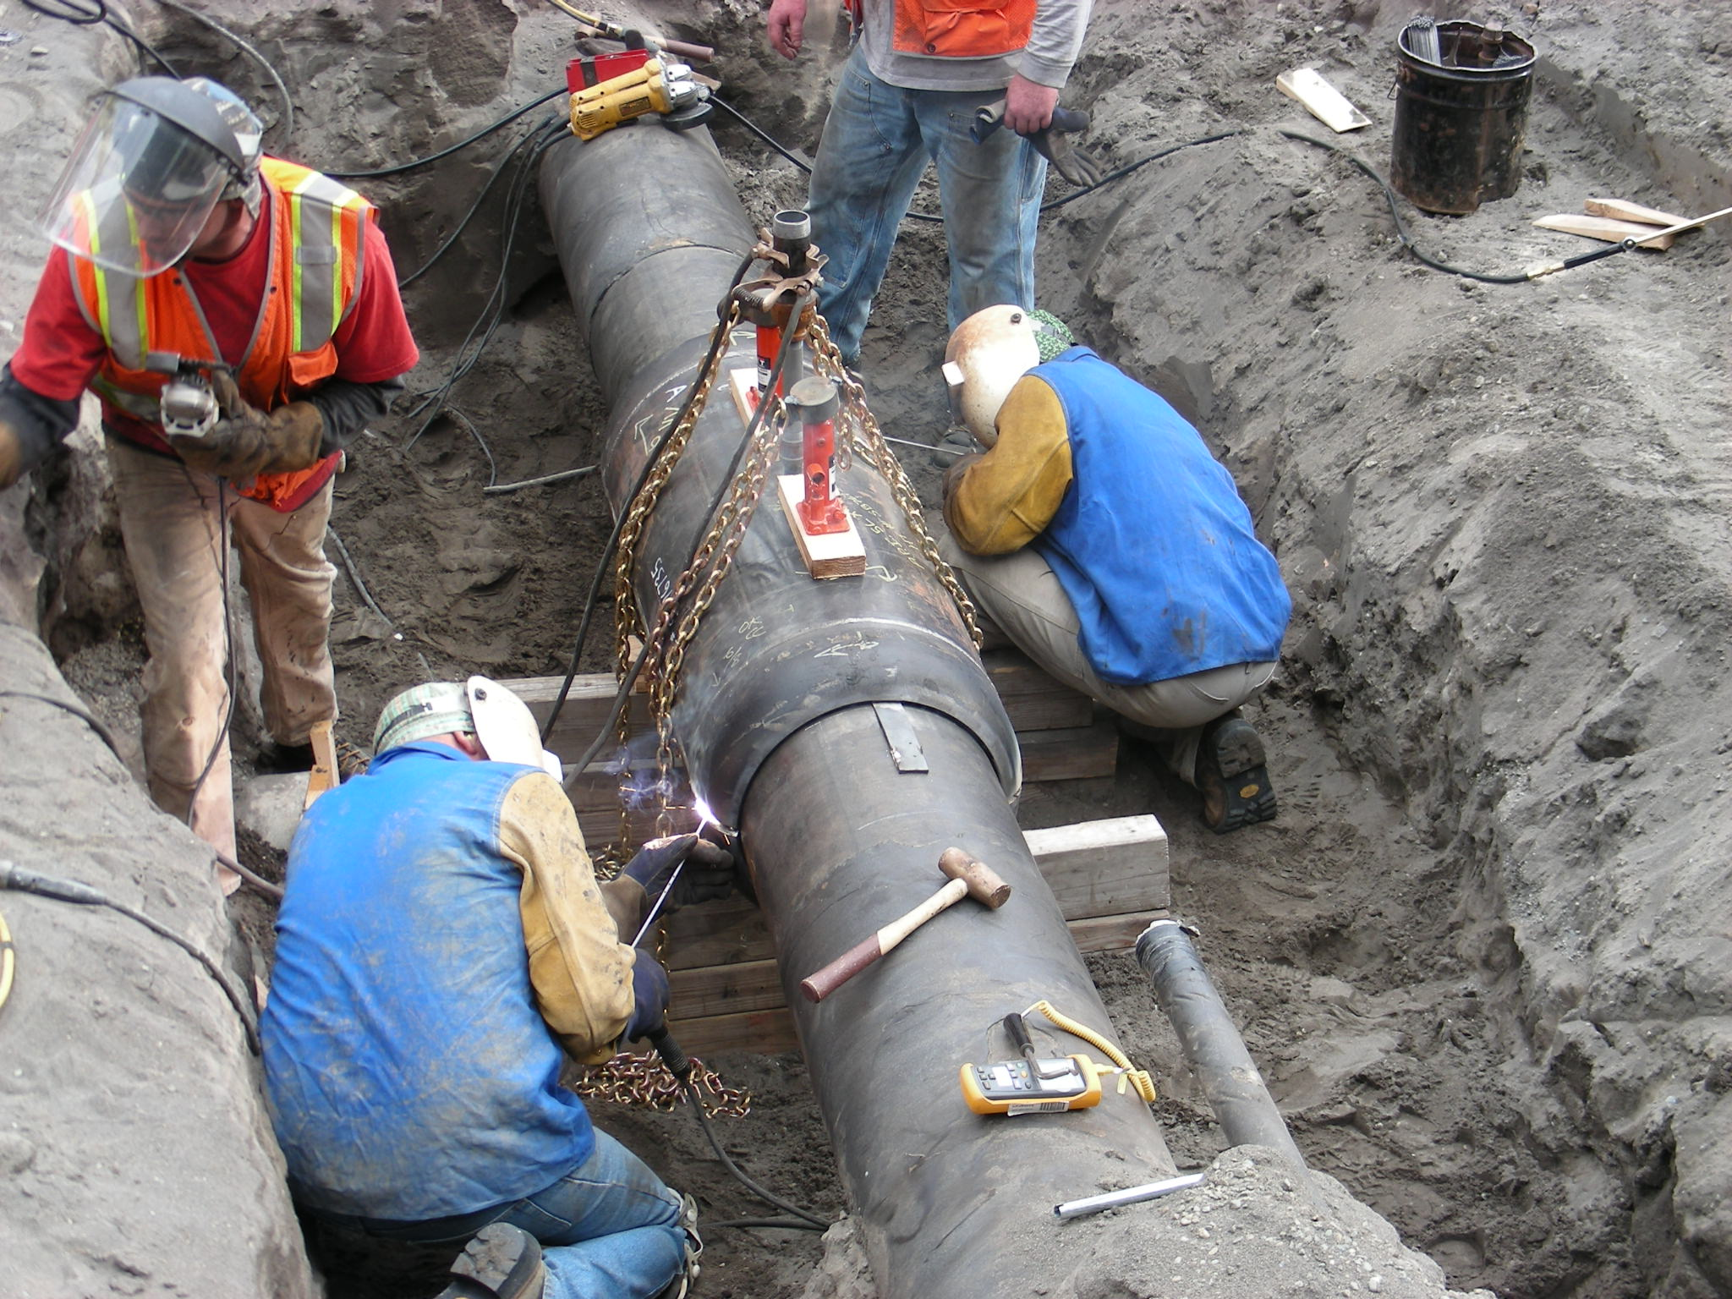

PUGET SOUND ENERGY
PIPELINE REPLACEMENT PLAN

Puget Sound Energy (“PSE”) provides the following Pipeline Replacement Plan regarding the company’s existing plans for replacement of higher risk pipe and an accelerated plan that could be possible with an appropriately designed cost recovery mechanism. PSE’s pipeline replacement plan focuses on two emerging threats to PSE’s distribution system that have been highlighted through the DIMP risk analysis processes. These areas are: 1) Replacement of DuPont High Density polyethylene pipe, and 2) Identification and remediation of sewer cross bore installations. Through its integrity management efforts and analysis of system performance data, PSE has determined that, at this time, there are not current systemic problems with the wrapped steel piping in its distribution system.

DUPONT POLYETHYLENE (PE) PIPE

EXISTING DUPONT POLYETHYLENE (PE) PIPE REPLACEMENT PROGRAM

The natural gas industry has identified certain vintage and manufacture of polyethylene (PE) plastic pipe that has not performed as well as newer resins, leading to an increased risk of pipe failure. One of these products is DuPont’s medium density PE product marketed as “Aldyl A.” This product has shown a property described as “Low Ductile Inner Wall” which under certain situations results in the formation of cracks and premature failures.

Puget Sound Energy did not install any of the DuPont Aldyl A material but did install DuPont’s high density PE marketed as “Aldyl-HD”. While a search of available literature and published reports has not indicated that Aldyl-HD has exhibited these same "low ductile inner wall" issues, PSE has been monitoring the performance of this material over the last several years as it has demonstrated similar premature, brittle-like cracking failures as the Aldyl A material. The Aldyl A material was more widely used than the Aldyl HD resulting in significantly more industry data being available on the Aldyl A material. The other operators that did install the Aldyl HD material operated in warmer climates than PSE’s service territory. Elevated temperature has been shown to have a significant impact on the life expectancy of PE pipe with these premature cracking characteristics.

As a result, there is generally less data available on the performance of this material, specifically for installations similar to PSE’s. In 2008, PSE improved its material failure analysis processes providing more data on the types and frequency of failures of its PE piping system. Based on this data, PSE has determined that DuPont pipe in the larger sizes (1-1/4”, 2” and 4”) is most susceptible to these types of failures. As a result of the failure trends PSE has observed, a risk model specifically for DuPont pipe segments was developed in 2009 to facilitate the prioritization of the replacement of these segments of pipe that had experienced failure. Since that time, PSE has replaced 5.3 miles (approximately 2 miles per year of this pipe) based on the risk model prioritization. In addition to replacing the highest risk pipe, PSE is leak surveying all pipe segments within our system at a minimum of every 3 years which is more frequent than the regulatory requirement of every 5 years.

The detailed calculation of the risk model is contained in PSE’s Distribution Integrity Management (DIM) Plan which is filed with the WUTC Pipeline Safety Staff. The following is a high level description of the factors that are considered in prioritizing these segments for replacement. The factors that are considered include: historical leaks that are consistent with material or fusion failures; reports of unsatisfactory backfill; and the types of structure and concentration of people in the vicinity that could be affected by a future failure. Segments are “scored” via a risk model and prioritized based on the resulting risk rating. A subsequent review is performed to insure that segments with unique site specific issues are appropriately rated (for example, a segment in close proximity to a school may be adjusted upwards). Specific segments are then identified and a detailed scope of work and cost estimates for projects are then prepared. In accordance with PSE’s DIM Plan, PSE reports the footage of older vintage PE pipeline replaced during the previous calendar year compared to the target footage as well as the plan for the current year. This information is reported in the Continuing Surveillance Annual Report which is submitted to WUTC Pipeline Safety Staff each year.

While PSE has good records of where its pipe is installed, one of the challenges PSE faces is identifying where material of this specific manufacture is installed. DuPont Aldyl-HD was one of three manufacturers of pipe that was installed during the time period 1977 thru 1985. The manufacturer of the pipe was not recorded at the time of installation. As a result, the DuPont segments that have been identified consist primarily of segments that have already experienced a leak. PSE has identified approximately 100 miles of this pipe. Purchase records indicate that as much as 500 miles of DuPont pipe of sizes 1-1/4”, 2” and 4” was purchased between 1977 and 1985. PSE estimates that approximately 400 miles of this pipe remains in the system. This is approximately 5% of the PE currently in service in PSE’s system.

To identify additional locations where this specific manufacturer of pipe has been installed, PSE captures data when a leak occurs and is currently implementing a method to capture the pipe manufacturer anytime routine construction or maintenance activities are performed on PE pipe. In 2011, PSE also began excavating selected candidate services to high occupancy structures to identify any DuPont Aldyl HD installed in these locations. Any of this material identified on services to these structures will be prioritized for replacement.

Over the next 3 years, PSE plans to replace approximately 4 miles per year of this pipe at an average expected cost of $5,500,000 per year. During this timeframe, PSE will continue to monitor the performance of this pipe and perform reliability engineering studies to assess the long term performance of this pipe. Reliability engineering studies are expected to provide a forecast of future performance of pipe of this manufacturer considering data such as the current age of the pipe, historic and current failure information and repair data.

ACCELERATED PIPELINE REPLACEMENT PROGRAM

If a cost recovery mechanism were approved to provide companies with an appropriate incentive to replace higher risk pipe more rapidly, PSE would not only replace all DuPont Aldyl-HD pipe at an accelerated rate but it would also expand its efforts to determine where pipe of this manufacturer had been installed. To supplement the current efforts to identify where this pipe is installed, PSE would physically excavate portions of the candidate segments to determine the manufacturer.

Under an accelerated scenario, PSE estimates it would spend approximately $57 million to replace approximately 37 miles of this pipe over the next three years and $2.3 million to investigate candidate locations to determine where additional DuPont Aldyl-HD has been installed. Over the life of the program, PSE estimates it would spend approximately $663 million to replace all DuPont Aldyl-HD pipe and $4.6 million to complete the investigation of all the candidate locations. PSE would plan to complete the identification of all candidate locations within 7 years and complete replacement of all identified pipe within 21 years, or such timeframe as is supported by the results of the reliability engineering studies.

Response to WUTC’s Specific Questions:

- Identification of Pipe of Concern:

While PSE is replacing bare steel pipe and some wrapped steel pipe, PSE believes the existing programs are addressing the risk posed by these pipelines and is not proposing to accelerate the current replacement plans for these pipelines.

PSE has identified a certain manufacture of PE pipe, DuPont Aldyl-HD, which has demonstrated premature, brittle-like cracking failures, and has begun an effort to prioritize the replacement of segments that have previously leaked. If a cost recovery mechanism where approved to provide companies with an appropriate incentive to replace higher risk pipe more rapidly, PSE would accelerate the identification and replacement of the DuPont Aldyl-HD material that has demonstrated premature, brittle-like cracking failures. While PSE has good records of where its pipe is installed, one of the challenges PSE faces is identifying where material of this specific manufacture is installed. DuPont Aldyl-HD was one of three manufacturers of pipe that was installed during the time period 1977 thru 1985. The manufacturer of the pipe was not recorded at the time of installation. To identify where pipe of this manufacturer was installed, under an accelerated scenario, PSE would physically excavate portions of the candidate segments based on installation year to determine the manufacturer. PSE would plan to complete this identification plan within 7 years.

- Scope of Work/Program Rational:

Under the accelerated scenario PSE would plan to replace all the identified DuPont Aldyl-HD material over the next 21 years, or such timeframe as is supported by the results of the reliability engineering studies. The program would ramp up over the first three years to address issues with permitting and workforce availability and then maintain a steady replacement schedule of approximately 21 miles per year. PSE would continue to monitor the performance of the material and may accelerate or decelerate the replacement schedule based on the ongoing performance of the material.

- Project Cost Estimates:

Under the current plan, over the next 3 years, PSE expects to replace approximately 4 miles per year of this pipe at an average at an average expected cost of $5,500,000 per year.

With a mechanism approved to accelerate cost recovery, PSE estimates it would spend approximately $57 million to replace this pipe over the next three years and $2.3 million to investigate candidate locations to determine where additional DuPont Aldyl-HD has been installed. Over the life of the program, PSE estimates it would spend approximately $663 million to replace all DuPont Aldyl-HD pipe and $4.6 million to complete the investigation of all the candidate locations.

- Pipeline Threat Model and Methodology:

PSE has developed a detailed risk model that calculates a risk score and provides a prioritization for the replacement of each segment of identified DuPont Aldyl-HD. This risk model is updated annually with newly identified segments of pipe as well as new data obtained on the pipe performance and installation characteristics relevant to the risk and the priority for replacement. The detailed calculation is contained in PSE’s DIM Plan which is filed with the WUTC Pipeline Safety Staff. The following is a high level description of the factors that are considered in prioritizing these segments for replacement.

The factors that are considered include historical leaks that are consistent with material or fusion failures, reports of unsatisfactory backfill, and the types of structure and concentration of people that could be affected by a future failure. Segments are “scored” via a risk model and prioritized based on the resulting risk rating. A subsequent review is performed to insure that segments with unique site specific issues are appropriately rated (for example, a segment in close proximity to a school may be adjusted upwards).

- Other Factors:

A replacement effort of the magnitude contemplated for the potential accelerated scenario in this response will present many scheduling, coordination and logistical challenges that will be managed within the scope of the program. Our experience in replacing approximately 500 miles of cast iron and bare steel systems over the last 25 years suggests that these challenges, while not trivial, can be effectively managed over the timeframe being proposed.

- Interim Safety Measures:

In addition to replacing the highest risk pipe, PSE is leak surveying all pipe segments within our system at a minimum of every 3 years which is more frequent than the regulatory requirement of every 5 years.

- Reporting Progress Reports:

In accordance with PSE’s DIM Plan, PSE reports the footage of older vintage PE pipeline replaced during the previous calendar year compared to the target footage as well as the plan for the current year. This information is reported in the Continuing Surveillance Annual Report which is submitted to WUTC Pipeline Safety Staff each year. Any changes in prioritization methodology are also documented in the DIM Plan which is submitted to WUTC Pipeline Safety Staff when changes are made.

PROPOSED SEWER CROSS BORE REPLACEMENT PROGRAM

OVERVIEW OF PROPOSED SEWER CROSS BORE REPLACEMENT PROGRAM

Identifying and replacing natural gas pipe that penetrates a sewer line has become an issue of concern to both PSE and the industry. Natural gas pipes that penetrate a sewer are known as “cross bores”. Cross bores can occur when gas facilities are installed using trenchless technology (e.g., hole hogging or directional drilling). Sewer lines present a unique challenge because:

- they are often owned by the homeowner who is unaware of their location,
- they are often unmapped by the sewer district or municipal provider,
- due to the ownership and unmapped nature of these facilities, they are not marked when other underground facilities are located, and
- the material they are made of often makes them not able to be located using traditional locating equipment and makes it difficult to know when the facility has been penetrated.

As a result, gas facilities that are installed using trenchless methods may penetrate an unmarked sewer lateral without the installer knowing the sewer lateral has been penetrated. The installed gas line may provide partial blockage of the sewer lateral and, over time, the sewer may back up. Common clearing techniques employ the use of a mechanical cutter or “sewer auger” device that may also damage or cut through the gas line, resulting in natural gas migrating through the sewer into the home.

This issue has been of national interest over the past few years due to incidents that have occurred as a result of sewer cross bores. PSE has not had any incidents as a result of sewer cross bores but has received notifications of sewer facilities that have been damaged by gas lines and gas lines that have been damaged due to sewer cleaning. As a result, PSE began a pilot program in 2011 to understand the variety of issues associated with mitigating existing and preventing additional sewer cross bores.

The pilot included investigating the various approaches used or being considered by other gas operators to reduce the risk of sewer cross bores. The pilot also included performing sewer inspections using a camera launched through the sewer main to understand:

- how the camera could be used to prevent new cross bores and identify existing cross bores;
- the cost of using sewer launch cameras; and
- the issues associated with gaining access to various jurisdictions sewers to perform camera inspections.

Based on this pilot program PSE has identified three areas of focus to minimize the risk of sewer cross bores. These include 1) Public Awareness, 2) New Installations, and 3) Identification and replacement of legacy cross bore installations. The goal of the awareness plan is to educate plumbers, sewer facility owners, sewer equipment rental companies and the public about the dangers of a cross bore by a gas facility and what steps should be taken if a cross bore is suspected.

To prevent new cross bores, PSE is finalizing its evaluation of construction practices and requirements for preventing sewer cross bores on new construction which may include post camera inspection of sewers when trenchless installation methods are used. For legacy cross bores, PSE is developing a risk based approach to identify locations that should be inspected to determine where cross bores exist and if so, to replace those facilities.

PROPOSED NEW SEWER CROSS BORE

For 2013, PSE plans to spend $300,000 educating plumbers, sewer facility owners, sewer equipment rental companies and the public about sewer cross bores. This will include providing guidelines for the steps that should be taken prior to clearing a sewer backup. It will also include raising awareness of PSE’s availability to support homeowners and plumbers’ requests to determine if a sewer backup is caused by a gas facility. PSE will continue the public awareness efforts and adjust the approach and funding level until there is an adequate level of understanding of the issues associated with sewer cross bores.

For 2013, PSE current plan is to spend $700,000 dollars inspecting between 500 and 1,000 existing locations to identify and replace sewer cross bores. Future expenditures will be determined based on the findings from these inspections.

ACCELERATED PIPELINE REPLACEMENT PROGRAM

If a cost recovery mechanism where approved to accelerate the identification and replacement of pipe that has been cross bored through sewers, PSE anticipates this may be accomplished in 15 years based on the information gained from the pilot program.

PSE estimates this would cost up to $7 million per year to inspect up to 26,000 parcels per year with up to $105 million invested over the life of the program.

Response to WUTC’s Specific Questions:

- Identification of Pipe of Concern:

Identifying and replacing pipe that penetrates a sewer line has become an issue of industry concern. The risk posed by these pipelines is that over time they may cause a sewer back up and the methods used to clear the sewer blockage may damage or cut through the gas line. This can result in gas migrating through the sewer into the home.

These installations are difficult to identify as the installer did not know that the gas facility penetrated the sewer lateral at the time of installation. These installations can occur when a facility is installed using trenchless technology (e.g., hole hogging or directional drilling). Sewer laterals present a unique challenge because they are not marked when other underground facilities are located as they are usually owned by the homeowner. In addition, the material they are made of often makes them not able to be located using traditional locating equipment and makes it difficult to know when the facility has been penetrated.

Absent an appropriate cost recovery mechanism, PSE has not identified a timeframe for completing the identification of sewer cross bores. PSE is planning to begin inspecting the highest risk locations in 2013 and based on the information gained from these inspections, PSE will develop a schedule for additional inspections using integrity management risk based approach. Integrity management risk based approach incorporates the information gained from the inspections and determines appropriate mitigative measures to reduce the identified risks.

If an appropriate cost recovery mechanism were approved to accelerate the identification and replacement of pipe that has been cross bored through sewers, PSE anticipates this may be accomplished in 15 years based on the information gained from the pilot program.

- Scope of Work/Program Rational:

For 2013, PSE expects to inspect between 500 and 1,000 parcels for possible sewer cross bores. Based on our current knowledge, PSE estimates that approximately 400,000 parcels will require inspection over the life of the program. Based on the information gained from the inspections performed, PSE will determine scope and schedule scenarios for future inspections using an integrity management risk based approach.

All cross bores that are identified will be replaced as soon as practical. Until the pipe can be replaced, PSE will notify building occupants and sewer jurisdictions as appropriate of the existence of the cross bore to prevent damage to the gas pipe until the facility is replaced.

- Project Cost Estimates:

Legacy cross bore inspections:
For 2013, PSE current plan is to spend $700,000 dollars inspecting existing locations to identify and replace sewer cross bores. Future expenditures will be determined based on the findings from these inspections.

If an appropriate mechanism is approved to accelerate this program, PSE estimates it could inspect up to 26,000 parcels per year and estimates this would cost up to $7 million per year to inspect and remediate sewer cross bores over a 15 year time frame. This would mean PSE could spend up to $21 million in the first 3 years of the program and up to $105 million over the life of the program.

Public Awareness:

For 2013, PSE plans to spend $300,000, in addition to the $700,000 described above, educating plumbers, sewer facility owners, sewer equipment rental companies and the public about sewer cross bores. This will include providing guidelines for the steps that should be taken prior to clearing a sewer backup. It will also include raising awareness of PSE’s availability to support homeowners and plumbers’ requests to determine if a sewer backup is caused by a gas facility. PSE will continue the public awareness efforts and adjust the approach and funding level until there is an adequate level of understanding of the issues associated with sewer cross bores.

New Construction:

If PSE decides to perform camera inspections on 100% of all trenchless installations, PSE estimates it would spend approximately $4.5 million in 2013. Future expenditures would be expected to be similar but would increase or decrease depending on the actual amount of gas mains and services installed during the year.

- Pipeline Threat Model and Methodology:

PSE is in the process of developing a methodology for prioritizing the inspection of locations that may have sewer cross bores. The initial methodology will focus on prioritizing the review of parcels with structures that have been identified as hard to evacuate or high occupancy structures. PSE will use the results of these and future inspections to develop a methodology to prioritize future inspections.

- Other Factors:

During the pilot program, PSE developed relationships with a variety of sewer jurisdictions to allow PSE access to their facilities to perform the camera inspections to identify sewer cross bores. During this process, PSE found that some jurisdictions have concerns with allowing PSE to access their facilities. In order to complete this program, PSE will need to continue to work with these jurisdictions to try address their concerns in order to gain access to perform camera inspections.

- Interim Safety Measures:

As discussed in Section C, PSE plans to implement a Public Awareness plan related specifically to sewer cross bores targeting plumbers, sewer facility owners, sewer equipment rental companies and the public for the year 2013. This is a safety measure that PSE has already begun developing and implementing.

- Reporting Progress Reports:

PSE plans to report the total number of parcels inspected each year as well as the number of cross bores found and remediated. This information would be included in PSE’s Continuing Surveillance Annual Report which is submitted to WUTC Pipeline Safety Staff each year. As the program is expanded beyond the pilot phase, PSE may determine there are additional measures that are appropriate to report on and would plan to also add those to the Continuing Surveillance Annual Report.

