July 13th, 2018

Mr. Mark L. Johnson, Executive Secretary
Washington Utilities and Transportation Commission
1300 South Evergreen Park Drive SW
Olympia, WA 98504-7250

Re: FCC annual 481 filing
Docket No. UT-180004

Dear Mr. Johnson:

Enclosed is a copy of FCC Form 481 and supporting documents for 2018. Please contact me should you require any additional information.

Sincerely,

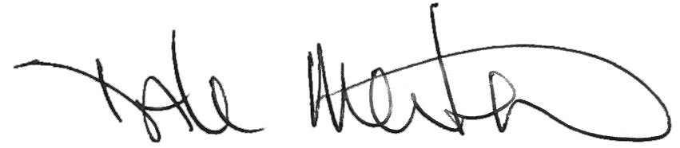

Dale Merten
Chief Operating Officer

