Williams Northwest Pipeline
Howard Hanson Dam and Green River Flooding

The Williams Northwest Pipeline (Northwest) system is located approximately three miles upstream from the City of Auburn in the Green River Valley and is located outside of the major flood impact areas. The flood maps indicate that in a worst-case scenario this area could see 1 to 3 feet of water. Our pipeline system crosses under the Green River and only minor auxiliary equipment is located above ground in the valley.

A pipeline profile survey has been checked by surveyors, and this survey indicates that the pipeline is more then six feet below the river bed.

A local geotechnical consulting firm has been retained and is reviewing the soils, stream banks and hillsides in the area.

Our concerns are with the following: added water flow past this point; the changes in water level; the velocity of the water at this crossing; and the impacts these changes could have on bank erosion and streambed scour.

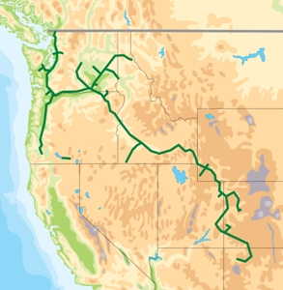

The Williams Northwest Pipeline system transports natural gas through seven western states.
Northwest’s bi-directional system
provides access to British Columbia, Alberta, Rocky Mountain and San Juan Basin gas supplies. Our system consists of high pressure pipelines ranging in size from 4 to 36 inches.

