July 2, 2014

Steven V. King, Executive Director and Secretary
Utilities and Transportation Commission
1300 S. Evergreen Park Dr. SW
P.O. Box 47250
Olympia, WA 98504-7250

RE: Washington Utilities and Transportation Commission v. Radix Networks LLC

Commission Staff’s Response to Application for Mitigation of Penalties UT-140912

Dear Mr. King:

On June 3, 2014, the Utilities and Transportation Commission issued a $300 Penalty Assessment in Docket UT-140912 against Radix Networks LLC for 3 violations of Washington Administrative Code (WAC) 480-120-382, which requires telecommunications companies to furnish annual reports to the commission no later than May 1 each year.¹

On June 18, 2014, Radix Networks LLC wrote the commission requesting mitigation of penalties (Mitigation Request).² In its Mitigation Request Radix Networks LLC contests the penalty assessed and disputes that the violation occurred. The company states, “We complied with the WUTC regulation to submit our annual report no later than May 1st. We received an email from Ms. Amy Andrews late Friday afternoon May 2nd requesting altered copies of previously submitted documentation. In our attempt to comply with WUTC regulations we responded to Ms. Williams in a timely manner and submitted the requested information via the WUTC website within 1.5 business days.” The statement continues, “Considering our diligence and full cooperation with WUTC requests for filing annual reports in a timely manner we kindly ask you to rescind the assessed penalty.”

It is the company’s responsibility to ensure that the regulatory fee is paid and the annual report is filed by the May 1 deadline. On February 28, 2014, Annual Report packets were mailed to all regulated telecommunication companies. The instructions for annual report completion page of
the annual report informed the regulated company that it must complete the annual report form, pay the regulatory fees, and return the materials by May 1, 2014, to avoid enforcement action.

UTC Annual Reports
July 2, 2014
Page 2

The instructions for the annual report completion page also provided reference to WAC 480-07-160 for the requirements to file documents with a confidential status.

On May 6, 2014 Radix Networks LLC filed its completed annual report, which contained the required redacted version of the company financial statements, with no regulatory fees due. The company has been active since October 9, 2006. No previous violations of WAC 480-120-382 are on commission record. Staff does not support the company’s request to rescind the penalty. However, as this is the first delinquent filing for Radix Networks LLC, staff does support mitigation of the penalty to $25 per day for a total assessed penalty of $125.

If you have any questions regarding this recommendation, please contact Amy Andrews, Regulatory Analyst, at (360) 664-1157, or aandrews@utc.wa.gov.

Sincerely,

Sondra Walsh, Director
Administrative Services

ATTACHMENT A
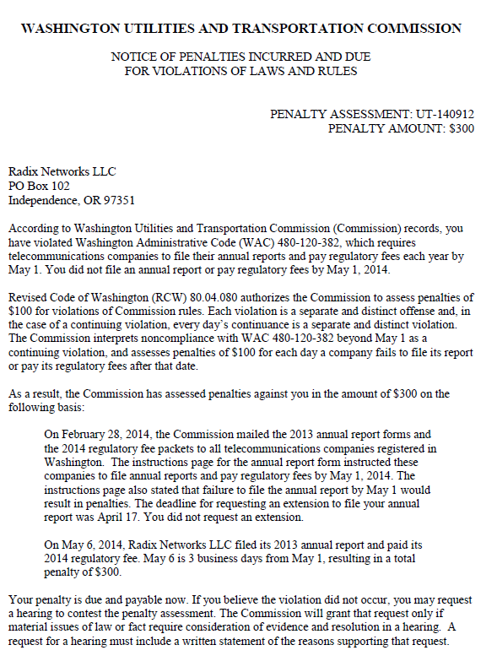

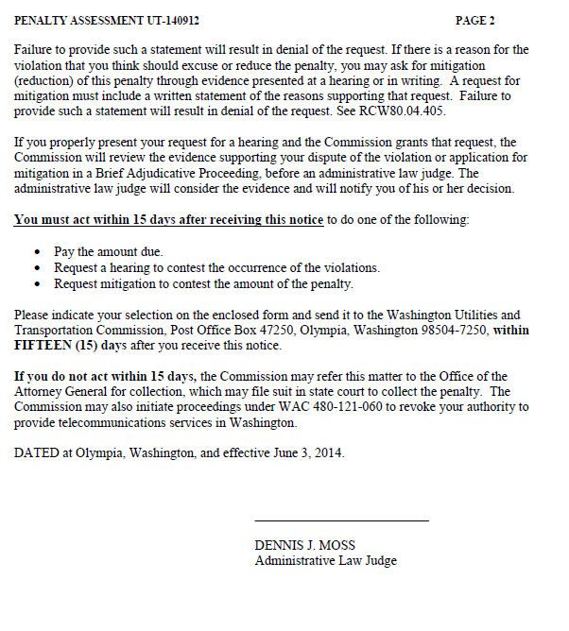

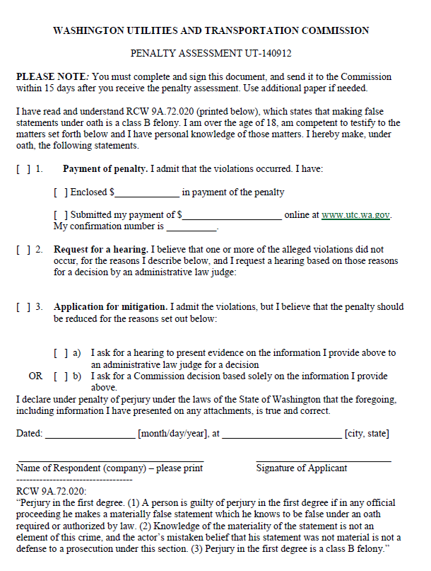

ATTACHMENT B
