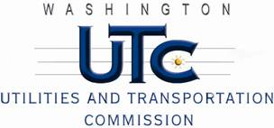

Memorandum
December 19, 2012

To: TR-121075 - File

From: Betty Young, Compliance Investigator, Transportation Safety

Subject: TR-121075 – Kettle Falls International Railway (Kettle Falls Railway)
Grade Crossing Protective Fund (GCPF) project to modify active warning devices at Meyers Street in Kettle Falls (USDOT 059316C)

On July 6, 2012, the Washington Utilities and Transportation Commission (Commission) awarded Kettle Falls International Railway (Kettle Falls Railway) a GCPF grant in the amount of $11,663.25 to improve modify active warning devices at Meyers Street in Kettle Falls (USDOT 059316C). The estimated project cost was $22,104.25 with Kettle Falls Railway paying for all costs exceeding $11,663.25. The actual cost of the project was $10,995.42.

On December 19, 2012, Kettle Falls Railway submitted a request for reimbursement for work pursuant to Commission order. Commission staff conducted a site visit of the crossing and verified that the project was completed according to the specifications outlined in the order approving the grant.

Please close this docket.

