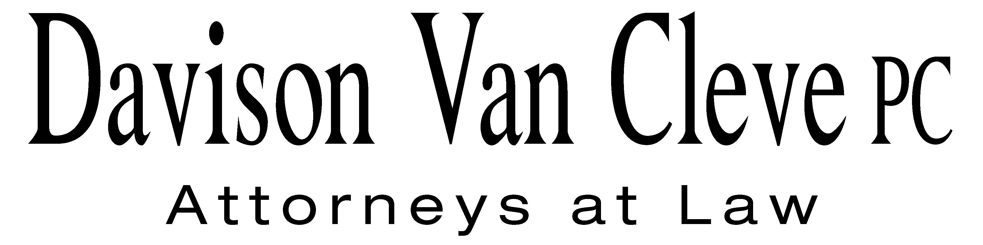
TEL (503) 241-7242 ● FAX (503) 241-8160 ● mjd@dvclaw.com
Suite 400
333 SW Taylor
Portland, OR 97204
September 8, 2015

Via Electronic Mail and U.S. Mail
David Nightingale, C.E.M.
Senior Regulatory Engineering Specialist
Washington Utilities and Transportation Commission
PO Box 47250
1300 S. Evergreen Park Drive, SW
Olympia, WA 98504-7250

Re: PacifiCorp Reliability Issues at the Boise White Paper, LLC Wallula Mill
Docket UE-121680

Dear Mr. Nightingale:

Boise White Paper, LLC (“Boise”) has reviewed your suggested courses of action in response to Boise’s March 20, 2015 letter, regarding the continued status of Boise’s request for a Commission investigation into power reliability and service quality issues concerning PacifiCorp’s (or the “Company”) transmission of electricity to Boise’s mill facility in Wallula, Washington (“Wallula Mill”). Boise understands that the Commission does not have an “inactive” docket status; however, if quarterly updates are required in order to keep this docket open, Boise would be happy to provide them.

In all events, Boise does not wish to close Docket UE-121680 because power quality is still a significant problem at the Wallula Mill. Over the last nine months, Boise has experienced three separate instances of major power disruption at the Wallula Mill, two of which resulted in production disruptions. Fortunately, one of the major power disruption events occurred during a scheduled maintenance downtime period—nonetheless, each outage event is indicative of ongoing deficiencies in a Company system that fails to adequately protect the Wallula Mill from power disturbances. Moreover, Boise has experienced several other instances of power disruption over the past year, in addition to the major outages.

Boise continues to maintain that PacifiCorp has failed to meet its service quality improvement obligations, agreed to as part of the Company’s acquisition by Berkshire Hathaway Energy. This has resulted in fully avoidable expenditures of incremental capital, on Boise’s part, in order to secure internal protection against the risk of further outages at the Wallula Mill. Accordingly, Boise believes that it would be appropriate to maintain the current open docket status, given the strong possibility of future power interruptions and service quality issues. Indeed, given the continued pattern of recent power disruptions and the failure of informal process to produce any actual results, Boise strongly believes that nothing short of prompt improvement to the Company’s antiquated power system will afford the Wallula Mill any material relief from further outages and production disruptions.

Thank you for your consideration of Boise’s concerns and request to maintain the open status of this complaint docket. Please advise us as to any specific informational requests that Staff may have, either in regard to future quarterly reports or any other process necessary to ensure that PacifiCorp begins acting upon its service quality improvement obligations.

Sincerely yours,

/s/ Melinda J. Davison
Melinda J. Davison

cc: Patrick Loupin
Ellis Cunningham
David Tobin
Sarah Wallace
R. Bryce Dalley

