June 27, 2014

Steven V. King, Executive Director and Secretary
Utilities and Transportation Commission
1300 S. Evergreen Park Dr. SW
P.O. Box 47250
Olympia, WA 98504-7250

RE: Washington Utilities and Transportation Commission v. Cristalina, LLC

Commission Staff’s Response to Application for Mitigation of Penalties UW-140840

Dear Mr. King:

On May 28, 2014, the Utilities and Transportation Commission issued a $1,000 Penalty Assessment in Docket UW-140840 against Cristalina, LLC for 10 violations of Washington Administrative Code (WAC) 480-110-505, which requires water companies to furnish annual reports to the commission no later than May 1 each year.¹

On June 13, 2014, Cristalina, LLC wrote the commission requesting mitigation of penalties (Mitigation Request).² In its Mitigation Request, Cristalina, LLC does not dispute that the violation occurred. The company states, “Due to the extensive amount of reporting required by the UTC and customer complaints this report deadline was missed by accident despite having been given notice by the UTC previously.” The mitigation request also indicates Cristalina, LLC is working on a transfer of the water system.

It is the company’s responsibility to ensure that the regulatory fee is paid and the annual report is filed by the May 1 deadline. On February 28, 2014, Annual Report packets were mailed to all regulated water companies. The instructions for annual report completion page of the annual report informed the regulated company that it must complete the annual report form, pay the regulatory fees, and return the materials by May 1, 2014, to avoid enforcement action.

On June 13, 2014, Cristalina, LLC filed its completed annual report and paid the regulatory fees and late payment penalty. On June 17, 2014, Cristalina, LLC filed documents regarding the transfer of assets to Washington Water Service Company in Docket UW-141301.³ The company
UTC Annual Reports
June 27, 2014
Page 2

had prior violations of WAC 480-110-505 during the 2005 and 2011 reporting years. Staff does not support the company’s request for mitigation due to prior violations.

If you have any questions regarding this recommendation, please contact Amy Andrews, Regulatory Analyst, at (360) 664-1157, or aandrews@utc.wa.gov.

Sincerely,

Sondra Walsh, Director
Administrative Services

ATTACHMENT A
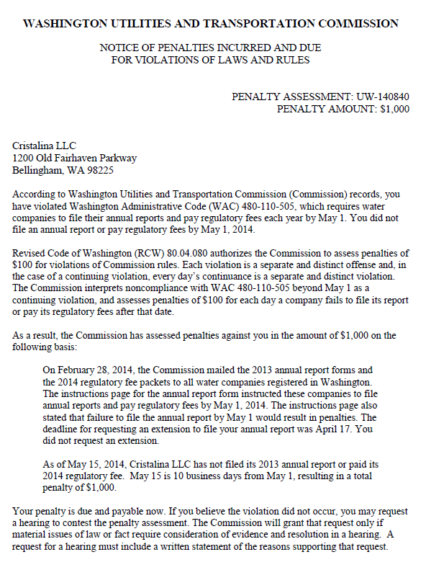

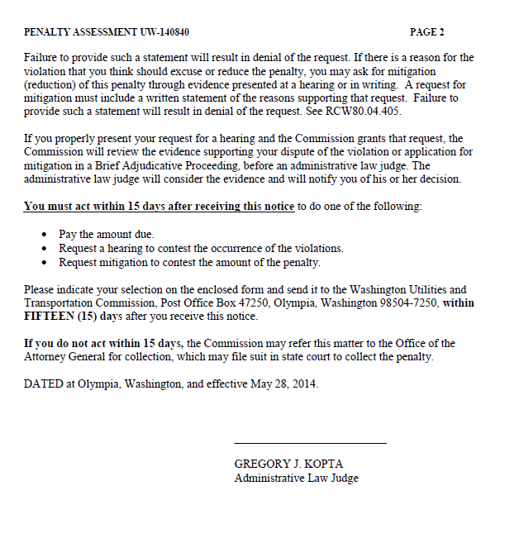

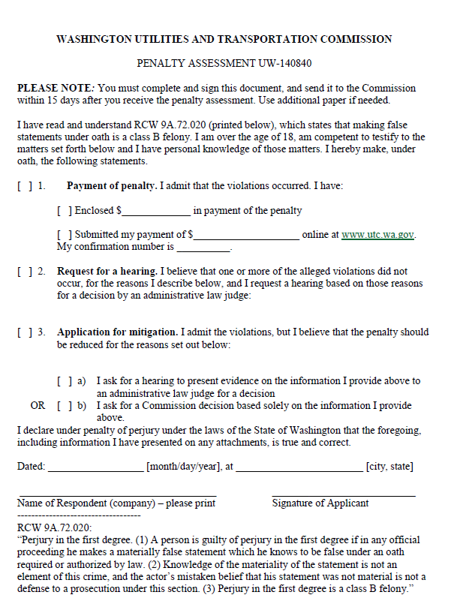

ATTACHMENT B
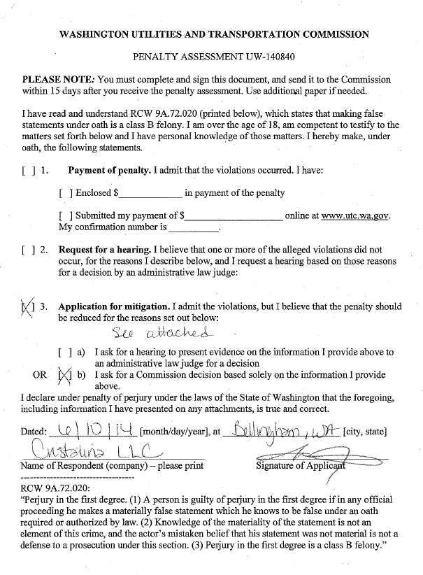

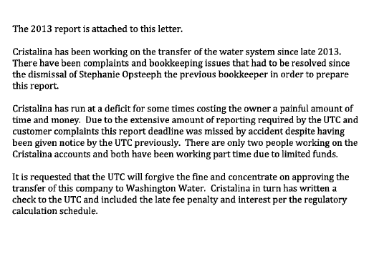

ATTACHMENT C
