December 1, 2017

Mr. Steven V. King
Executive Director and Secretary
Washington Utilities and Transportation Commission
P.O. Box 47250
1300 S. Evergreen Park Drive S.W.
Olympia, WA 98504-7250.

Re: Comments of Utility Conservation Services, LLC (UCONS)
On Avista Corporation’s Biennial Conservation Plan
Docket UE-171091

Dear Mr. King:

Utility Conservation Services LLC (UCONS) is a national leader in the development and implementation of residential conservation programs, headquartered in Kirkland, Washington. UCONS has done or is doing business in Washington, California, Oregon, Idaho, Texas, Utah, and New York. We provide services under contract to a large number of utilities, both investor-owned and publicly-owned, as well as to major property management firms. Since 1993, UCONS has delivered direct-install energy efficiency programs to over 320,000 multifamily tenants and over 100,000 manufactured home utility customers. The aggregate energy savings from these efforts total nearly 500,000,000 kWh and 10,000,000 therms. In recent years, we have focused our work on hard-to-reach (HTR) markets, particularly in the manufactured homes (MH) sector.
Since the Northwest Power and Conservation Council included in its 7th Power Plan a section describing the potential for cost-effective conservation in the MH sector, UCONS has worked with Commission Staff, utilities, and various stakeholders to encourage further attention to this HTR sector by utilities in the development of their biennial conservation plans and their integrated resource plans. UCONS made special efforts with Puget Sound Energy by participating in PSE’s RFI and RFP processes.
Attached is a copy of the comments we provided to the Commission on the PSE BCP. It covers the history of UCONS involvement in this issue, the available cost-effective conservation in the MH sector, the legal reasons why, under Initiative 937, utilities must pursue conservation from this sector, and why, based on our experience, the Commission should commence rulemaking to overcome institutional barriers to pursue all cost-effective conservation under the current regulatory framework. Those comments are relevant to the conservation efforts of Avista as well as to those of PSE. We urge the Commission to consider them in its review of Avista’s BCP.

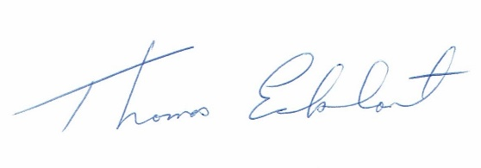
Sincerely,

Tom Eckhart, PE
CEO, UCONS, LLC
10612 NE 46th Street
Kirkland, WA 98033
(425) 576-5409 (office)
(425) 827-2489 (fax)
tom@UCONS.com
www.ucons.com

Enclosure

