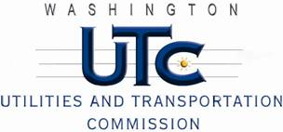

Memorandum
December 17, 2010

To: TR-101453 - File

From: Kathy Hunter, Deputy Assistant Director Transportation Safety

Subject: TR-101453 Tacoma Rail
Grade Crossing Protective Fund (GCPF) Project at the Intersection of
Deschutes Parkway and Tacoma Rail’s Tracks in the City of Olympia, Washington

On September 10, 2010, the Washington Utilities and Transportation Commission (Commission) awarded a GCPF grant totaling $19,705 to install walk-out type cantilevers and a bungalow and replace obsolete incandescent lights with LED type lights at the Deschutes Parkway crossing in the City of Olympia. The USDOT number assigned to this crossing is 085295E.

On December 17, 2010, the applicant, Tacoma Rail submitted a request for reimbursement pursuant to Commission order. On December 8, 2010, Commission staff conducted a site visit and verified that the project is completed according to the specifications outlined in the order approving the grant.

Please close this docket.

