September 15, 2017
VIA WEB PORTAL AND OVERNIGHT MAIL
Mr. Steven King
Executive Director and Secretary
Washington Utilities and Transportation Commission
1300 S. Evergreen Park Drive SW
Olympia, Washington 98504-0128
Re: Puget Sound Energy 2017 General Rate Case
Docket Nos. UE-170033 and UG-170034
Dear Mr. King:
Enclosed for filing please find the original and eleven (11) copies of the following documents in the above-referenced dockets:
(i) the Multiparty Settlement Stipulation and Agreement, dated as of September 15, 2017, by and between Puget Sound Energy (“PSE”), the Commission’s regulatory staff (“Commission Staff”), the Industrial Customers of Northwest Utilities (“ICNU”), NW Energy Coalition/Renewable Northwest/Natural Resource Defense Council, The Energy Project, Sierra Club, Federal Executive Agencies, The Kroger Co., the State of Montana, and Northwest Industrial Gas Users; and
(ii) the Joint Memorandum in Support of the Multiparty Partial Settlement, dated as of September 15, 2017, filed by PSE, Commission Staff, ICNU, NW Energy Coalition/Renewable Northwest/Natural Resource Defense Council, The Energy Project, Sierra Club, Federal Executive Agencies, The Kroger Co., the State of Montana, and Northwest Industrial Gas Users.
Please feel free to contact me if you have any questions regarding the enclosed documents.
Very truly yours,
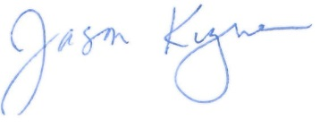
Jason Kuzma
Enclosures
cc: Service List in Docket Nos. UE-170033 and UG-170034

