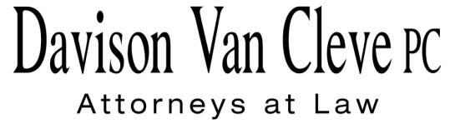
TEL (503) 241-7242 ● FAX (503) 241-8160 ● jog@dvclaw.com
Suite 400
333 S.W. Taylor
Portland, OR 97204

December 12, 2016

Via E-mail and Federal Express

Mr. Steven V. King
Executive Director
Washington Utilities & Transportation Commission
1300 S. Evergreen Pk. Dr. S.W.
P. O. Box 47250
Olympia, WA 98504-7250

Re: WUTC v. Pacific Power & Light Co.
Docket UE-161204

Dear Mr. King:

Enclosed for filing in the above-referenced docket, please find the original and twelve (12) copies of the Notice of Appearance of Boise White Paper, L.L.C.

Thank you for your assistance. If you have any questions, please do not hesitate to call.

Sincerely,

/s/ Jesse O. Gorsuch
Jesse O. Gorsuch
Enclosure
cc: Service List

CERTIFICATE OF SERVICE

I hereby certify that I have this day served the attached Notice of Appearance upon all parties in this proceeding, as shown below, by sending a copy via electronic mail and First Class U.S. Mail, postage prepaid.
DATED this 12th day of December, 2016.
Davison Van Cleve, P.C.

/s/ Jesse O. Gorsuch
Jesse O. Gorsuch

 | R. BRYCE DALLEY  Vice President, Regulation  PacifiCorp  825 NE Multnomah STE 2000  Portland, OR 97232  bryce.dalley@pacificorp.com  CHRISTOPHER CASEY  Assistant Attorney General  WUTC  PO Box 40128  Olympia, WA 98504-0128  ccasey@utc.wa.gov | LISA GAFKEN  Office of the Attorney General  800 Fifth Avenue STE 2000  Seattle, WA 98104-3188  simonf@atg.wa.gov

