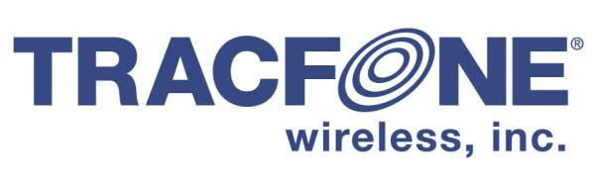

October 31, 2017

VIA ELECTRONIC FILING

Mr. David Danner
Executive Director and Secretary
Washington Utilities and Transportation Commission
1300 S. Evergreen Park Drive S.W.
Olympia, WA 98504-7250

Re: Quarterly Activity Report of TracFone Wireless Inc., Docket No. UT-093012

Dear Mr. Danner:

Attached for filing in the above-referenced docket is the quarterly activity report of TracFone Wireless, Inc. for the third quarter of 2017. TracFone is filing this report in compliance with the Commission’s order designating the company as an eligible telecommunications carrier.

The document is designated as confidential pursuant to WAC 480-07-160, because it contains valuable commercial information, including the number of customers subscribing to TracFone’s service and the type of services selected by customers. TracFone Wireless, Inc., would be directly and adversely affected by disclosure of the confidential information. A redacted copy is also attached.

Please contact me if you have any questions about this submission. If you have any questions, please feel free to contact me at (305) 715-3613, or sathanson@tracfone.com.

Sincerely,

Stephen Athanson
Regulatory Counsel

Enc.

