What Does Capital Really Cost a Utility?
A new study suggests excess compensation to shareholders is costing ratepayers billions.
Regulating an electric or gas utility is a tough job. You want utilities to have the funding they need to serve the public reliably and safely while also keeping rates under control and distributing the revenue burden fairly among customers. Setting rates and monitoring the service performance of utilities gets a lot of attention. What gets much less attention is one of the biggest challenges the regulator faces: figuring out a utility’s costs.
For many costs this seems trivial – the regulator can see what the company paid for everything from fuel to software to the CEO simply by looking at the utility’s books. There is, of course, still the question of whether the utility is overpaying or is using too much (or too little) of an input.
But when it comes to the cost of capital things get murkier. Determining the interest rate the utility must pay lenders or the rate of return it must pay shareholders when they finance investment by issuing stock has been a constant challenge since utility regulation began about a century ago. Unlike most other inputs to utility operations, the cost of capital depends very much on the utility itself, in particular on its finances and risk.
(Source)
A regulator can see the interest rate the utility pays to a lender or bond purchaser, though there is always concern that the utility isn’t getting the best deal it could in those thin markets. The much bigger problem, however, is how much to compensate shareholders who own a piece of the firm. Those costs don’t appear anywhere on the books and are not straightforward to estimate.
These numbers really matter. US investor-owned electric utilities had assets of nearly $1.4 trillion when 2022 started, and about half of that is financed with shareholder equity. That’s why a lot of time in utility rate cases is spent fighting over the relatively obscure technical question of how much return investors require in order to buy the utility’s stock.
A new Energy Institute working paper by recently-graduated EI alumni, Karl Dunkle Werner and Stephen Jarvis, takes a deep dive into this question and suggests that U.S. regulators are not doing a great job overseeing these costs.
Karl and Stephen (K&S) do this by collecting data on over 3500 regulatory rate cases for electricity and natural gas utilities between 1980 and 2021. They then compare the allowed rate of return on equity to a variety of capital cost indexes, including government and corporate bonds. As the figure below shows, the real (inflation-adjusted) return regulators allow equity investors to earn has been pretty steady over the last 40 years, while many different measures of the actual cost of capital have been declining.
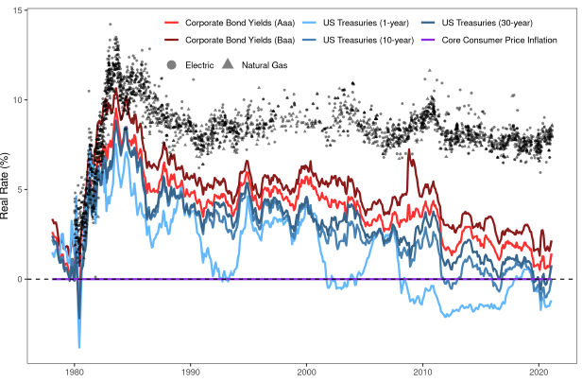
These trends could be explained if utilities have gotten riskier over the last 40 years. But if that were the case it would affect bond ratings, as well as the cost of equity. Increased industry risk would be borne more by equity than debtholders, but it would still be hard to explain a substantial change in the riskiness of utility equity while their debt remained rock-solid. As the paper shows, utility debt ratings have barely budged. That may be a surprise to some folks in California – it’s easy to think of particular utilities that may face more risk today than in past decades – but overall the folks who rate the riskiness of US utilities’ don’t see a systematic trend in recent decades.
All these different benchmarks yield different estimates of the gap in allowed equity returns compared to 25 years ago, but the median is around 2 percentage points, which is real money when it is multiplied by about $700 billion in equity financing of electric utilities alone. Still, there is a valid question of whether utilities are being over-compensated today or were being under-compensated 25 years ago.
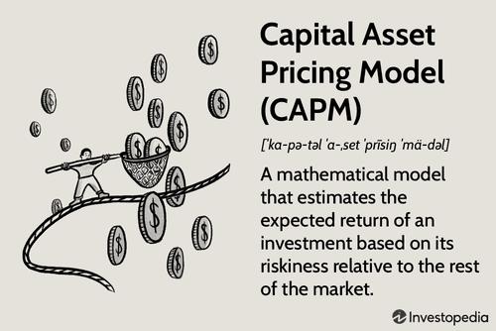(Source)
But K&S don’t just compare to debt ratings. They also look at the direct economic models of what equity should actually cost, built around what’s known as the Capital Asset Pricing Model (CAPM), the workhorse finance model for asset valuation that is frequently referenced in regulatory hearings. This approach accounts for how risky a company is and the market compensation for taking on extra risk. Consistent with earlier research on utility equity returns, they find that there is also a significant and growing gap between the return regulators allow shareholders and what the CAPM would say they need to be paid to attract investment. They also show just how sensitive this approach is to the underlying assumptions, a fact that utilities are no doubt aware of and that should make regulators wary.
Along the way, the study finds an interesting empirical pattern that suggests what might be going on with these regulatory decisions. Both the return on equity requested by utilities and the return granted by regulators respond more quickly to rises in market measures of capital cost than to declines. In other words, utilities get in there quickly and demand higher returns when they can make the case shareholders are being under-compensated, and regulators respond to those demands. But when shareholders are being over-compensated, the adjustment tends to take longer (consistent with research that Paul Joskow did nearly 50 years ago), about twice as long, K&S estimate. Combining this slow response to over-compensation with the declining cost of capital over most of the last four decades (at least until 2022 came along) would explain why the gap in equity returns has widened on average.
(Source)
We worry about regulators over-compensating shareholders because the costs are paid through higher utility rates, which disproportionately hurt the poor, as Jim Sallee blogged about last week. And higher electric rates undermine building and transportation decarbonization
But utilities also have an incentive to overinvest in capital projects if they are earning an outsized return on those investments. Sure enough, the paper finds that every extra percentage point of allowed return on equity causes a utility’s capital rate base to expand by an extra 5% on average. Overall the paper estimates excess costs to consumers could range from $2 billion to $20 billion per year, with the most likely number in the middle of that range. That doesn’t mean all of that extra investment is wasted – the capital is still doing something that is presumably useful unless it’s being spent on gold-plated coffee mugs – but it should make regulators think carefully about utilities’ motivations when they argue for particular new capital expenditures.
Obviously, we need electric utilities, and we even need gas utilities for at least a while. Some people may argue K&S’s results make the case for government-owned utilities so there are no shareholders to compensate, but to anyone who has studied the alternatives carefully, it’s clear that each model is subject to abundant inefficiencies. I think this study should be another reminder not just that regulating utilities is a tough job, but also that investing in high-quality regulation – hiring adequate numbers of highly-skilled staff, paying well enough to retain the best of them, and giving them the resources to do their jobs – is likely to have enormous payback.
Find me @BorensteinS most days tweeting energy news/research/blogs.
Keep up with Energy Institute blog posts, research, and events on Twitter @energyathaas.
Suggested citation: Borenstein, Severin. “What Does Capital Really Cost a Utility?” Energy Institute Blog, UC Berkeley, October 3, 2022, https://energyathaas.wordpress.com/2022/10/03/what-does-capital-really-cost-a-utility/
CATEGORIES
Uncategorized
TAGS

