Report to the Washington Utilities and Transportation Commission

Electric Service Reliability - Major Event Report

Event Date: August 13, 2016
Date Submitted: October 20, 2016
Primary Affected Locations: Sunnyside/Yakima
Primary Cause: Loss of Supply
Exclude from Reporting Status: Yes
Report Prepared by: April Brewer
Report Approved by: Heide Caswell / Kevin Putnam / David O’Neil / Steve Henderson

Event Description
On August 13, 2016, Sunnyside and Yakima operating areas, experienced a system average interruption frequency index-driven (SAIFI)-based major event when a loss of transmission event occurred on the Bonneville Power Administration (BPA) 230 kilovolt (kV) transmission feed. The outage event affected 17,196 customers with all customer restorations completed within 32 minutes. During the day, sustained interruptions were experienced by 16% of the combined total customers in the Sunnyside and Yakima operating areas.

Event Outage Summary
# Interruptions (sustained) | 24
Total Customer Interrupted (sustained) | 17,238
Total Customer Minutes Lost | 332,150
Event SAIDI | 2.49 Minutes
CAIDI | 19
Major Event Start | 8/13/16 12:00 AM
Major Event End | 8/14/16 12:00 AM

Restoration Summary
Pacific Powers Outlook substation is fed from two 230 kV BPA sources; BPA’s North Bonneville and Midway substations. At 8:17 pm on August 13, 2016, BPA opened the 230kV Midway line feeding the Outlook substation for a scheduled outage. A failed light on the breaker indicated that the second feed to the Outlook substation from the Northern Bonneville 230 kV line was energized, when actually the breaker was open and the line was not energized. Subsequently, when the BPA de-energized feed from the Midway substation to the Outlook substation, the substation and its feeds were all de energized.
The loss in transmission affected power feeds from the Outlook substation to three other substations, feeding 15 distribution lines, and serving 17,196 customers. Grid operations quickly notified BPA of the outage and at 8:28 pm supply was restored to 11,085 customers. Field personnel were advised of the outages and dispatched to the Toppenish substation to manually close breakers, as no remote operation is possible. At 8:49 the remaining 6,111 customers were restored.
There were no company or commission customer complaints made regarding the major event.
Restoration Intervals
Total Customers Sustained | < 3 Hrs. | 3 - 24 Hrs. | 24+ Hrs.
17,238 | 17,231 | 25 | 0

Restoration Resources
No additional restoration resources were used during this event.
State Estimated Major Event Costs
No additional costs were accrued during this event.
Major Event Declaration
Pacific Power is requesting designation of this event and its consequences to be classified as a “Major Event” for exclusion from underlying network performance reporting. This major event exceeded the company’s current Washington system average interruption frequency index-driven (SAIFI) threshold of 10% total operating area customers served sustained interruptions (17,238 customers interrupted out of a combined total of 104,922 Sunnyside and Yakima operating area customers, or 16% of the combination of the two operating area customers) simultaneously in a 24-hour period.
Event Detail
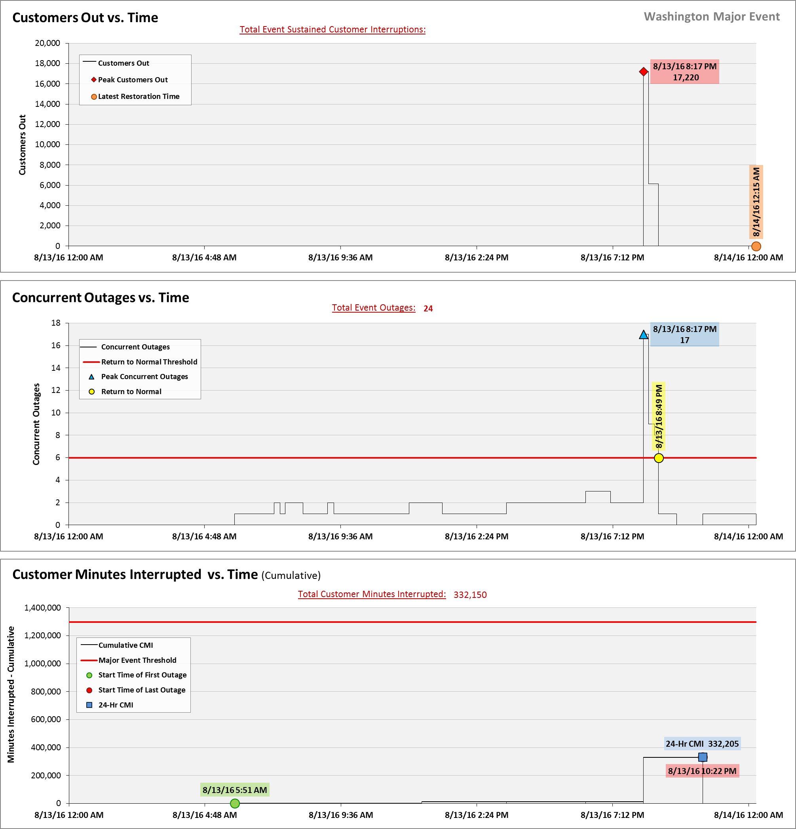
SAIDI, SAIFI, CAIDI by Reliability Reporting Region
Please see the attached system-generated reports.

A SAIFI-based major event threshold (as identified in PacifiCorp’s reporting plan, pursuant to Washington Administrative Code (WAC) 480-100-393 & 398 Electric Reliability Annual Monitoring and Reporting Plan) is defined as an event in which more than 10% of an operating area’s customers are simultaneously without service as a result of a sustained interruption. Sunnyside operating area’s Calendar 2016 Frozen Customer Count is 24,317 customers and Yakima’s 2016 Frozen Customer Count is 80,605, for a combined total of 104,922.

