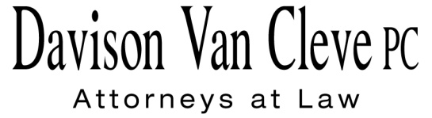
TEL (503) 241-7242 ● FAX (503) 241-8160 ● mail@dvclaw.com
Suite 400
333 SW Taylor
Portland, OR 97204

January 20, 2011

Via Federal Express

Patricia Clark
Administrative Law Judge
Washington Utilities and Transportation Commission
PO Box 47250
1300 S. Evergreen Park Drive, SW
Olympia, WA 98504-7250

Re: WUTC v. PacifiCorp d/b/a Pacific Power & Light Company,

Docket No. UE-100749

Dear Judge Clark:

Enclosed please find the original and seventeen (17) copies of the additional cross-examination exhibits for Nicholas L. Nachbar and Randall J. Falkenberg on behalf of the Industrial Customers of Northwest Utilities in the above-referenced docket.

If you have any questions, please feel free to give our office a call. Thank you for your assistance.

Sincerely yours,

/s/ Jacqueline E. Smith
Jacqueline E. Smith

Enclosures
cc: Service List

