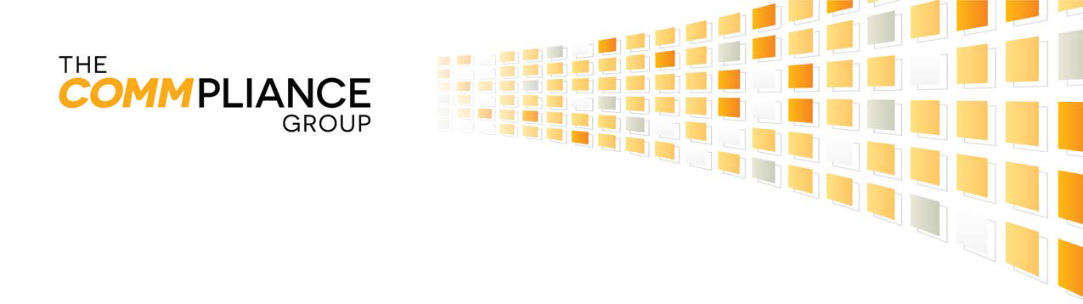

March 9, 2017

IMPORTANT NOTICE REGARDING COMPLIANCE & REPORTING

Washington Utilities and Transportation Commission
Utilities Division Annual Reports
P.O. Box 47250
Olympia, WA 98504

Re: inContact, Inc., d/b/a UCN, Inc.
Docket # UT-170145
Carrier Annual Reporting Requirements
For the Year Ended December 31, 2016

To Whom It May Concern:

This letter is being sent to request an extension until June 1, 2017 of the filing deadline of the State’s Carrier Annual Reporting Requirements for the year ended December 31, 2016, due on May 1, 2017 on behalf of inContact, Inc., d/b/a UCN, Inc. inContact will not have its year-end financial statements completed by the Commission deadline of. A copy of inContact’s Financial Statements will be submitted once this has been filed with the Securities and Exchange Commission.

Please contact Kitty Whitt at (703) 663-6758 or kit@commpliancegroup.com with any questions concerning this filing. Thank you for your assistance in this matter.

Sincerely,

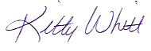
Katherine “Kitty” Whitt
The Commpliance Group Managing Consultant Telephone: (703) 663-6758
Email: kit@commpliancegroup.com

