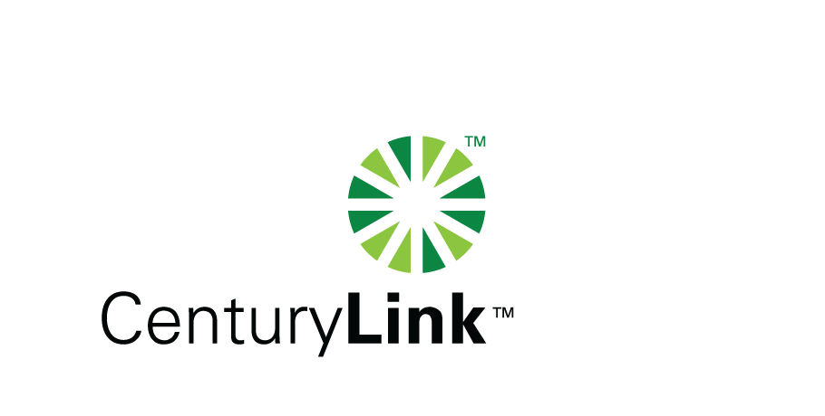
CenturyLink
1600 7th Avenue, Room 1506
Seattle, Washington 98191
(206) 345-1568
Facsimile (206) 343-4040

Mark S. Reynolds
VP Regulatory & Legislative Affairs
Western Region

June 23, 2014

Steven V. King
Executive Director and Secretary
1300 S. Evergreen Park Dr. S.W.
P.O. Box 47250
Olympia, Washington 98504-7250

Re: Docket UT-143015
Annual reporting requirement for CAF ICC recipients pursuant to 47 C.F.R. 54.304(c)(1)

Dear Mr. King:

The Federal Communications Commission’s (“FCC") November 18, 2011 USF/ICC Transformation Order, FCC 11-161 (WC Docket No. 10-90), requires price cap carriers seeking CAF ICC support to file data establishing the amount of the price cap carrier’s eligible CAF ICC funding per 47 C.F.R. §54.304(c)(1). The attached letter reflects the anticipated CAF ICC support and Access Recovery Charge Revenue amounts for CenturyLink as submitted to the FCC for 2014. This filing is being made with the Commission pursuant to the requirements of 47 C.F.R. §54.304(c)(1).

If you have questions concerning this filing, please contact Gary Kepley at 913-345-7572.

Sincerely,

Mark Reynolds

Attachment

CenturyLink
Gary Kepley
5454 West 110th Street
Overland Park, KS 66211
Tel: 913-345-7572 Fax: 913-345-6756
E mail: Gary.Kepley@CenturyLink.com

June 16, 2014

The Federal Communications Commission’s (“FCC") November 18, 2011 USF/ICC Transformation Order, FCC 11-161 (WC Docket No. 10-90), requires price cap carriers seeking CAF ICC support to file data establishing the amount of the price cap carrier’s eligible CAF ICC funding per 47 C.F.R. §54.304(c)(1).

Below are CenturyLink’s anticipated CAF ICC support and Access Recovery Charge Revenue amounts submitted with its 2014 Annual Access Tariff Filing with the FCC.

Holding Company Eligible Recovery | Holding Company Maximum ARC Revenues | Maximum CAF ICC Support
$158,508,025 | $203,900,294 | $0

Please call me at 913-345-7572 if you have any questions regarding this filing.

Sincerely,
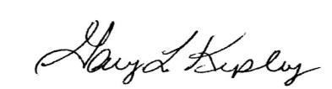

Gary Kepley
Director – Regulatory Operations

