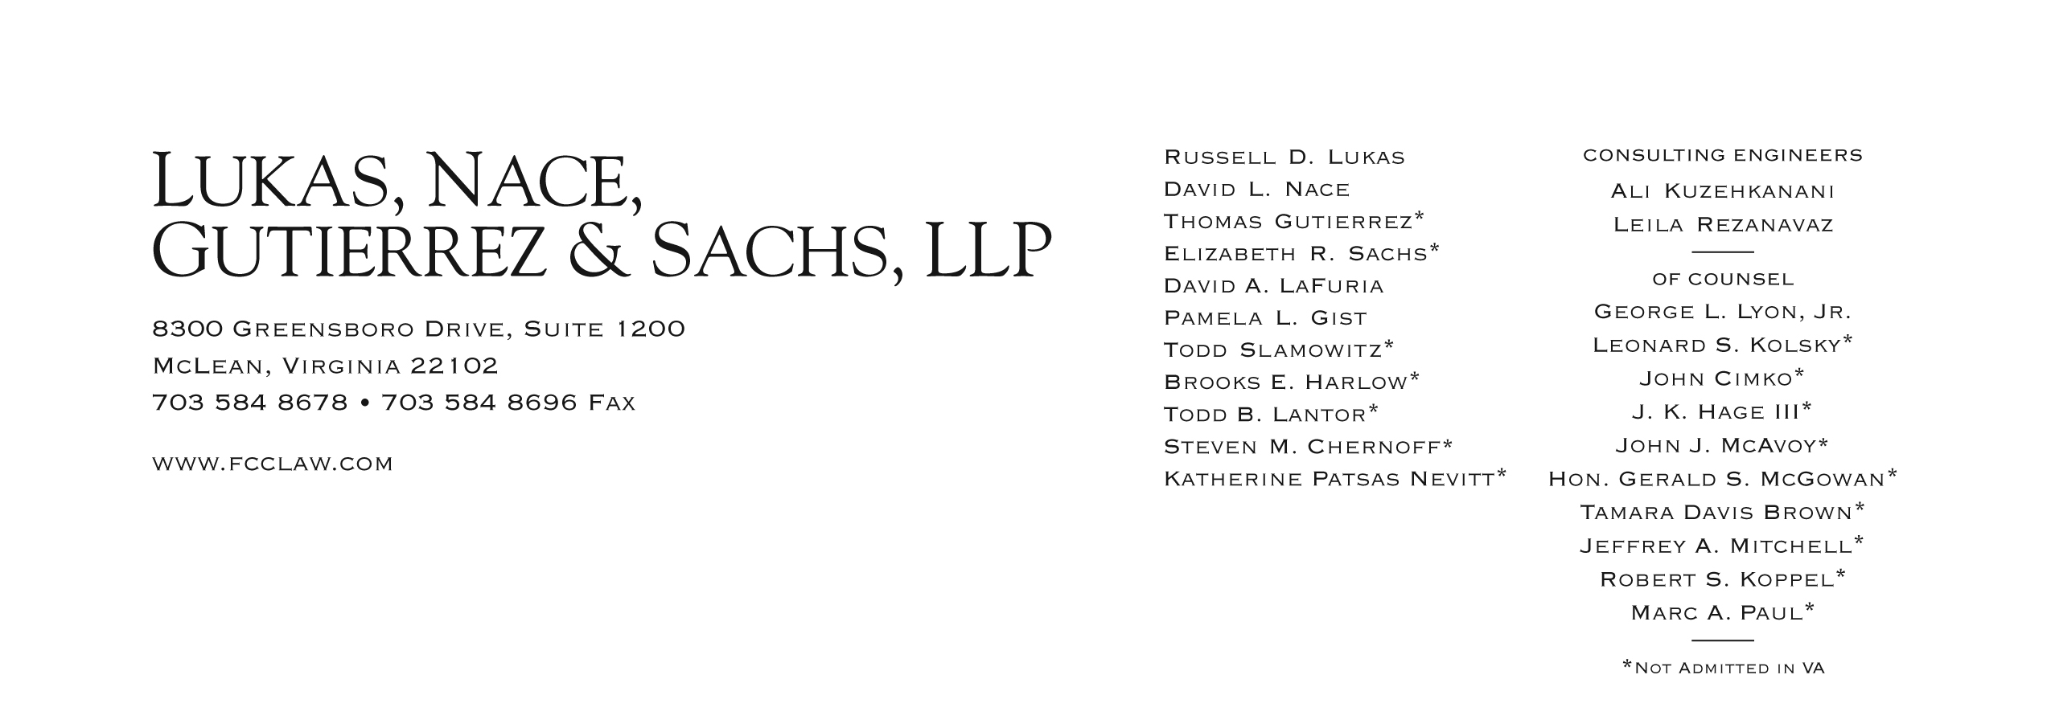

Brooks E. Harlow
(703) 584-8680
bharlow@fcclaw.com

March 8, 2012

VIA WEB PORTAL AND OVERNIGHT MAIL

David S. Danner
Secretary and Executive Director
Washington Utilities and Transportation Commission
1300 S. Evergreen Park Drive S.W.
Olympia, WA 98504-7250
Re: In the Matter of the Petition of Budget PrePay, Inc. for Limited Designation as an Eligible Telecommunications Carrier in Washington
Docket No. UT-111570

Dear Mr. Danner:

Budget PrePay, Inc. (“Budget PrePay” or “Company”) respectfully submits this supplement to its pending Petition for Limited Designation ("Petition") as an Eligible Telecommunications Carrier (“ETC”) in Washington. This supplement is being filed in response to the Federal Communications Commission’s (“FCC”) recently released order In the Matter of Lifeline and Link Up Reform and Modernization (“Lifeline Reform Order”) which modified the FCC's Rules with respect to Lifeline-only ETC designations.

Budget PrePay hereby clarifies its Petition as follows:

Forbearance Request - "Own Facilities" Requirement of 47 U.S.C. § 214(e)(1)(A)

In accordance with the FCC's Lifeline Reform Order, Budget PrePay has requested that the FCC forbear from applying the “own facilities” requirement of Section 214(e)(1)(A) of the Communications Act, 47 U.S.C. § 214(e)(1)(A). Budget PrePay's request is consistent with the Commission’s determination to forbear from applying this requirement to Lifeline-only applications that comply with the conditions set forth in the Lifeline Reform Order. In connection with its forbearance request, Budget PrePay has submitted its Compliance Plan for approval by the FCC, as set forth in the Lifeline Reform Order. A copy of the Compliance Plan is attached as Attachment A to this supplement.

Link Up Support

In accordance with the FCC's Lifeline Reform Order, Budget PrePay no longer seeks to partcipate in the Link Up support program.

Budget PrePay’s Lifeline Service Offerings

The details of Budget PrePay’s two revised Lifeline offerings are set forth in Exhibit A to the attached Compliance Plan, and reflect the new federal Lifeline subsidy support amounts that will be made available to eligible consumers and qualified ETCs. These plans and the description of these plans set forth in the Compliance Plan replace the plan description set forth in Budget PrePay's Petition.

Consistent with representations made by Budget PrePay in its pending ETC application, residents of Tribal Lands will have the option to participate in a Lifeline plan offered by Budget PrePay. Tribal Lands residents that choose the Active User Talk & Text Lifeline plan will receive an additional $25.00 Lifeline credit, thereby reducing the cost of that Lifeline plan for Tribal Lands residents to $0.

Compliance with Revised Section 54.101(a) of the FCC's Rules

In its Lifeline Reform Order the FCC revised 47 C.F.R. § 54.101 to read as follows:
§ 54.101. Supported Services for rural, insular and high cost areas.
- Services designated for support. Voice telephony services shall be supported by federal universal service support mechanisms. Eligible voice telephony services must provide voice grade access to the public switched network or its functional equivalent; minutes of use for local service provided at no additional charge to end users; access to the emergency services provided by local government or other public safety organizations, such as 911 and enhanced 911 systems …; and toll limitation services to qualifying low-income consumers as described in subpart E of this part.

Budget PrePay complies with the revised version of Section 54.101 of the FCC's Rules, 47 C.F.R. § 54.101, and provides the requisite supported services, as follows:

Voice Grade Access. Eligible voice telephony services must provide voice grade access to the public switched network or its functional equivalent. “Voice grade access” permits a telecommunications user to transmit voice communications, including signaling the network that the caller wishes to place a call, and to receive voice communications, including receiving a signal that there is an incoming call. Budget PrePay will provide its customers with “voice grade access” by enabling such customers to make and receive calls on the public switched telephone network.

Minutes of Use for Local Service at No Additional Charge. Budget PrePay will provide its Lifeline customers with minutes of use for local service at no additional charge. Both of the Lifeline plans to be offered by Budget PrePay (as described more fully in Exhibit A to Budget PrePay’s Compliance Plan) will provide local usage at no additional charge to customers.

Access to Emergency Services. Budget PrePay will provide access to emergency services in conformance with the FCC’s requirements. All of the phones that Budget PrePay will distribute to subscribers will be capable of delivering automatic numbering information (“ANI”) and automatic location information (“ALI”), and otherwise satisfy applicable enhanced-911 requirements.

Toll Limitation. Budget PrePay will provide toll limitation services to qualifying low-income customers.

Certification and Verification Requirements

Budget PrePay substitutes the discussion of certification and verification requirements set forth in the attached Compliance Plan for the discussion of such requirements at pages 9–11 of its Petition. As set forth in the Compliance Plan, Budget PrePay has developed a detailed compliance policy consistent with the requirements of the Lifeline Reform Order that includes procedures for initial, as well as on-going, certification and verification of consumer eligibility for participation in the Lifeline program.

Financial and Technical Qualifications

As part of the Lifeline Reform Order, the FCC amended its rules to require a carrier seeking designation as a Lifeline-only ETC to demonstrate that it is financially and technically capable of providing the supported Lifeline service in compliance with all of the low-income program rules. Budget PrePay satisfies these criteria, as set forth below and in Budget PrePay’s responses to Staff’s request for information submitted on September 29, 2011.

Budget PrePay, based in Bossier City, Louisiana, has been in business since 1996. Budget PrePay currently derives the majority of its revenue from selling low-cost prepaid telephone services on a nationwide basis to tens of thousands of customers and employs approximately 340 people. Budget PrePay will not need to rely exclusively on USF support to provide wireless Lifeline services.

Budget PrePay owns and operates its own switching facilities in Dallas, Texas and Shreveport, Louisiana. These switching facilities are used to provide access to directory assistance and operator services, both of which are provided by Budget PrePay employees. The switching facilities are also used to provide access to some interexchange services (for the routing of certain domestic and all non-domestic) calls. In addition, Budget PrePay has invested millions of dollars in software development, including its own customized, user friendly point-of-sale software.

Budget PrePay has not been subject to any enforcement action at the FCC or in any state. No ETC designations held by Budget PrePay have been rescinded, revoked or terminated by the FCC or by any state.

Contact Person

Budget PrePay updates its contact person to work with Commission staff to resolve any complaints or other compliance matters:

Ms. Robin Enkey
Budget PrePay, Inc.
1325 Barksdale Blvd.
Bossier City, LA 71111
Phone: (888) 424-5588
E-mail: robine@budgetprepay.com

Expeditious Grant Requested
In light of these clarifications, Budget PrePay respectfully requests expeditious approval of its pending Petition so that the Company, upon designation as an ETC, may quickly begin providing essential Lifeline service to eligible low-income customers.

If you have any questions or require any additional information, please contact undersigned counsel directly.

Continued Processing Requested
In light of this supplement, Budget PrePay respectfully requests that Staff complete its review of Budget’s pending Petition so that the Commission will be in a position to act promptly on the pending Petition upon approval of the Company's Compliance Plan by the FCC. The Company, upon designation as an ETC, looks forward to providing essential Lifeline service to eligible low-income customers in Washington.

If you have any questions or require any additional information, please contact undersigned counsel directly.

Respectfully submitted,
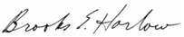
Brooks E. Harlow

Cc (via email): Mr. William Weinman
Ms. Jing Liu

Attachment

ATTACHMENT A:
Budget PrePay, Inc. Compliance Plan

In the Matter of the Petition of Budget PrePay, Inc. for Limited Designation as an Eligible Telecommunications Carrier in Washington, WUTC Docket No. UT-111570 (filed Aug. 29, 2011).
In the Matter of Lifeline and Link Up Reform and Modernization, WC Docket No. 11-42, Report and Order and Further Notice of Proposed Rulemaking, FCC 12-11, rel. Feb. 6, 2012 ("Lifeline Reform Order").
See Lifeline Reform Order at ¶ 368.
See Lifeline Reform Order at ¶ 368. See Budget PrePay, Inc. Compliance Plan, WC Docket No. 09-197 and WC Docket No. 11-42 (filed March 1, 2012). While Budget PrePay owns some facilities and appears to satisfy the revised supported services requirements applicable to ETCs in the Lifeline Reform Order, Budget PrePay has filed its Compliance Plan with the FCC out of an abundance of caution, to illustrate its support for many of the recent reform measures taken by the FCC that attempt to curb waste, fraud and abuse in the Low Income Fund, and in the hopes that its filing will expedite processing of its pending ETC designation Petitions at the FCC and several state commissions.
See Lifeline Reform Order at ¶ 387.

