AVISTA CORP.

RESPONSE TO REQUEST FOR INFORMATION

JURISDICTION: WASHINGTON DATE PREPARED: 05/08/2018

CASE NO.: U-170970 WITNESS: Mark Thies

REQUESTER: UTC Staff RESPONDER: Liz Andrews

TYPE: Bench Request DEPT: Regulatory Affairs

REQUEST NO.: Bench Request No. 1 TELEPHONE: (509) 495-8601
EMAIL: liz.andrews@avistacorp.com

REQUEST:

On March 27, 2018, all Parties in this case filed a Settlement Stipulation and Agreement (Settlement) with the Commission that, if approved, would resolve all issues in these proceedings. The Settlement, among other things, proposes to set depreciation rates for Colstrip Units 3 and 4 based on a remaining life through December 31, 2027, with a portion of the remaining $114.2 million plant balance being recovered through temporary tax credits resulting from the Tax Cuts and Jobs Act (TCJA). The impacts of the TCJA were also implicated in Avista’s recently decided general rate case (Avista 2017 GRC).

The Commission requests that the Parties identify specifically, and explain, how Commission determinations in Order 07 may affect the proposed Settlement Stipulation in this proceeding. Please explain, in addition, how the Settling Parties propose to resolve any conflicts between Order 07 and the proposed Settlement Stipulation.

RESPONSE:

The Commission, in Order 7 in Dockets UE-170485 et. al., reduced the amount of deferred federal income tax that could be applied towards accelerated depreciation of Colstrip Units 3 and 4. To address the conflict between Order 7 and the Settlement in this docket (U-170970), the Parties in this proceeding have agreed to amend Commitment No. 76, appearing at page 22 of Appendix A to the Settlement Stipulation, and amend Attachment A to Appendix A, to reduce the amount of deferred federal income tax benefit from $16.7 million to $10.4 million to be used for purposes of accelerating the depreciation of Colstrip Units 3 and 4, to reflect a “useful life” of 2027 for depreciation purposes. “Bench Request No. 1 - Attachment A” provides the First Amendment to Settlement Stipulation and Agreement, including the revisions listed above, as well as Revised Joint Testimony and Exhibits and Individual Testimony in Support of the Settlement Stipulation. These revisions were filed with the Commission on May 7, 2018.

As discussed in Commitment No. 76, appearing at page 22 of Appendix A to the Settlement Stipulation, and Attachment A to Appendix A, the Parties agreed to adopt a depreciable balance of Colstrip Units 3 and 4, including Colstrip transmission assets, of $114.2 million (Washington share) as of December 31, 2017. This included the unrecovered plant balance of $71.5 million (Washington share), as well as the estimated asset retirement obligations previously not included in rates of $42.7 million (Washington share). The table below summarizes the revised recovery of Washington’s current depreciable Colstrip Unit 3 and 4 balance of $114.2 million, reflecting the changes made to revised Commitment No. 76 (resulting from the Commission’s Order 07):

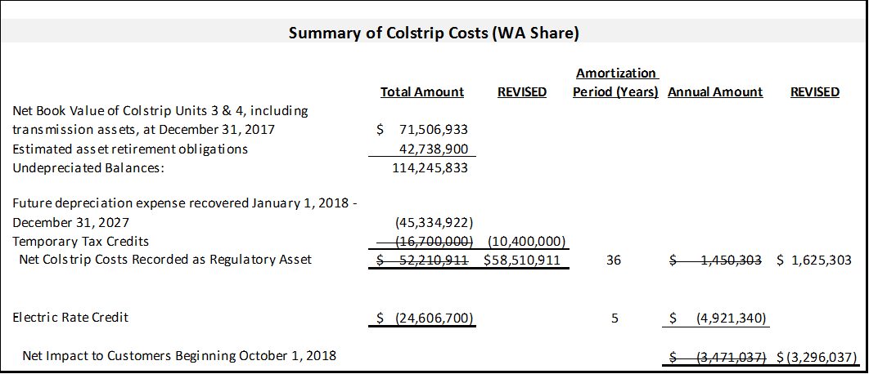

As shown in the table above, the Temporary Tax credits have been revised from $16.7 million to $10.4 million, resulting in a net Colstrip Regulatory Asset to be amortized over 36 years of $58.5 million. If the revised Settlement were to be approved by the Commission, the amortization of the revised Regulatory Asset of $58.5 million over 36 years would result in an increase in annual regulatory amortization expense of $1.63 million, effective October 1, 2018. This would be offset by the Washington electric rate credit of $4.9 million, annually for five years beginning October 1, 2018, and would result in a net reduction to customer rates of $3.3 million October 1, 2018, rather than the $3.5 million originally agreed to by the Parties.

