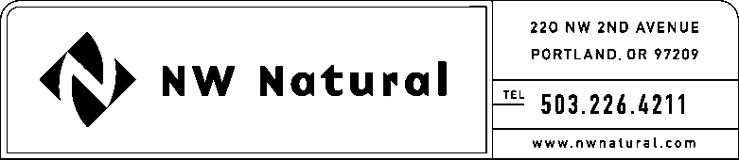

MARK R. THOMPSON
Manager, Rates & Regulatory Affairs
Tel: 503.721.2476
Fax: 503.721.2516
Email: mark.thompson@nwnatural.com

May 29, 2015

VIA ELECTRONIC FILING

Steven V. King, Executive Director and Secretary
Washington Utilities & Transportation Commission
1300 S. Evergreen Park Drive, S.W.
P.O. Box 47250
Olympia, Washington 98504-7250

Re: UG 131473 – NW Natural’s 2014 Integrated Resource Plan
North Mist Expansion Update

Northwest Natural Gas Company, dba NW Natural (“NW Natural” or “Company”), files herewith the Company’s IRP Update relating to the completion of its analysis of a North Mist expansion as described in Action Item 2.3a in the 2014 IRP.

Please call me if you have any questions or require any further information.

Sincerely,

/s/ Mark R. Thompson

Mark R. Thompson
Manager, Rates and Regulatory Affairs

MRT/sls

Enclosure

