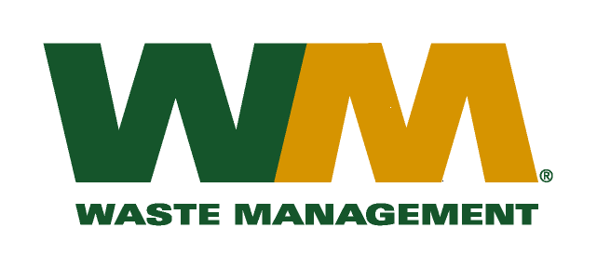

April 29, 2011

Washington Utilities and Transportation Commission
Chandler Plaza Building
1300 S. Evergreen Park Drive SW
P.O. Box 47250
Olympia, WA. 98504-7250

Subject: Waste Management of Skagit County, a division of Waste Management of Washington, Inc. (G-237); Tariff No. 18

Enclosed herein, you will find our new Tariff No.18 for the above-referenced company. This tariff replaces Waste Management of Skagit County Tariff No.17. In this new tariff, we are requesting adjustments to our rates attributed to increased disposal, maintenance, labor, fuel and other operating and administrative costs since our last general rate increase. In addition, due to operational changes that now include the transportation and processing of recyclable materials at our processing facility Cascade Recycling Center (CRC) this rate filing reflects the additional cost of processing these materials. Furthermore, consistent with our other operations in the Puget Sound that have their materials processed at CRC, we are proposing to implement a commodity rebate to our customers for the first time. This rebate initially established at $2.31 per month per recycling customer will significantly mitigate the increased cost of processing the material reflected in our proposed recycling collection rates. On an annual basis this rebate will be adjusted in accordance with the “deferred accounting method” similar to our other operations throughout the state.
This company received its last general rate increase on May 1, 2008, nearly three years ago. This new tariff, if approved by the commission, would increase Company revenue by approximately $574,000 (8.4%) ($377,000 net of the rebate mentioned above) and collectively, residential and commercial rates by 9.4%. This new tariff is being filed with a proposed effective date of July 1, 2011.
Enclosed for your review are one paper and two electronic copies (excel and pdf. format) of our accounting workpapers. Please note that our filing includes certain information that is confidential. Sample customer notices are also enclosed. Customer notices will be mailed on or before June 1, 2011. In addition, a copy of this transmittal letter was mailed to Skagit, Island County and Snohomish Counties on April 29, 2011.
Also enclosed is a “Petition for Rule Exemption”, seeking the Commission’s approval to file Work Papers that vary from a strict interpretation of the general rate filing regulations, similar to the Work Papers permitted under prior exemptions granted in Waste Management of Washington, Inc.’s three most recent general rate increase filings. In the Matter of the Petition of Waste Management of Washington, Inc. d/b/a/ Waste Management of Kennewick, Docket TG-101706 Order 01 – Granting Exemption From Rule (November 24, 2010), In the Matter of the Petition of Waste Management of Washington, Inc. d/b/a Waste Management – South Sound and Waste Management of Seattle, Docket TG-101080 Order 01 – Granting Exemption From Rule (July 16, 2010) and WUTC v. Waste Management of Washington d/b/a Waste Management Sno-King, Docket TG-091933 Order 04 & TG-091945 Order 03 (Consolidated) – Denying Petition For Rule Interpretation; Granting Exemption To Rule (March 23, 2010).
If you have any questions or need additional information, please contact me at:
Address: 13225 NE 122nd Place, Kirkland, WA 98034
Telephone /Fax #: (425) 814-7840 / (425) 814-7866
e-mail: mweinstein@wm.com
Respectfully,

Michael A. Weinstein
Senior Pricing Manager, Pacific Northwest Market Area

cc: Tim Crosby
Clerk of the Board, Skagit County
Clerk of the Board, Island County
Clerk of the Board, Snohomish County

