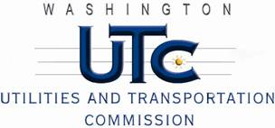

Memorandum
March 13, 2011

To: TR-110262 - File

From: Kathy Hunter, Deputy Assistant Director Transportation Safety

Subject: TR-110262 Washington and Idaho Railway
Grade Crossing Protective Fund (GCPF) Project at the Intersection of
State Route 27 (SR-27) and Washington and Idaho Railway’s Tracks in the City of Oakesdale, Washington

On February 15, 2011, the Washington Utilities and Transportation Commission (Commission) awarded a GCPF grant totaling $15,363.60 to install newer shoulder mounted signals with LED lights and upgrade the train detection to constant warning at the SR-27 crossing in the City of Oakesdale. The USDOT number assigned to this crossing is 058580G.

On April 8, 2011, the applicant, Washington and Idaho Railway submitted a request for reimbursement pursuant to Commission order. On April 7, 2011, Commission staff conducted a site visit and verified that the project is completed according to the specifications outlined in the order approving the grant.

Please close this docket.

