BEFORE THE WASHINGTON UTILITIES AND TRANSPORTATION COMMISSION
In the Matter of Avista’s Energy and Emissions Intensity Report in Compliance with WAC 480-109-300  ____________________________________ | )  )  )  )  )  )  )  ) | DOCKET NO. UE-17_____  COMPLIANCE REPORT OF AVISTA CORPORATION
In compliance with WAC 480-109-300, Avista Corporation (hereinafter Avista or Company) respectfully submits its 2016 Energy and Emissions Intensity (EEI) report.

EXECUTIVE SUMMARY
Table 1 below summarizes data collected and calculated for the Energy and Emissions Intensity Report (“EEI Report”) for the Washington share of Avista’s customers in 2016. The following sections show the prior 10-year annual metrics for all generating resources serving Washington customers, the trend analysis narrative and graphics, and a list of the appendices included with this filing.
Table 1: 2016 Summary Energy and Emissions Intensity Report
Utility |  | Avista
Reporting for year |  | 2016 | MWh per Capita
Population Served |  | 535,707 | 10.28
 | Energy Intensity Metrics
 |  |  |  |  | Customer  Count | MWH per  Customer
 |  |  | MWh at Meter | MWh Proportion
Residential Customers |  |  | 2,359,388 | 42.8% | 219,569 | 10.7
Commercial Customers |  |  | 2,160,405 | 39.2% | 24,507 | 88.2
Industrial Customers |  |  | 986,915 | 17.9%
Total Load Served |  |  | 5,506,707

 | Emissions Intensity Metrics
 |  |  |  | Percent of | Short
 |  |  | Busbar MWh | Total Load | Tons CO₂
Known Resources Serving WA |  |  | 7,195,859 | 132.2% | 1,942,966
Unknown Resources Serving WA |  |  | (1,753,883) | -32.2% | (66,117) | % of 1990 CO₂
 |  |  | 2016 | Tons CO₂ | 1,876,849 | 165.8%
 |  |  |  |  | 1990 Short Tons CO₂ | 1,131,957

II. PRIOR 10-YEAR ANNUAL METRICS
WAC 480-109-300 requires reporting of ten years of annual metrics for all generating resources serving Washington customers as part of the annual Report. Required data includes:
- Average MWh per residential customer;
- Average MWh per commercial customer;
- MWh per capita;
- Annual CO₂ emissions in short tons;
- Ratios of annual CO₂ emissions to CO₂ emissions in 1990
- Subtotal metrics – Energy and emissions from unknown generation sources
  - Annual CO₂ emissions in short tons from unknown generation sources
  - Annual MWh delivered to retail customers from unknown generation sources
  - Percentage of load served by unknown generation source

The first and second annual metrics cover the average MWh per residential and commercial customer over the past 10 years. The results are shown in Table 2 below. The values per year for both have been fairly consistent from year-to-year, with a slight downward trend over the historical reporting period. The trends are discussed in Section IV of this filing.

Table 2: Average MWh per Residential and Commercial Customer 2007 – 2016
 | Average MWh per Residential Customer | Average MWh per Commercial Customer
2007 | 12.1 | 95.5
2008 | 11.9 | 94.3
2009 | 12.2 | 94.3
2010 | 11.7 | 92.6
2011 | 12.0 | 92.8
2012 | 11.6 | 92.0
2013 | 12.0 | 92.3
2014 | 11.6 | 90.1
2015 | 11.3 | 91.9
2016 | 10.7 | 88.2

The third annual metric covers the MWh per capita over the past 10 years. The results are shown in Table 3 and the results are further discussed in Section III and shown in Chart 2. The trend shows decreasing MWh per capita. The large decrease from 2015 to 2016 is a result of lower usage by Washington customers combined with increasing population. More details about these trends are discussed in Section IV.
Table 3: MWh per Capita 2007 – 2016
Year | MWh per Capita
2007 | 10.97
2008 | 10.80
2009 | 10.71
2010 | 10.75
2011 | 10.93
2012 | 10.68
2013 | 10.95
2014 | 10.84
2015 | 10.85
2016 | 10.28

The last two annual metrics show the amount of CO₂ emissions per year from 2007 through 2016 and the comparison of those annual emissions with Avista’s 1990 emissions. Table 4 was developed by using the average emissions per MWh from the Department of Commerce for purchases from unknown sources and the average emissions per MWh of Avista’s owned and controlled known sources for sales. Beginning with this report, the emissions from the Environmental Protection Agency (EPA) Acid Rain Report were used where available and the emissions from the World Resource Institute (WRI) protocol were used for known thermal sources that are not part of the Acid Rain Program. The WRI protocol is the same data used in Avista’s report submitted in 2016. Applicable Avista owned or controlled plants in the Acid Rain Program include Colstrip, Coyote Springs 2, Lancaster and Rathdrum.
Table 4: Annual CO₂ Emissions in Short Tons 1990 and 2007 – 2016
Year | Annual Emissions | 1990 Emissions | % of 1990 CO₂
2007 | 2,305,449 | 1,131,957 | 203.7
2008 | 2,321,346 | 1,131,957 | 205.1
2009 | 2,539,254 | 1,131,957 | 224.3
2010 | 2,807,671 | 1,131,957 | 248.0
2011 | 1,906,402 | 1,131,957 | 168.4
2012 | 1,809,486 | 1,131,957 | 159.9
2013 | 2,210,196 | 1,131,957 | 195.3
2014 | 2,040,498 | 1,131,957 | 180.3
2015 | 2,063,798 | 1,131,957 | 182.3
2016 | 1,876,849 | 1,131,957 | 165.8

The calculations for energy and emissions for each year are included in the workpapers filed with this report. The workpapers for each year includes the annual CO₂ emissions in short tons from unknown generation sources, the annual MWh delivered to retail customers from unknown generation sources, and a calculation of the percentage of load served by unknown generation sources. The adjustments made to the data for this report are described below.

Known resources include all of Avista’s owned generation and contracts from known sources, such as purchases of a percentage of specified Mid-Columbia hydro projects and the power purchase agreement for the Lancaster combined cycle combustion turbine. Purchases from the Bonneville Power Administration (BPA) were assigned as known or unknown percentages based on the fuel mix disclosure on the BPA web site for 2012 through 2014. The remaining years were assigned based on an average of the three years of available fuel mix for BPA purchases and 2016 data was updated using the four-year BPA average (2012 – 2015). The percentage of assigned BPA purchases were zero emitting resources including biomass and waste, small and large hydroelectric, nuclear and wind resources. The remaining, or unknown, BPA percentage of purchases were assigned the default regional emissions factor calculated and provided by the Washington Department of Commerce (Commerce) for each year from 2006 through 2014. An average of the previous nine years emissions was used for 2015 and 2016, because the data has not been released by Commerce to calculate updated 2015 and 2016 emissions factors for unknown resources. Resources specifically assigned to serve Avista’s Idaho customers were not included in the emissions calculations. Total sales to non-Avista customers were netted from the emissions calculation in the unknown resources section of the workpapers. The busbar MWh and short tons of CO₂ of the Energy and Emissions Annual Report spreadsheets were multiplied by 65 percent to only show the Washington share of customers.

III. ALTERNATIVE EMISSIONS CACULATION METHODOLGY
Avista presents two alternative calculation methodologies for the EEI Report to what it used to calculate its 2007 – 2016 emissions as discussed above. The first, as requested by UTC Commission Staff (Staff), is an alternative to the methodology used in the Company’s 2016 revised EEI Report and this report. The second is an Avista-recommended alternative that addresses some of what it sees as a gross inequity based on large volumes of market sales and purchases made not to support serving retail loads directly, but instead reflect purchases and sales of energy between trading hubs and partners to the financial benefit of customers.
- Staff-Proposed Alternative Emissions Calculation Methodology
Calculation of the total CO₂ emissions numbers and their intensity by year has revealed some unique conclusions about the data for Avista because of the large number of purchases and sales that were and are being made for the benefit of customers. The large amount of purchases and sales from counterparties with unknown resources skews Avista’s emissions data depending on the methodology used to assign emissions. Discussions with Staff towards the end of 2016 resulted in an updated methodology to assign emissions factors to the unknown sources based on if they were a purchase or a sale. The updated method developed with Staff and used for the revised report submitted in December 2016, and for this report, applies the Commerce number to purchases from unknown sources and the average emissions number from Avista’s owned and controlled resources to the sales. The amount of CO₂/MWh from Avista owned and controlled resources is significantly lower than the regional number from Commerce, and a much better reflection of actual portfolio carbon intensity. Please refer to Table 5 for the differences in the Avista and Commerce pounds of CO₂/MWh numbers for 2007 through 2016.
Table 5: Commerce and Avista Emissions Factors (Pounds CO₂ per MWh)
 | 2007 | 2008 | 2009 | 2010 | 2011 | 2012 | 2013 | 2014 | 2015 | 2016
Avista | 593 | 596 | 497 | 616 | 465 | 530 | 529 | 519 | 607 | 540
Commerce | 1,202 | 1,025 | 1,119 | 1,192 | 905 | 903 | 1,132 | 1,024 | 1,046 | 1,046

Continued discussions with Staff resulted in another methodology for calculating the annual emissions numbers from unknown sources. This methodology considers each counterparty the Company made purchases from individually, where the source of the generation was unknown. For each counterparty, any sales made to them were subtracted from the purchases to get the net purchase or net sales amount for that counterparty. In cases where there is a net purchase from a counterparty the Commerce emission number is applied and for net sales the average emissions number from Avista’s owned and controlled resources is applied. The results of this netting methodology are included as Appendix C: Alternative A - Netting Methodology Calculations for this report. In addition, Chart 1 shows the generally decreased levels of emissions using this methodology.
Chart 1: Tons of CO₂ Emissions – Original and Netting Alternative 2006 – 2016
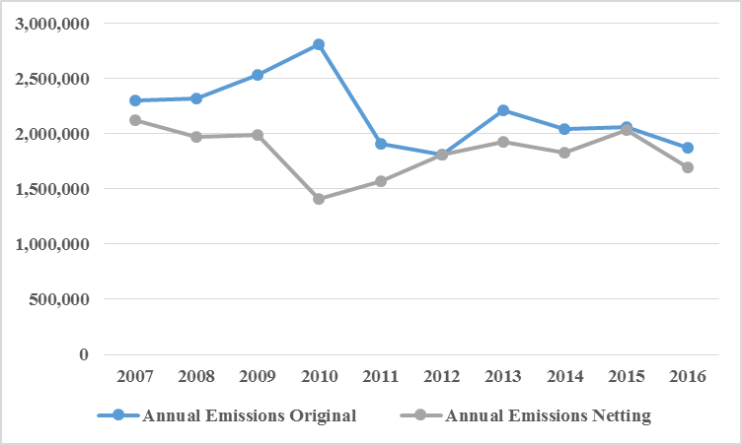
- Avista-Proposed Alternative Emissions Calculation Methodology
Even with improvements contained in the Staff-proposed netting methodology, some of the emissions calculations still rely on Commerce numbers encompassing a much wider regional emissions profile than where Avista actually trades resources. It also does not benefit from hourly data that more accurately reflects Avista’s actual hourly operations. This issue led Avista to consider a model focusing on how Avista’s hourly loads were actually met, as discussed below.

The more precise alternative method for calculating emissions data utilizes a multi-step process with hourly data. This process begins with a query of hourly loads from Avista’s then-current Energy Trading and Risk Management System (CASSO for 1990 data, and Nucleus for 2006 through the present). The second step queries the hourly generation from owned and controlled resources from the Energy Trading and Risk Management Systems. The third step pulls net generation from loads by hour. The fourth step is a determination of the hourly percentage of resources serving load by allocating the percentage equally across resources ignoring generation technology, resource economics, or emissions. The fifth step calculates the emissions associated with the generation allocated to load using annual actual emissions rates for the respective calendar year. In hours where loads exceed generation, emissions are added to meet the deficit based on the calendar year regional average emissions level. The total emissions are summed for the portfolio and are then multiplied by 65 percent to show the Washington allocation. This methodology reduces the annual CO₂ emissions levels significantly, and provides a more granular and precise analysis of how Avista actually served its Washington customers. This same methodology was also used to calculate an updated 1990 emissions number, which the Company advocates is a much more accurate and truer reflection of its actual 1990 emissions than what was assigned by Commerce. Chart 2 compares the annual tons of CO2 emissions for 1990 along with the current and alternative methods for calculating yearly emissions. Appendix D: Alternative B - Hourly Data Methodology Calculations contains the data and analysis supporting this alternative methodology.

Chart 2: Comparison of Annual Tons CO₂ Emissions under the Different Methods
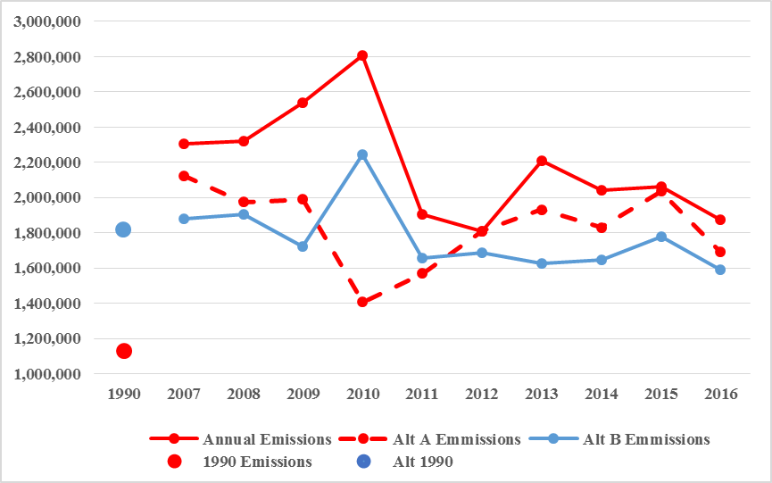

IV. TREND ANALYSIS NARRATIVE AND GRAPHICS
The average MWh use per customer has experienced fairly minor variation from year-to-year, which started decreasing on the residential side in 2014. Commercial customers exhibited a large increase from 2015 to 2016. Please refer to Chart 3 for the average use per commercial and residential customers. While reviewing the data for this report, it was determined that annual residential and commercial customer counts were not updated on the 2007 through 2015 spreadsheets in last year’s report. This report corrects that error. Since this is a very short-term trend, there is very little data to speculate on the causes for the beginning of this trend. However, Avista’s own energy efficiency efforts combined with regional efforts, improved energy efficiency technologies and more stringent codes and standards are expected to be driving the decreases. The scope of commercial customers is wide enough to make detailed analysis difficult, if not impossible to identify any specific causes for the fluctuation. This analysis is based on actual load data and is not normalized for weather.

Chart 3: Average MWh per Commercial and Residential Customers 2006 – 2016
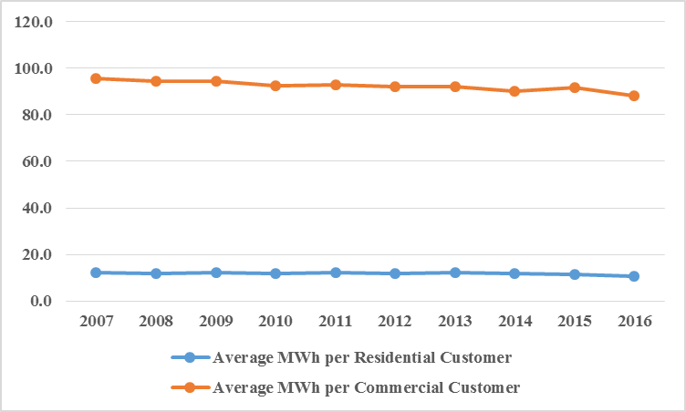
The next metric covers the amount of MWh/capita from 2007 through 2016. The specifics underlying the calculation of the population for Avista’s service territory can be found in Appendix B – Population Methodology. The trend line shows a more pronounced decreasing MWh per capita trend, with a significant decrease from 2015 to 2016 pulling the trend downwards as shown in Chart 4. This is a short enough trend to make it difficult, if not impossible, to determine the ultimate root cause.
Chart 4: Avista MWh per Capita 2006 – 2016
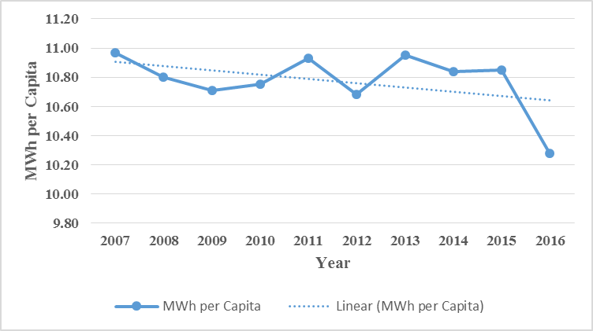
The estimated annual population growth is trending up to previous levels. Please see Chart 5 for details.
Chart 5: Estimated Annual Population Growth Rates
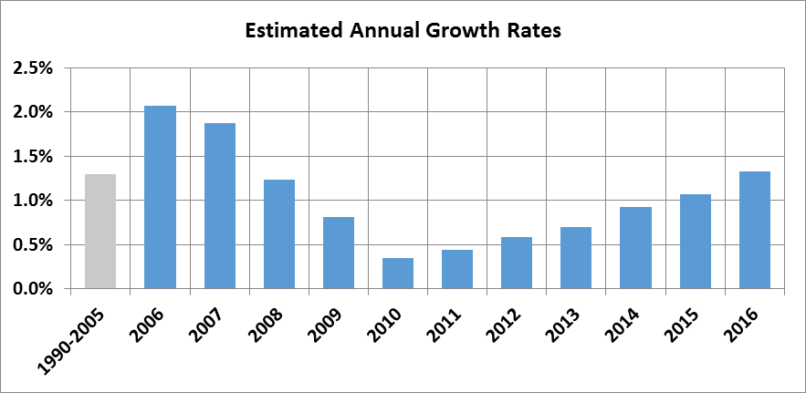
The last two metrics include the annual Avista CO₂ emissions in short tons from 2007 through 2016 and a comparison of those emissions with the 1990 emissions data. Chart 6 shows the emissions data for this report. Emissions increased from 2007 through 2010, with another increase from 2012 to 2013, yet still show an overall downward trend. There is an expectation that emissions will decrease over time as a higher percentage of zero emitting resources are added to the regional mix under the Energy Independence Act and as regional coal plants are closed.
Chart 6: Avista Annual CO₂ Emissions in Short Tons and 2007 – 2016
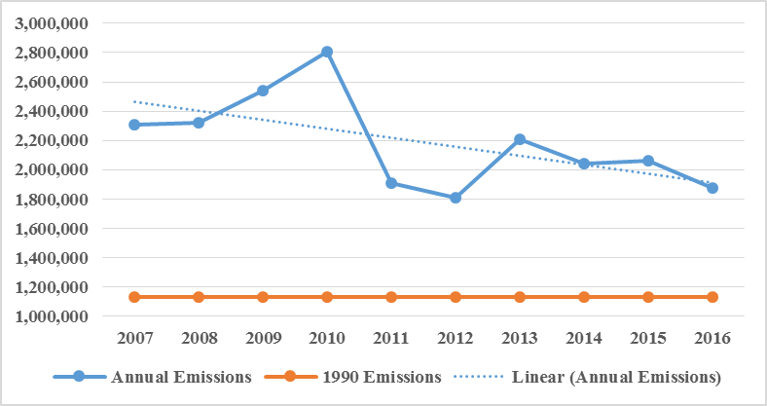
However, CO₂ emissions from year-to-year may still increase in any given year because the regional generation system is based on hydro generation, which will affect the resource mix from year to year. Charts 7 and 8 show regional variability in hydro generation and the Northwest CO₂ emissions intensity, which tracks hydro production.
Chart 7: Regional Hydro Variability
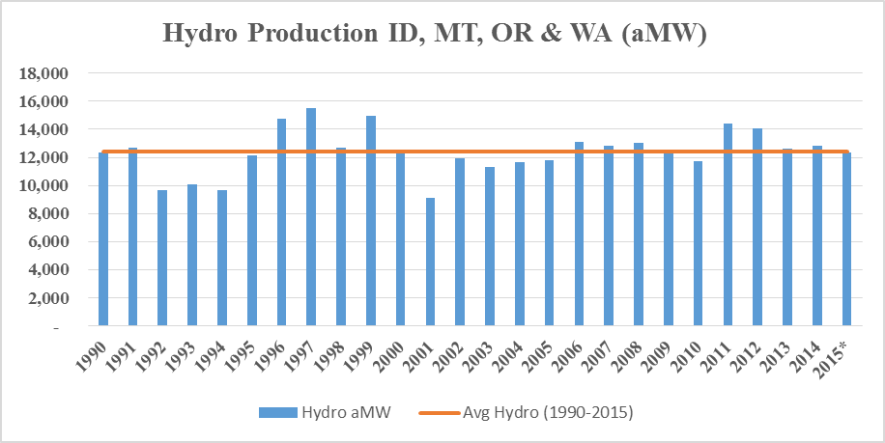
Chart 8: Northwest CO₂ Emissions Intensity
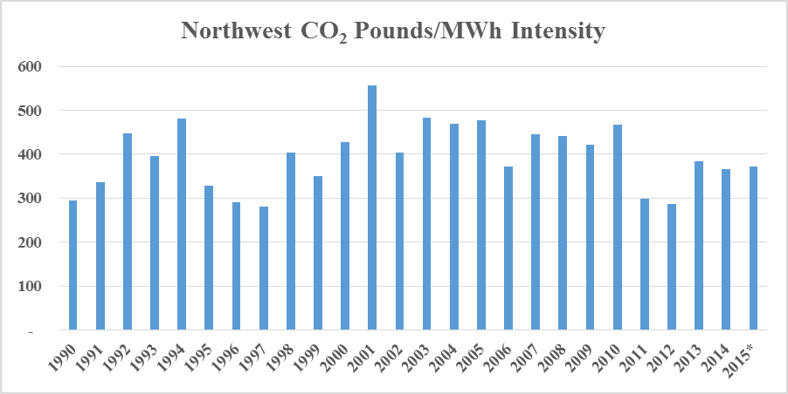

V. APPENDICES
The following appendices provide details about Avista’s 2016 Energy and Emissions Intensity Report. The spreadsheets with the raw data are included in the workpapers for this filing.
Appendix A: Summary Energy and Emissions Intensity Reports for 2007 – 2016
Appendix B: Population Methodology
Appendix C: Alternative A - Netting Methodology Calculations
Appendix D: Alternative B - Hourly Data Methodology Calculations

RESPECTFULLY SUBMITTED this 1st day of June 2017.

AVISTA CORPORATION

By:
Kelly O. Norwood
Vice President, State and Federal Regulation

