June 26, 2014

Steven V. King, Executive Director and Secretary
Utilities and Transportation Commission
1300 S. Evergreen Park Dr. SW
P.O. Box 47250
Olympia, WA 98504-7250

RE: Washington Utilities and Transportation Commission v. Public Wireless, Inc.

Commission Staff’s Response to Application for Mitigation of Penalties UT-140911

Dear Mr. King:

On June 3, 2014, the Utilities and Transportation Commission issued a $1,000 Penalty Assessment in Docket UT-140911 against Public Wireless, Inc. for 10 violations of Washington Administrative Code (WAC) 480-120-382, which requires telecommunications companies to furnish annual reports to the commission no later than May 1 each year.¹

On June 12, 2014, Public Wireless, Inc. wrote the commission requesting mitigation of penalties (Mitigation Request).² In its Mitigation Request, Public Wireless, Inc. does not dispute that the violation occurred. The company states, “Reorganization of company roles and therefore, original letter to file was misplaced/or not received. New position/Regulatory Manager since the files dates were requested. We apologize for any miscommunications.”

It is the company’s responsibility to ensure that the regulatory fee is paid and the annual report is filed by the May 1 deadline. On February 28, 2014, Annual Report packets were mailed to all regulated telecommunication companies. The instructions for annual report completion page of
the annual report informed the regulated company that it must complete the annual report form, pay the regulatory fees, and return the materials by May 1, 2014, to avoid enforcement action.

On June 9, 2014, Public Wireless, Inc. filed its complete annual report with no regulatory fees
due. The company has been active since August 13, 2009. No prior violations of WAC 480-120-382 are on commission record. Staff supports the company’s request for mitigation as this is

UTC Annual Reports
June 26, 2014
Page 2

the first delinquent annual report filing. Staff recommends a reduced penalty assessment of $200.

If you have any questions regarding this recommendation, please contact Amy Andrews, Regulatory Analyst, at (360) 664-1157, or aandrews@utc.wa.gov.

Sincerely,

Sondra Walsh, Director
Administrative Services

ATTACHMENT A
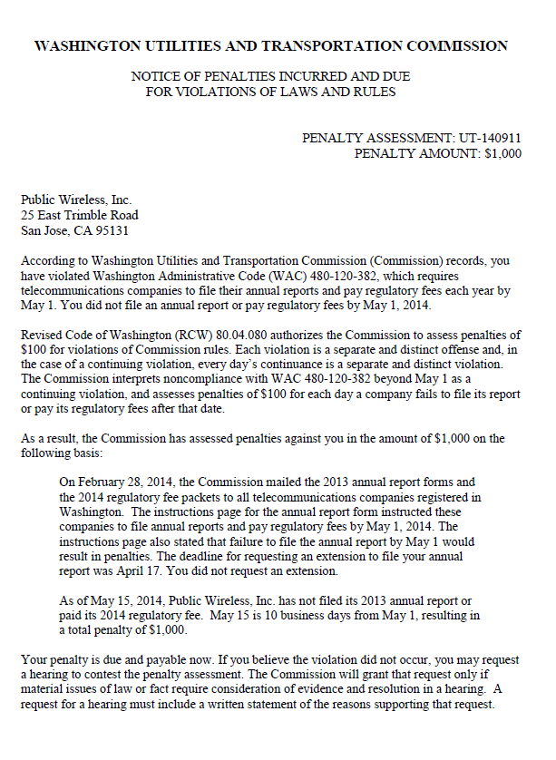

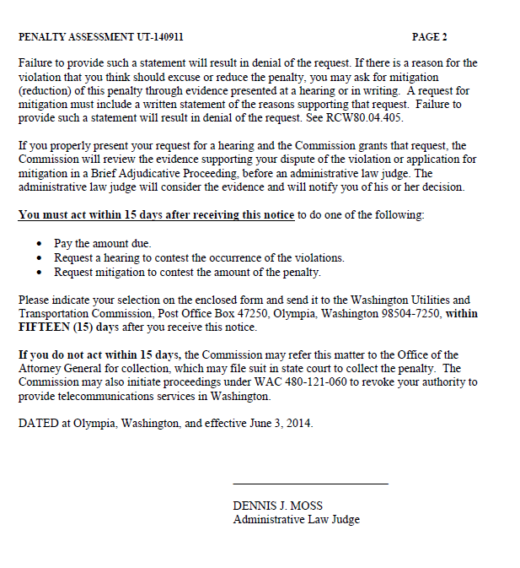

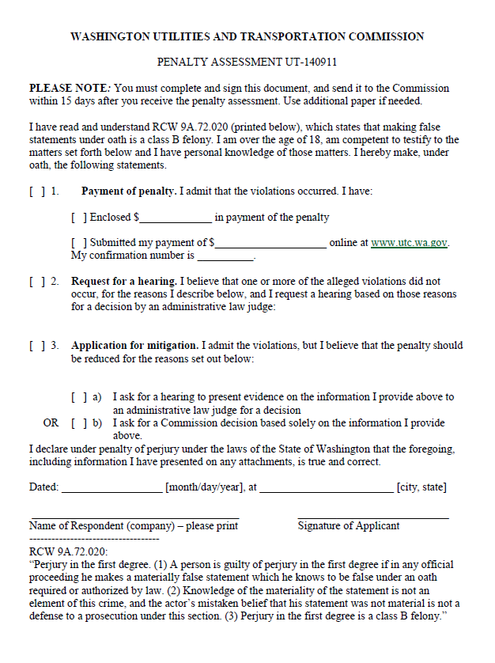

ATTACHMENT B
