July 27th, 2016

Mr. Steven V. King, Executive Secretary
Washington Utilities and Transportation Commission
1300 South Evergreen Park Drive SW
Olympia, WA 98504-7250

Re: Petition to receive support from the Universal Service Communications Program

Dear Mr. King:

Pursuant to WAC 480-123-110, Please find enclosed a petition for The Toledo Telephone Company, Inc. to receive funds under the Universal Service Communications Program.

All information is considered confidential under WAC 480-07-160 due to detailed financial information reported by the company.

Sincerely,

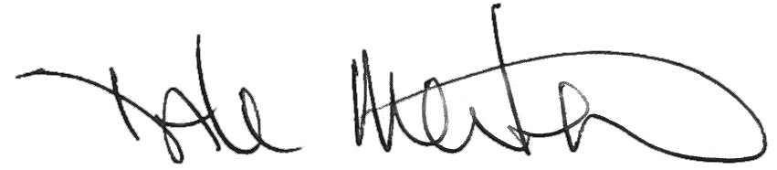

Dale Merten
Chief Operating Officer

Encl/

