
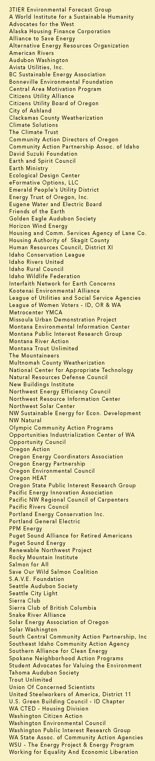

June 4, 2010

BY ELECTRONIC FILING AND FIRST CLASS MAIL

Mr. David Danner, Executive Director and Secretary
Washington Utilities and Transportation Commission
P.O. Box 47250
1300 S. Evergreen Park Drive SW
Olympia, WA 98504-7250

RE: Conservation Incentive Inquiry, Docket No. U-100522

Dear Mr. Danner:

Attached please find the NW Energy Coalition's responses to the Commission’s consolidated issues list in the above-referenced docket.

Sincerely,

Danielle Dixon
Senior Policy Associate

