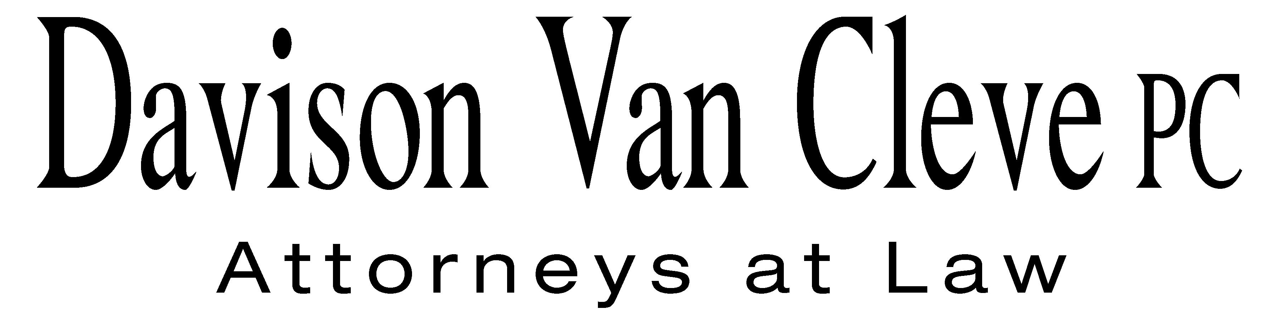
TEL (503) 241-7242 ● FAX (503) 241-8160 ● mail@dvclaw.com
Suite 400
333 SW Taylor
Portland, OR 97204

August 2, 2013

Via E-Mail and Federal Express

Mr. Steven V. King
Acting Executive Director and Secretary
Washington Utilities and Transportation Commission
P.O. Box 47250
1300 S. Evergreen Park Drive
Olympia, WA 98504-7250

Re: In the Matter of WUTC v. PacifiCorp
Docket No. UE-130043

Dear Mr. King:

Enclosed for filing in the above-referenced docket, please find the original and nineteen (19) copies of the Cross Answering Testimony of Michael C. Deen on Behalf of Boise White Paper, LLC.

Thank you for your assistance, and please do not hesitate to call our office with any questions.

Sincerely,

/s/ Jesse Gorsuch
Jesse Gorsuch

Enclosures
cc: Service List
CERTIFICATE OF SERVICE

I HEREBY CERTIFY that I have this day served the attached Cross Answering Testimony of Michael C. Deen upon all parties of record in this proceeding by causing the same to be sent via e-mail and via First Class U.S. Mail, postage prepaid, to each individual’s last-known address, as shown below
Dated at Portland, Oregon, this 2nd day of August, 2013.

/s/ Jesse Gorsuch
Jesse Gorsuch

ROBERT D. CEDARBAUM
ASSISTANT ATTORNEY GENERAL  WUTC  P.O. BOX 40128  OLYMPIA, WA 98504-0128  bcedarba@wutc.wa.gov | SARAH K. WALLACE  SENIOR COUNSEL  PACIFIC POWER & LIGHT CO.  825 NE MULTNOMAH STE 1800  PORTLAND, OR 97232  sarah.wallace@pacificorp.com
LISA W. GAFKEN  OFFICE OF THE ATTORNEY GENERAL  800 FIFTH AVENUE, SUITE 2000  SEATTLE, WA 98104-3188  lisa.gafken@atg.wa.gov | BRAD M. PURDY  ATTORNEY AT LAW  2019 N. 17TH ST.  BOISE, ID 83702  bmpurdy@hotmail.com
KATHERINE MCDOWELL  MCDOWELL RACKNER & GIBSON PC  419 SOUTHWEST 11TH AVENUE  SUITE 400  PORTLAND, OR 97205-2605  katherine@mcd-law.com | WASHINGTON DOCKETS  PACIFICORP  825 NE MULTNOMAH, SUITE 2000  PORTLAND OR 97232  washingtondockets@pacificorp.com
THE ENERGY PROJECT  3406 REDWOOD AVE.  BELLINGHAM, WA 98225 | BOISE WHITE PAPER, LLC.  PO BOX 50  BOISE, ID 83728

