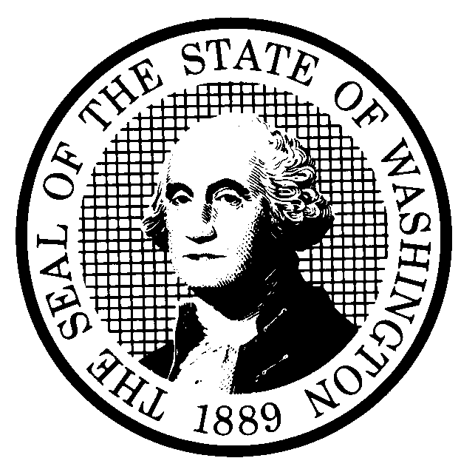 | PROPOSED RULE MAKING  (RCW 34.05.320) |  |  |  |  |  |  |  |  | CR-102 (7/22/01)  Do NOT use for expedited  rule making
Agency: Utilities and Transportation Commission |  |  |  |  |  |  |  |  |  | X Original Notice
Preproposal Statement of Inquiry was filed as WSR 99-09-027 ; or  Expedited Rule Making -- Proposed notice was filed as WSR ; or  Proposal is exempt under RCW 34.05.310(4). |  |  |  |  |  |  |  |  |  | Supplemental Notice  to WSR  Continuance of WSR
(a) Title of rule: (Describe Subject) Customer information rules, WAC 480-120-201 through WAC 480-120-209 and WAC 480-120-211 through WAC 480-120-216. The proposed rules would consider the use of information made available to telecommunications companies by customers solely by virtue of the customer-company relationship.

Purpose: The proposed rules would clarify the extent to which customer information may be used by telecommunications companies; establish notice requirements; establish operational requirements for customer approval mechanisms; establish requirements for confirmation of customer approval for the use of customer information; and limit the use, under some circumstances, of subscriber list information. The proposed rules would replace the current rules on this topic: WAC 480-120-144 and WAC 480-120-151 through WAC 480-120-154.

Other identifying information: Docket UT-990146, Customer privacy notification rules. This is the second CR-102 proposal in this docket. The first covered general rules and was adopted at WSR 01-15-022. Another proposal will be filed that will address remaining rules.

(b) Statutory authority for adoption: RCW 80.01.040 and RCW 80.04.160 |  |  |  |  |  |  |  |  | Statute being implemented:
(c) Summary:

See section (j) below

Reasons supporting proposal:

(d) Name of Agency Personnel Responsible for: |  |  |  |  |  | Office Location |  |  |  |  | Telephone
1. Drafting............... Robert Shirley |  |  |  |  |  | 1300 S. Evergreen Park Dr. S.W., Olympia, WA 98504-7250 |  |  |  |  | 360-664-1292
2. Implementation.... Carole J. Washburn, Secretary |  |  |  |  |  | 1300 S. Evergreen Park Dr. S.W., Olympia, WA 98504-7250 |  |  |  |  | 360-664-1174
3. Enforcement.......... Carole J. Washburn, Secretary |  |  |  |  |  | 1300 S. Evergreen Park Dr. S.W., Olympia, WA 98504-7250 |  |  |  |  | 360-664-1174
(e) Name of proponent (person or organization): Washington Utilities and Transportation Commission |  |  |  |  |  |  |  |  |  |  | Private  Public  X Governmental
(f) Agency comments or recommendations, if any, as to statutory language, implementation, enforcement and fiscal matters:
None

(g) Is rule necessary because of:  Federal Law?  Federal Court Decision?  State Court Decision? |  | Yes  Yes  Yes |  |  | X No  X No  X No |  | If yes, ATTACH COPY OF TEXT  Citation:
(h) HEARING LOCATION: |  |  |  |  |  |  |  | Submit written comments to:
Washington Utilities and Transportation Commission  Headquarters, Room 206  1300 S. Evergreen Park Dr. S.W.  Olympia, Washington 98502-7250 |  |  |  |  |  |  |  | Secretary, Docket No. UT-990146  Washington Utilities and Transportation Commission  1300 S. Evergreen Park Dr. S.W.  P.O. Box 47250  Olympia, Washington 98504-7250  FAX (360) 586-1150 By (date) May 22, 2002
Date: July 26, 2002 Time:. 1:30 P.M. |  |  |  |  |  |  |  | DATE OF INTENDED ADOPTION: July 26, 2002
Assistance for persons with disabilities: Contact  Mary De Young by Friday, July 19, 2002 |  |  |  |  |  |  |  | CODE REVISER USE ONLY
TDD (360) 586-8203 or (360) 664-1133
NAME (TYPE OR PRINT)

CAROLE J. WASHBURN
SIGNATURE

TITLE  SECRETARY |  |  | DATE  April 3, 2002
(COMPLETE REVERSE SIDE)
(j) Short explanation of rule, its purpose, and anticipated effects:
The rule concerns the use of customer information made available to telecommunications companies by customers solely by virtue of the customer-carrier relationship. Its purpose is to clarify the uses of the information and the approval, or lack of approval, that must be given by the customer to the company before the information is used.

The anticipated effect is to permit the use of call detail information (e.g., whom you call and when and where you call) only with affirmative approval of a customer (so-called “opt-in” approval). Other, less personal information (e.g., whether customer subscribes to one line or two) may be used by companies or entities under common control of or with a telecommunications company after annual notice and opportunity to “opt-out” (i.e., disapprove) the use of that less personal information. Customers will be in a position to control the use of certain very private information and some less private information, while companies will be in a position to conduct the day-to-day operations of their business and use, with the approval of the customer, certain information that may be useful in marketing telecommunications-related services and other products and services.

The proposed rules would clarify permitted and not permitted uses of customer information that has been rendered uncertain by a decision of the 10th Circuit Court of Appeals and a revision of the FCC’s rules on this topic. For example, a recent action by one company to use opt-out approval where current rules require opt-in approval resulted in substantial confusion among customers.
Does proposal change existing rules? | XYES NO | If yes, describe changes:
The proposal would permit customers to opt-out of the use of certain private account information by their telecommunications company. Federal law, 47 U.S.C. § 222, requires customer approval before certain customer information may be used by a company for other than day-to-day operations. The proposed rules replace WAC 480-120-151 through WAC 480-120-154, which did not permit customers to opt-out of certain uses under certain circumstances. Call detail information that once was permitted to be used without affirmative approval and without an opportunity to opt-out under some circumstances, will now require affirmative, opt-in approval before it can be used.

(k) Has a small business economic impact statement been prepared under chapter 19.85 RCW?
X Yes. Attach copy of small business economic impact statement.
A copy of the statement may be obtained by writing to:
Washington Utilities and Transportation Commission
P.O. Box 47250
1300 S. Evergreen Park Dr. S.W.
Olympia, Washington 98504-7250

telephoning: (360) 664-1234
faxing: (360) 586-1150

The SBEIS addresses this proposal and the remaining rules that will be filed under a subsequent proposal.
No. Explain why no statement was prepared

(l) Does RCW 34.05.328 apply to this rule adoption? Yes X No
Please explain:
The Commission is not an agency to which RCW 34.05.328 applies. The proposed rules are not significant legislative rules as referenced in RCW 34.05.328(5).

