March 4, 2016

VIA WEB PORTAL AND OVERNIGHT MAIL

Mr. Steven King
Executive Director and Secretary
Washington Utilities and Transportation Commission
1300 S. Evergreen Park Drive, SW
Olympia, WA 98504
Re: Petition of Puget Sound Energy, Inc. for (i) Approval of a Special Contract for Liquefied Natural Gas Fuel Service with Totem Ocean Trailer Express, Inc. and
(ii) a Declaratory Order Approving the Methodology for Allocating Costs Between Regulated and Non-regulated Liquefied Natural Gas Services
Docket No. UG-151663
Dear Mr. King:
Enclosed for filing please find an original and twelve (12) copies of the following:
1. Puget Sound Energy’s Motion to Establish a Bifurcated Proceeding;
2. Declaration of Roger Garratt in Support of Motion to Establish a Bifurcated Proceeding; and
3. Certificate of Service.
If you have any questions, please contact the undersigned, or Pam Anderson at (425) 635-1417.

Very truly yours,
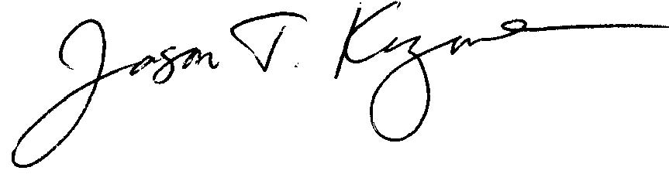
Jason Kuzma
JK:cgm
Enclosures

cc: Service List (First Class Mail & E-mail)

