Attached is a spreadsheet of how many staff hours are used to audit auto transportation cases as requested during the June 1 workshop.

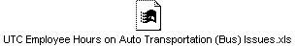

Sincerely,
Penny Hansen
Regulatory Analyst
WUTC
360-664-1242

