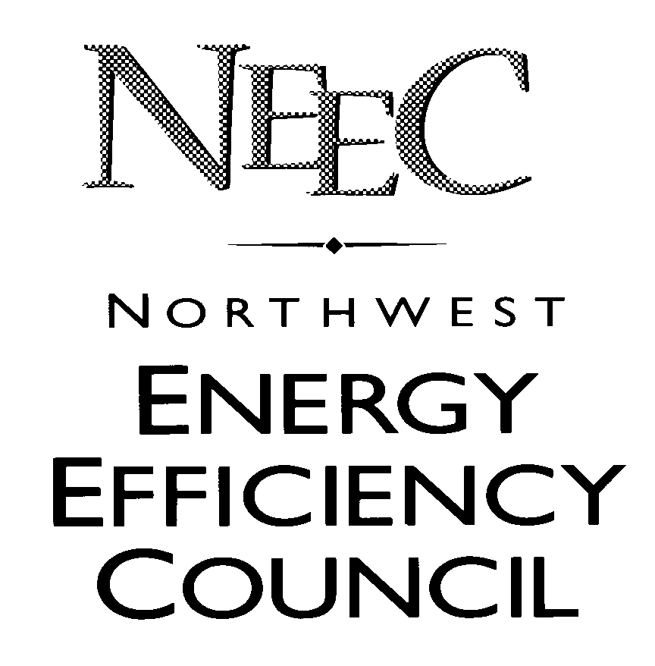

157 Yesler Way, Ste. 409 Seattle, WA 98104

January 13, 2004

Washington Utilities and Transportation Commission
1300 S. Evergreen Park Drive SW
Olympia, WA 98504-7250

Re: Docket No. UE-031353
Draft Request for Electric Energy Efficiency Resources
Proposals and for Limited Efficiency Pilot Projects Proposals

The Northwest Energy Efficiency Council (NEEC) offers the following comments on the Draft Request for Proposals (RFP) to be issued by Puget Sound Energy. NEEC is a regional trade association representing the energy efficiency industry.

Though, in general, NEEC is supportive of RFP processes, we find the Draft document deficient in a number of key areas. We find the proposed timeline for this RFP process to be unreasonable and dysfunctional to the goal of finding and implementing cost effective energy efficiency resources in PSE’s service territory. The 18 to 24 month time gap between the time proposers develop bids and the actual execution of contracts and implementation of efficiency program services will likely create undue uncertainty in the marketplace about the nature of and participation requirements for efficiency projects. There is no better way to stall the development of any industry market than to introduce uncertainty and confusion for customers related to participation rules and financial incentive levels for projects.

The long time gap between proposals and contacts also subjects potential proposers to the uncertainty of future costs and market conditions. These risks will only tend to increase the cost of resource bids rather than achieve the desired results of the RFP solicitation – finding more efficiency resources at a potentially lower cost.

As a wide open solicitation, this Draft RFP also establishes a perplexing competitive environment in which proposers submit program ideas that may be in direct competition with already established PSE efficiency programs – only to be evaluated on their merits by the utility itself.

Beyond these specific structural concerns with the Draft RFP, NEEC also is perplexed by the nature and timing of the proposed solicitation. As a participant in and supporter of the PSE Conservation Resource Advisory Group (CRAG) process, we are supportive of the targets and types of efficiency resource programs that PSE has outlined for its 2004-2005 activities. The haste with which this RFP has been developed in light of the year long work of the CRAG coupled with the long timeline of the RFP process seems to add little value to the near term conservation work of the utility while creating unreasonable uncertainty about the nature of program opportunities in the long term.

Based on all these concerns, NEEC is not supportive of the Draft RFP as written. NEEC would support a different solicitation design, however, which was targeted to specific end use sub-sectors and/or specifically targeted program design approaches where PSE needs additional support to achieve conservation goals in the near term. NEEC is not prepared to define at this time which markets or program approaches should be targeted, but we are willing to participate in a process with PSE and other interested parties in defining those areas. We believe that such a process could take place early in 2004 and lead to a more targeted RFP process in 2004. This RFP should contain a more “traditional” timeline for proposals and contacts such that conservation resources developed from the solicitation would come on-line by 2005.

NEEC appreciates the opportunity to provide these comments. We would be pleased to work with PSE and other interested parties to develop an RFP process that supports the goal of achieving cost effective electricity efficiency resources.

Sincerely,

Stan Price
Executive Director

cc: Cal Shirley, Puget Sound Energy

