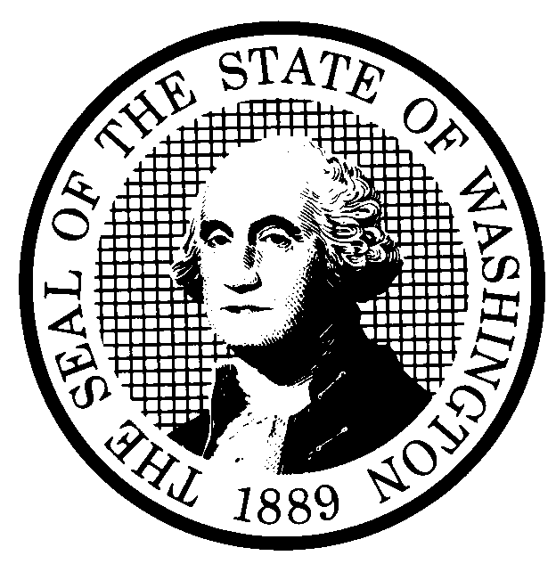 | PROPOSED RULE MAKING |  |  |  |  | CR-102 (June 2004)  (Implements RCW 34.05.320)  Do NOT use for expedited rule making
Agency: Washington Utilities and Transportation Commission
Preproposal Statement of Inquiry was filed as WSR 04-05-103; or  Expedited Rule Making--Proposed notice was filed as WSR or  Proposal is exempt under RCW 34.05.310(4). |  |  |  |  |  |  | Original Notice  Supplemental Notice to WSR  Continuance of WSR 04-21-037
Title of rule and other identifying information:

WAC 480-62-218, Point Protection. WUTC Docket No. TR-040151.
Hearing location(s):  Commission Hearing Room 206  Second Floor, Chandler Plaza Building  1300 S. Evergreen Park Drive S.W.  Olympia, WA 98504 |  |  |  | Submit written comments to:  Name: Carole J. Washburn, Secretary  Address: P.O. Box 47250, Olympia, WA 98504-7250  e-mail records@wutc.wa.gov  fax (360) 586-1150 by November 19, 2004  Please include Docket No. TR-040151 in your communication.
Date: December 10, 2004 Time: 1:30 P.M. |  |  |  | Assistance for persons with disabilities: Contact  Mary DeYoung by December 8, 2004  TTY (360)-586-8203 or (360) 664-1133
Date of intended adoption: December 10, 2004
(Note: This is NOT the effective date)
Purpose of the proposal and its anticipated effects, including any changes in existing rules:

The proposal would add to rules governing railroad operations a rule addressing point protection. The proposed rule would require railroads to protect the leading end of train movements to add safety for employees that might be present on the tracks ahead of the movement, vehicles using road crossings, and trains on connected tracks.

The purpose of the continuance of WSR# 04-21-03 is to provide notice of a change in the time of the hearing to receive public comment regarding adoption of the rule proposal in this docket. The hearing time has been changed from 9:30 a.m. on December 10, 2004, to 1:30 p.m. on December 10, 2004.

Reasons supporting proposal:
Statutory authority for adoption: |  |  |  | Statute being implemented:
Is rule necessary because of a:  Federal Law?  Federal Court Decision?  State Court Decision?  If yes, CITATION: |  | Yes  Yes  Yes | No  No  No |  | CODE REVISER USE ONLY  Filed with the Code Reviser’s Office  November 12, 2004, 10:50 a.m.  WSR 04-23-053
DATE
November 12, 2004
NAME
CAROLE J. WASHBURN
SIGNATURE

TITLE
EXECUTIVE SECRETARY
(COMPLETE REVERSE SIDE)
Agency comments or recommendations, if any, as to statutory language, implementation, enforcement, and fiscal matters:

Name of proponent: Washington Utilities and Transportation Commission |  |  | Private  Public  Governmental
Name of agency personnel responsible for:
 | Name | Office Location | Phone
Drafting.......... Mike Rowswell, Rail Safety Manager |  | 1300 S. Evergreen Park Drive S.W., Olympia WA 98504 | (360) 664-1265
Implementation....Carole J. Washburn, Executive Secretary |  | 1300 S. Evergreen Park Drive S.W., Olympia WA 98504 | (360) 664-1174
Enforcement........Carole J. Washburn, Executive Secretary |  | 1300 S. Evergreen Park Drive S.W., Olympia WA 98504 | (360) 664-1174
Has a small business economic impact statement been prepared under chapter 19.85 RCW?
Yes. Attach copy of small business economic impact statement.

A copy of the statement may be obtained by contacting:
Name:
Address:

phone ( )
fax ( )
e-mail
No. Explain why no statement was prepared.

Is a cost-benefit analysis required under RCW 34.05.328?

Yes A preliminary cost-benefit analysis may be obtained by contacting:
Name:
Address:

phone ( )
fax ( )
e-mail

No: Please explain:

