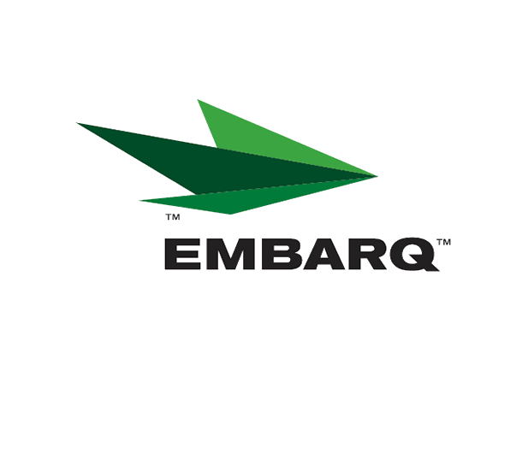


February 22, 2007

Ms. Carole J. Washburn, Secretary
Washington Utilities & Transportation Commission
P. O. Box 47250
Olympia, Washington 98504-7250

Re: Washington Quality of Service Report

Dear Ms. Washburn:

Attached is United Telephone Company of the Northwest d.b.a. EMBARQ “Service Quality Reports” for the month of January 2007.

The following provides a description of the maintenance issues for those exchanges that exceeded the trouble reports of 4 per 100 access lines for the month:

All exchanges met objective.

Should you have any questions, please contact me at (541) 387-9289 or by e-mail at Becky.Sandercock@embarq.com.

Sincerely,

Becky Sandercock
Government Affairs Docket Manager

Enclosures: Installation/Repair Appointments
Service Activation in 5 Days
Trouble Per 100/Access Lines
Switching – Dial Tone Speed in 3 Seconds
Final Trunk Blockage (EAS and Toll)
Out of Service Trouble Cleared in 48 Hours
Not Out of Service Trouble Cleared in 72 Hours

