November 16, 2009

NOTICE OF OPPORTUNITY TO FILE WRITTEN COMMENTS
(By Friday, January 8, 2010)

RE: Solid Waste Definitions Rulemaking, WAC 480-70
Docket TG-080591

TO INTERESTED PERSONS:

On May 7, 2008, the Washington Utilities and Transportation Commission (Commission) filed with the Code Reviser a Preproposal Statement of Inquiry (CR-101) to initiate a rulemaking to consider revisions to WAC 480-70, governing solid waste collection companies.

On April 20, 2009, the Commission Staff solicited comments from stakeholders on a discussion draft rule. Many stakeholders provided comments and those comments are available for inspection on the Commission’s web site at www.utc.wa.gov/080591.

Having reviewed the comments, Staff has developed a new draft rule. Because the new draft represents a substantial departure from the previous draft rule circulated to stakeholders on April 20, 2009, we are again soliciting written comments. The new draft rule is available for inspection on the Commission’s web site at www.utc.wa.gov/080591. The Commission will send you a paper copy of the discussion draft rule or will send the proposal via electronic mail, if you ask.

1. This draft reflects a more focused approach than the prior draft.

A major purpose of this rulemaking is to flesh out RCW 81.77.010(8). That statute exempts from the definition of “solid waste collection” the activity of “collecting or transporting recyclable materials . . . on behalf of a commercial or industrial generator of recyclable materials to a recycler for reuse or reclamation.” Unlike the previous draft, this new draft is not intended to address every set of circumstances to which the commercial recyclables exemption from regulation might apply. Instead, this draft is narrowly focused on the question of when a company engaging in for-hire transportation of construction and demolition (C&D) waste for recycling is exempt from regulation as a solid waste collection company. As Waste Management observed in its comments, the collection of commingled recyclables from construction sites is the most contentious issue for purposes of the commercial recyclables exemption. It is also the area where rules are most needed to provide certainty to market participants and to enable the Commission to fairly and expeditiously enforce the requirements of RCW 81.77.

This rule would not replace existing WAC 480-70-016 – Determination of authority required to transport specific commodities or provide specific services. Aside from the issues surrounding transportation of C&D waste, the test set out in that rule has proven adequate for distinguishing activities regulated under RCW 81.77 (solid waste collection) from those regulated under RCW 81.53 (motor freight carriers). Thus, the proposed draft is a stand-alone rule.

2. Materials recovery facilities (MRFs) that are permitted by the jurisdictional local health department for solid waste handling present the most difficult issue.

The language of RCW 81.77.010(8) makes it clear that a carrier collecting commodities that have been separated on site (e.g., metals in one bin, drywall in another, clean wood in another) and carrying them directly to a manufacturer that utilizes those materials is squarely within the commercial recycling exemption. On the other hand, it is also clear that hauling C&D waste from a customer location to a landfill, transfer station or incinerator clearly is not exempt from regulation under RCW 81.77 and requires a certificate of public convenience and necessity. The difficult question is, when is it permissible for a carrier claiming exemption from RCW 81.77 to carry C&D waste from a construction site to a materials recovery facility (“MRF”)?

Not all MRFs are alike. Generally, in order to be exempt from intermediate solid waste handling permit requirements a material recovery facility may “accept only source separated recyclable materials and dispose of an incidental and accidental residual not to exceed five percent of the total waste received, by weight per year, or ten percent by weight per load.” WAC 173-350-310(2). However, many large scale facilities whose operators receive recyclable C&D waste and describe themselves as MRFs, do not meet this standard. Those MRFs are therefore required to have a solid waste handling permit. WAC 173-350-310(9). Recycling rates for some of these facilities are a matter of public record. Some are operated by companies that also hold themselves out as common carriers of recyclable C&D waste from construction sites. Despite being subject to the same permitting requirements as transfer stations, some of these permitted MRFs achieve a fairly high recycling or diversion rate, albeit not in excess of the 95 percent that would excuse them from obtaining a solid waste handling permit from the local health jurisdiction.

3. Under this draft rule, carriers claiming exemption from regulation as solid waste collection companies would not be allowed to haul C&D waste to MRFs that do not meet a specified recycling rate.

This draft rule would clarify that regulation under RCW 81.77 does not apply to carriage of commingled recyclable C&D waste from commercial and industrial generators to either (1) an exempt MRF (that meets the five percent annual residual waste exemption from permitting as an interim solid waste handling facility), or (2) to a permitted MRF (i.e., one that is permitted for solid waste handling) that nonetheless achieves a substantial recycling or diversion rate. In this draft, we propose a minimum 75 percent recycling rate for the permitted MRFs. Without a minimum recycling or diversion requirement, a permitted MRF could become a means for independent carriers and regulated solid waste collection companies alike to avoid economic regulation under RCW 81.77. The following diagram provides further explanation of the draft rule:
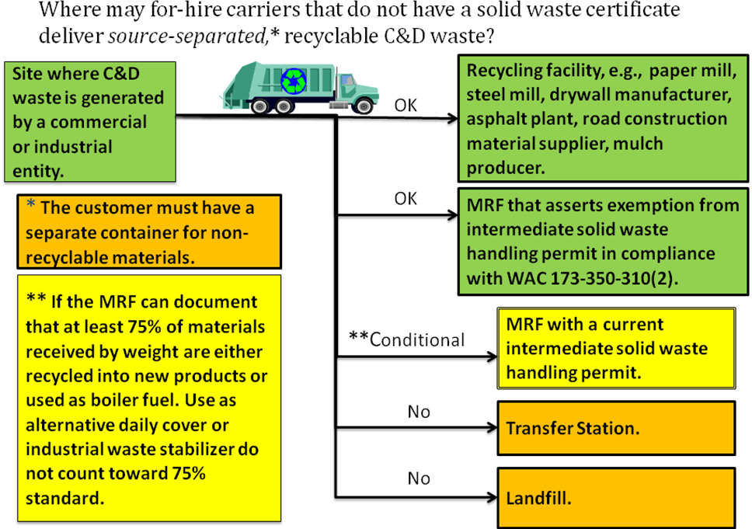

We do not adopt a per-load recycling rate because we believe a truckload standard would be impossible to enforce. The reason is that the commercial recycling exemption from RCW 81.77 does not simply require that the materials be “recyclable.” They must also ultimately be recycled or diverted from disposal. If a permitted MRF’s records show that it disposes of no more than 25 percent of what it takes in, then we can be confident that the permitted MRF is controlling its own intake and turning away excessively contaminated loads.

Deciding on a minimum recycling or diversion rate resolves only part of the question, however, because there is no consensus among the stakeholders as to which end-uses of C&D waste should be considered recycling.

a. Boiler Fuel

Almost all commenters, including DOE, agree that boiler fuel (also called “hog fuel”) is a commodity, and that using C&D waste as such is at least “diversion” from disposal, if not “recycling.” Therefore, our rule adopts this same conclusion regarding boiler fuel.

b. Alternative Daily Cover and Industrial Waste Stabilizer

Many commenters urge the adoption of rule language that would also define the use of C&D waste for landfill alternative daily cover (ADC) as diversion from disposal. However, DOE and Snohomish County strongly disagree. DOE states in its comments that if a hauler of recyclables were to deliver recyclable materials to a landfill for ADC, “this activity could subject the hauler to fines under DOE rules (WAC 173-345). We need to work together to ensure we do not create a regulatory Catch-22. ADC is not considered recycling by DOE.” King County, on the other hand, argues that defining ADC as disposal rather than recycling would “likely reduce the availability of recycling options for comingled C&D, putting existing C&D processing facilities out of business.” The reason for this, according to the County, is that a certain percentage of commingled recyclable construction and demolition debris received at handling facilities—15 percent in King County’s estimation—is ultimately used as ADC after materials are sorted out for other uses. King County therefore suggests that the Commission set a maximum percentage of the total tonnage received for processing at a MRF that can ultimately be used as ADC.

We propose to define ADC as disposal consistent with the interpretation already adopted by DOE. However, we also want to be careful of the practical implications of such an interpretation, as urged by King County. The recycling rate data for various facilities published on King County’s website supports the County’s contention that, even with the best of intentions, some residual waste, after sorting, may need to be landfilled as ADC or as “industrial waste stabilizer.” In fact, it appears that King County’s proposed 15 percent may be overly restrictive. For example, Recovery 1 reports between 20.9 and 15.8 percent of its intake was used as ADC during the period from January to July of 2009. Therefore, although we propose to define ADC and industrial waste stabilizer as disposal, the draft rule would allow companies holding out as carriers of recyclable C&D waste to deliver to facilities that meet a 75 percent recycling or diversion rate (excluding use as ADC or industrial waste stabilizer) with that material. This rate appears realistic based on the public data supplied by companies reporting on the King County website.

4. The Commission would rely on its powers under RCW 81.04.510 to enforce the rule.

This draft may raise questions about how the Commission would enforce the rule. The Commission has authority to investigate and determine whether a company engaging in for-hire transportation of construction and demolition waste is conducting operations that require a solid waste collection certificate under RCW 81.04.510. Specifically, if the Commission believes that a company is conducting operations requiring a certificate, it may initiate a proceeding in which the burden is on that company to show that its operations are exempt from regulation. In such a case, it would be incumbent on the company to present evidence that any facility with a solid waste handling permit to which it hauls C&D waste achieves at least a 75 percent recycling rate. The company might also need to show that the customers from which it collects recyclable C&D waste provide an appropriate-sized on-site container for non-recyclable waste. If the Commission chooses, it may subpoena documents from third parties, including from a MRF if there is doubt as to its recycling rate. Depending on what the Commission finds, it may order the company to cease and desist from hauling to or from a particular location, or to cease and desist from all operations.

WRITTEN COMMENTS

Written comments must be filed with the Commission no later than Friday, January 8, 2010. Please identify any written comments that relate to existing rules by reference to the existing rule section. Where you suggest clear language or substantive changes to rules, we would appreciate your suggestions for specific rule language. The Commission requests that comments be provided in electronic format to enhance public access, for ease of providing comments, to reduce the need for paper copies, and to facilitate quotations from the comments. Comments may be submitted via the Commission’s Web portal (www.utc.wa.gov/e-filing) or by electronic mail to the Commission’s Records Center at <records@utc.wa.gov>. Please include the:

- Docket number of this proceeding (TG-080591).
- Commenting party’s name.
- Title and date of the comment or comments.

An alternative method for submitting comments is by mailing or delivering an electronic copy to the Commission’s Records Center. Include all of the information requested above. The Commission will post on its web site all comments that are provided in electronic format. The web site is located at the following URL address: www.utc.wa.gov/080591.

If you are unable to file your comments electronically or submit them on a disk, the Commission will accept a paper document. Questions may be addressed to Penny Ingram at (360) 664-1242 or e-mail at pingram@utc.wa.gov.

Stakeholders will have further opportunity for comment. Information about the schedule and other aspects of the rulemaking, including comments, will be posted on the Commission’s web site as it becomes available. If you wish to receive further information on this rulemaking you may:

(1) Call the Commission’s Records Center at (360) 664-1234.

(2) E-mail the Commission at <records@utc.wa.gov>.

(3) Mail written comments to the address below.

When contacting the Commission, please refer to Docket TG-080591 to ensure that you are placed on the appropriate service list(s). The Commission’s mailing address is:

Executive Director and Secretary
Washington Utilities and Transportation Commission
1300 South Evergreen Park Drive S.W.
P.O. Box 47250
Olympia, Washington 98504-7250

Sincerely,

DAVID W. DANNER
Executive Director and Secretary

http://your.kingcounty.gov/solidwaste/greenbuilding/construction-recycling/rates.asp
http://your.kingcounty.gov/solidwaste/greenbuilding/documents/diversion-recycling-rates-2009.pdf

