May 18, 2007

Ms. Carole J. Washburn, Executive Secretary
Washington Utilities and Transportation Commission
1300 South Evergreen Park Drive S.W.
P.O. Box 47250
Olympia, Washington 98504-7250
(e-filed to records@wutc.wa.gov)

Re: Rules to implement the Energy Independence Act, Docket UE-061895

Dear Ms. Washburn:

On behalf of Public Utility District No. 1 of Chelan County (Chelan PUD), I appreciate this opportunity to comment on the Washington Utilities and Transportation Commission’s (Commission’s) March 30, 2007 notice of opportunity to file written comments regarding the implementation of the Energy Independence Act (RCW 19.285), commonly known as Initiative No. 937.

As a public utility district under Washington State law, Chelan PUD is not regulated by the Commission. However, there are certain terms in I-937 that apply equally to investor-owned utilities regulated by the Commission, and to consumer-owned utilities that are subject to the rulemaking underway at the Washington Department of Community, Trade and Economic Development (CTED). These terms should be defined in a consistent fashion by the two agencies.

Attached is Chelan PUD’s March 20, 2007 letter to CTED. In particular, I draw your attention to items (a) and (b), the two issues that should apply equally to investor-owned utilities and consumer-owned utilities. It would be helpful if both of these issues were addressed in the Commission’s initial rulemaking, in coordination with the CTED rulemaking. The other issues addressed in our letter to CTED are much less relevant to your rulemaking because they involve considerations specific to consumer-owned utilities.

Thank you for the opportunity to provide these comments. Please do not hesitate to contact me at (509) 661-4178 if you have questions.

Sincerely,
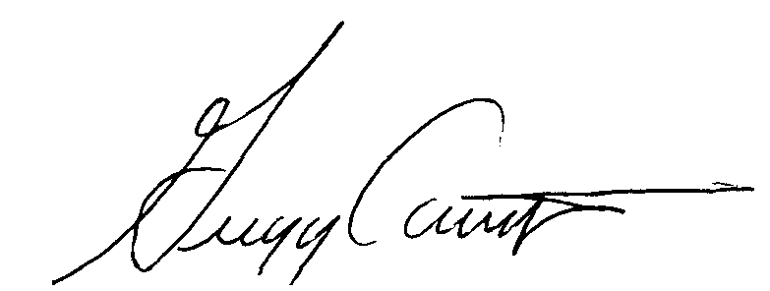
Gregg Carrington
Director, External Affairs Division

Enclosure

