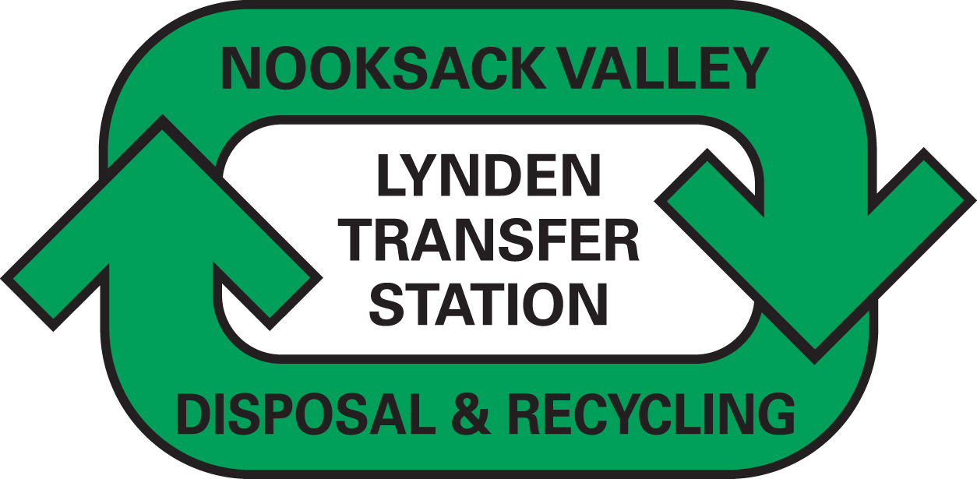
Mark Johnson, Executive Director and Secretary
Washington Utilities and Transportation Commission
1300 South Evergreen Park Drive SW
P.O. Box 47250
Olympia, WA 98504-7250 November 15, 2018

Dear Secretary Johnson,

We are submitting this transmittal letter and a request for a disposal-only rate increase for Nooksack Valley Disposal Inc., permit G-166. Enclosed please find revised tariff pages, the notice from the third-party disposal site, and work papers. This is an adjustment to Solid Waste Tariff Number 4, with an Effective Date of January 1, 2019.

Recycling and Disposal Services, Inc. has given notice that they are increasing our disposal fees by 6.7%, to a new rate of $105.34 per ton beginning January 1, 2019. The requested increase affects all residential and commercial garbage service rates related to disposal. If approved by the Commission as filed, these requested rates would result increase company revenues by $25,404, and residential and commercial rates would go up between 2.1% and 2.9% or by an average of 2.5%.

We are requesting an exemption for this submittal from the requirement to file work papers for a general rate proceeding as outlined in WAC 480-07-520(4), so that the tariff rates may be adjusted for the disposal fee increase only.

In accordance with WAC 480-70-271(2), affected customers will be notified on their next regularly scheduled billing after Commission approval.

The contact person for this submittal is: Calvin Den Hartog
P.O. Box 267, Lynden, WA 98264
Phone: (360) 354-3400 Fax: (360) 354-3288
Email: Calvin_NVD@msn.com

Sincerely,

Calvin Den Hartog
General Manager

CC: Whatcom County Council

