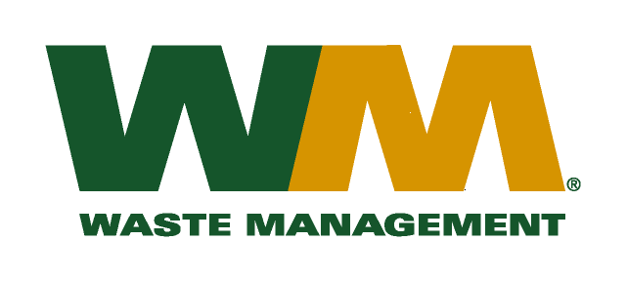

February 10, 2016
Washington Utilities and Transportation Commission
Chandler Plaza Building
1300 S. Evergreen Park Drive SW
P.O. Box 47250
Olympia, WA. 98504-7250
Dear Sirs:
Subject: Waste Management of Spokane, Valley Garbage Service Co., a division of Waste Management of Washington, Inc.(G-237); Tariff # 18 – TG-160192

Please find enclosed a less than statutory notice form (LSN) for the above-referenced docket number. The LSN treatment of the replacement tariff pages filed in the docket above is being requested so that these pages may become effective on March 1, 2016. Please do not re-docket.
If you have any questions or need additional information, please contact me at (425) 814-7840.
Respectfully,

Michael A. Weinstein
Senior Pricing Manager, Pacific Northwest Market Area

