November 7, 2011

Via Electronic Mail

Mr. David Danner
Executive Director & Secretary
Washington Utilities and Transportation Commission
1300 S. Evergreen Park Drive SW
P. O. Box 47250
Olympia, Washington 98504-7250

RE: Docket No. UG-111770 – Supplemental information regarding Avista Corporation Affiliated Interest Filing (Ecova, previously Advantage IQ, Inc.) pursuant to RCW 80.16.020.

Dear Mr. Danner:
On October 6, 2011, pursuant to RCW 80.16.020 and WAC 480-90-245, Avista Corporation filed with the Commission its Affiliated Interest Filing and “Master Promissory Note” between Avista Corporation and Advantage IQ, Inc. seeking Commission approval of intercompany debt, an affiliated interest transaction.
On October 17, 2011, the Company changed its name from Advantage I.Q. Inc. to Ecova. This change was in name alone, and there were no changes in the ownership percentage as a result of the name change.
Enclosed for filing with the Commission is a revised electronic copy of the “Master Promissory Note” between Avista Corporation and Ecova (previously Advantage IQ, Inc.) for the above referenced docket, included as Attachment A. An original and three hard copies of the “Master Promissory Note” between Avista Corporation and Ecova, an Affiliated Interest, for the Promissory Note by and between Avista and Ecova, an affiliate of Avista, will be provided to the Commission on November 8, 2011.

Please direct any questions regarding this filing to Liz Andrews at (509) 495-8601.

Sincerely,
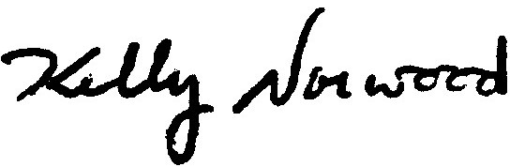
Kelly O. Norwood
Vice President, State and Federal Regulation
Enclosure

