January 7, 2011

Mr. David Danner
Executive Director and Secretary
Washington Utilities and Transportation Commission
1300 S. Evergreen Park Drive SW
P. O. Box 47250
Olympia, Washington 98504-7250

RE: Avista Corporation Affiliated Interest Filing (Steam Plant Square LLC) pursuant to RCW 80.16.020.

Dear Mr. Danner:
Pursuant to RCW 80.16.020 and WAC 480-90-245, please find enclosed for filing an original and three copies of the “Multi Tenant Lease Agreement” between Avista Corp. and Steam Plant Square, LLC, an Affiliated Interest, for the Property Lease and Conditional Use Agreement by and between Avista and Steam Plant Square, LLC, an affiliate of Avista. The Multi Tenant Lease Agreement is attached hereto as Attachment A.
Commencing May 1, 2010, the Company renewed a multi-year lease with, Steam Plant Square, LLC, which is an Affiliated Interest pursuant to RCW 80.16.020 and WAC 480-90-245. The basic terms of the lease (i.e. Square footage, monthly rents, etc.) remained the same, see attachment A. The space is a total of 6,036 square feet, which is occupied mainly by our Generation Department, using approximately 5,600 square feet of space for offices and the control room for dams located downtown. The remaining space is being used for displaced workers due to the Multi-Year HVAC renovation project at the Company’s general office building.
In accordance with WAC 480-07-160, Avista Corporation requests confidential treatment of the Details of Transaction provided in Attachment A. These exhibits are marked "Confidential.".
Please direct any questions regarding this filing to Liz Andrews at (509) 495-8601.

Sincerely,
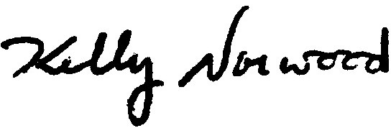
Kelly O. Norwood
Vice President, State and Federal Regulation
Enclosure

