
Frontier Communications Northwest Inc.
1800 – 41st Street WA0105RA
P. O. Box 1003
Everett, WA 98201-1003
Fax: 425-261-5262
October 21, 2010

VIA E-FILING

Mr. David Danner, Executive Director and Secretary
Washington Utilities and Transportation Commission
1300 S. Evergreen Park Drive SW
Olympia, WA 98504-7250

Subject: Docket No. A-101474

Dear Mr. Danner:

Please keep me on the mailing list in Docket No. A-101474. My contact information is noted below.

Frontier Communications Northwest Inc.
Lin Fogg – Regulatory Mgr. WA0105RA
1800 41st St.
Everett, WA 98201
Tel No. 425.261.6380
Fax No. 425.261.5262
Email: linda.fogg@FTR.com

Thank you.

Sincerely,
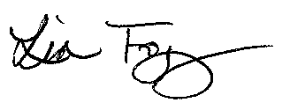
Lin Fogg
State Manager Regulatory/Legislative

