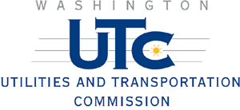

NOTICE
HICKOX ROAD HIGHWAY-RAIL GRADE CROSSING

BNSF Railway has filed a petition with the Utilities and Transportation Commission to close this railroad crossing. If you would like to comment on this petition e-mail your comments to records@wutc.wa.gov or send your written comments to:

Carole Washburn, Executive Secretary
Washington Utilities and Transportation Commission
P.O. Box 47250
Olympia, WA 98504-7250

Please include our reference number, TR-070696. You must submit your comments by May 17, 2007. If you have questions about the proposed petition, call Kathy Hunter at (360) 664-1257 or send her an e-mail, khunter@wutc.wa.gov.

