 | 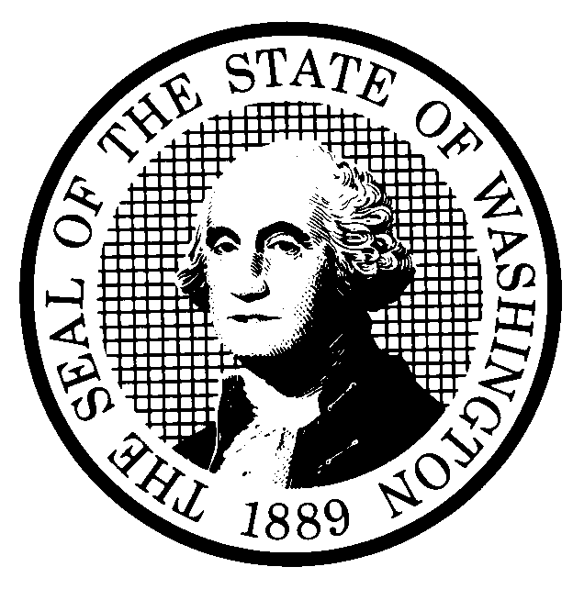 | EXPEDITED RULE MAKING |  |  |  |  | CR-105 (June 2004)  (Implements RCW 34.05.353)  EXPEDITED RULE MAKING ONLY
 | Agency: Washington Utilities and Transportation Commission
Title of rule and other identifying information: (Describe Subject)
This rulemaking would revise adoption-by-reference dates in WAC 480-93-999 and WAC 480-75-999 to incorporate the most recent version of adopted federal rules.
Commission Docket A-060464. Please refer to attachment A for the proposed changes.

NOTICE
THIS RULE IS BEING PROPOSED UNDER AN EXPEDITED RULE-MAKING PROCESS THAT WILL ELIMINATE THE NEED FOR THE AGENCY TO HOLD PUBLIC HEARINGS, PREPARE A SMALL BUSINESS ECONOMIC IMPACT STATEMENT, OR PROVIDE RESPONSES TO THE CRITERIA FOR A SIGNIFICANT LEGISLATIVE RULE. IF YOU OBJECT TO THIS USE OF THE EXPEDITED RULE-MAKING PROCESS, YOU MUST EXPRESS YOUR OBJECTIONS IN WRITING AND THEY MUST BE SENT TO
Name: Carole J. Washburn, Executive Secretary, Docket No. A-060464
Agency: Washington Utilities and Transportation Commission
Address: 1300 S. Evergreen Park Drive, S.W. Olympia, WA 98504-7250

AND RECEIVED BY (Date) June 5, 2006

Purpose of the proposal and its anticipated effects, including any changes in existing rules:

This proposal would revise the adoption-by-reference dates to reflect the current version of adopted material in Title 49 Code of Federal Regulations referenced in WAC 480-93-999(1) and WAC 480-75-999(1).

Reasons supporting proposal: The Commission adopts by reference several parts in Title 49 of the Code of Federal Regulations and other state rules and national standards. Commission rules need to reflect the most current versions of the adopted material.

 | Statutory authority for adoption: RCW 80.01.040,  RCW 80.04.160, RCW 80.28.210, RCW 81.04.160, RCW 81.88.020, RCW 34.05.353 |  |  |  |  | Statute being implemented:
Is rule necessary because of a:  Federal Law?  Federal Court Decision?  State Court Decision?  If yes, CITATION: |  |  | Yes  Yes  Yes | X No  X No  X No | CODE REVISER USE ONLY  Filed with the Code Reviser’s Office  March 31, 2006, 11:43 a.m.  WSR 06-08-059
DATE
March 31, 2006
NAME (TYPE OR PRINT)
Carole J. Washburn

SIGNATURE

TITLE
Executive Secretary

(COMPLETE REVERSE SIDE)
Name of proponent: (person or organization) Washington Utilities and Transportation Commission |  |  |  | Private  Public  Governmental
Name of agency personnel responsible for:
 | Name | Office Location | Phone
Drafting............... Sondra Walsh, Senior Policy Strategist |  | 1300 S. Evergreen Park Drive SW Olympia, WA 98504-7250 | (360) 664-1286
Implementation.... Carole J. Washburn, Executive Secretary |  | 1300 S. Evergreen Park Drive SW Olympia, WA 98504-7250 | (360) 664-1174
Enforcement.......... Carole J. Washburn, Executive Secretary |  | 1300 S. Evergreen Park Drive SW Olympia, WA 98504-7250 | (360) 664-1174
Agency comments or recommendations, if any, as to statutory language, implementation, enforcement, and fiscal matters:

None

