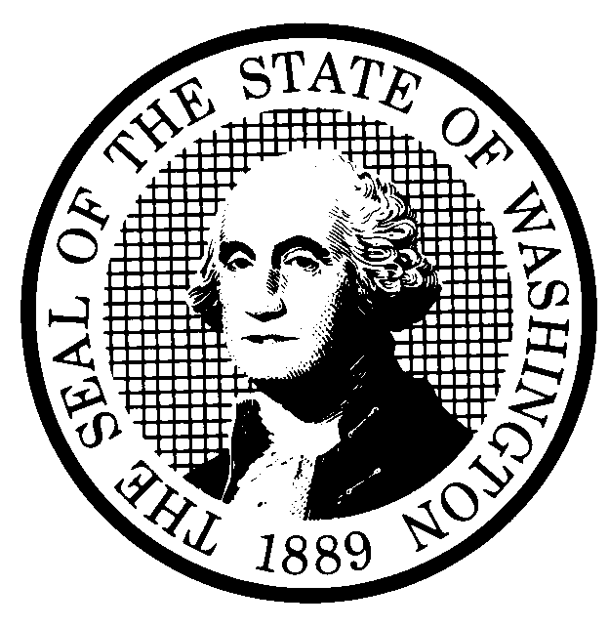 | PREPROPOSAL STATEMENT OF INQUIRY  (RCW 34.05.310) |  |  | CR-101 (7/22/01)  Do NOT use for expedited rule making
Agency: WASHINGTON UTILITIES AND TRANSPORTATION COMMISSION

Subject of possible rule making: This rulemaking inquiry would review rules relating to minimum regulatory fees for class 1 utilities and transportation industries, except motor freight carriers, to consider whether to amend those rules to increase the minimum regulatory fee, not to exceed the estimated cost of collecting the fee, and to consider rules that would waive collection of the minimum fee. In addition, this rulemaking would consider developing a rule that would address regulatory fees for railroads since no rule exists for that industry.
Docket No. A-031232
- Statutes authorizing the agency to adopt rules on this subject:

RCW 80.01.040, RCW 80.04.160, RCW 81.04.160, and Chapter 296, Laws of 2003
- Reasons why rules on this subject may be needed and what they might accomplish:
Chapter 296, Laws of 2003, amends RCW 80.24.010, RCW 81.24.010, RCW 81.24.020, RCW 81.24.030, and RCW 81.77.080 by deleting language that set statutory minimum fees for some industries and adding language that allows the Commission to set by rule minimum fees that do not exceed the cost of collecting the fees, or to waive minimum fees entirely. This rulemaking would consider increasing the minimum regulatory fees for class 1 utilities and transportation industries, except motor freight carriers, consistent with the amended statutes. Existing minimum fees of $1.00 to $5.00 are out-dated and insufficient to cover the cost of collecting and tracking the annual regulatory fees. Because no equivalent rule exists for railroads, this rulemaking would consider developing a minimum regulatory fee rule for rail.
- Identify other federal and state agencies that regulate this subject and the process coordinating the rule with these agencies:

(d) Process for developing new rule (check all that apply):
Negotiated rule making
Pilot rule making
X Agency study
X Other (describe)

The Commission will ask for initial written comments, and will provide the opportunity for additional comments. The Commission will conduct a workshop if there is stakeholder interest or disagreement.
(e) How interested parties can participate in the decision to adopt the new rule and formulation of the proposed rule before publication:
(List names, addresses, telephone, fax numbers of persons to contact; describe meetings, other exchanges of information, etc.)
Interested persons may contact the Secretary, Washington Utilities and Transportation Commission, P.O. Box 47250, 1300 S. Evergreen Park Drive, S.W., Olympia, Washington, 98504-7250; Telephone (360) 664-1174;
Facsimile (360) 586-1150.
Interested persons may file written comments on the CR-101 by September 24, 2003. For specific information regarding opportunities for written comment and to ensure receipt of further information concerning this rulemaking, please see the attachment to this form.

 |  |  | CODE REVISER USE ONLY
Filed with the Code Reviser's Office
September 3, 2003, 10:18 a.m.
NAME (TYPE OR PRINT)  CAROLE J. WASHBURN |  |  | WSR 03-18-116
SIGNATURE
TITLE  SECRETARY |  | DATE  SEPT. 3, 2003

WASHINGTON UTILITIES AND TRANSPORTATION COMMISSION
CR-101 - ATTACHMENT
DOCKET NO. A-031232

(e) Interested persons may contact the Secretary, Washington Utilities and Transportation Commission, P. O. Box 47250, Olympia, Washington, 98504-7250, 360-664-1174 (Fax: 360-586-1150).

WRITTEN COMMENTS
Written comments may be submitted to the Commission at the address given above and should be filed with the Commission no later than September 24, 2003.

Electronic copies. The Commission requests that comments be provided in electronic format to enhance public access, for ease of providing comments, to reduce the need for paper copies, and to facilitate quotations from the comments. Comments may be submitted by electronic mail to the Commission’s Records Center at records@wutc.wa.gov. Please include:

- The docket number of this proceeding (A-031232)
- The commenting party’s name
- The title and date of the comment or comments

An alternative method for submitting comments may be by mailing/delivering an electronic copy on a 3 ½ inch, IBM-formatted, high-density disk, in .pdf Adobe Acrobat format or in Word 97 or later. Include all of the information requested above. The Commission will post on the Commission’s web site all comments that are provided in electronic format. The web site is located at http://www.wutc.wa.gov/031232. If you are unable to file your comments electronically or to submit them on a disk, the Commission will always accept a paper document.

Opportunity for further comment is anticipated. Information about the schedule and other aspects of the rulemaking, including comments, will be posted on the Commission’s web site as it becomes available. If you wish to receive further information on this rulemaking you may (1) call the Commission’s Records Center at 360-664-1234, (2) e-mail the Commission at <records@wutc.wa.gov>, or (3) mail written comments to the address above to the attention of Carole J. Washburn, Secretary. When contacting the Commission, please refer to Docket No. A-031232 to ensure that you are placed on the appropriate service list. Questions may be addressed to Barbara Weigel (360) 664-1157 or e-mail at bweigel@wutc.wa.gov>.

TO CONTINUE RECEIVING NOTICES AND INFORMATION ABOUT THIS RULEMAKING -- The Commission wants to ensure its mailings are sent to persons who are interested in the topic and want to receive that information. ANY PERSON WHO COMMENTS will continue to receive notices and information. If you do not submit comments but wish to remain on the mailing list for this rulemaking, please advise the Records Center by any one of the following methods: (1) send a note with your name, address (or a copy of your mailing label), and telephone and fax numbers referencing Docket No. A-031232, and the words "Please keep me on the mailing list"; or (2) E-mail your name, address, telephone and fax numbers, referencing Docket No. A-031232, and the words "Please keep me on the mailing list" to <records@wutc.wa.gov>. Please note that all information in the mailings will be accessible through the Commission's Internet web site at <http://www.wutc.wa.gov/031232>. THOSE PARTIES WHO DO NOT RESPOND MAY NOT RECEIVE FURTHER MAILINGS OR INFORMATION ON THE RULEMAKING.
NOTICE

