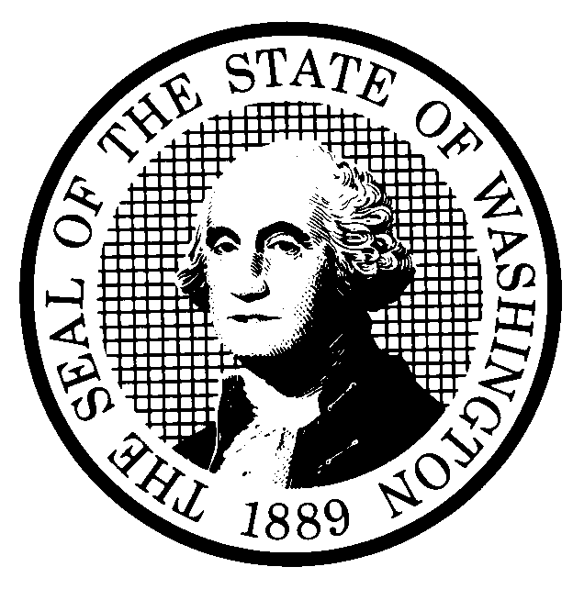 | PREPROPOSAL STATEMENT OF INQUIRY  (RCW 34.05.310) |  |  | CR-101 (7/22/01)  Do NOT use for expedited rule making
Agency: WASHINGTON UTILITIES AND TRANSPORTATION COMMISSION

Subject of possible rule making: Consider review of WAC 480-100-238, “Least-cost planning,” will be reviewed for content and readability consistent with Executive Order 97-02, with attention to the rule’s need; effectiveness and efficiency; clarity; intent and statutory authority; coordination; cost; and fairness. A review of WAC 480-100-238 may consider whether substantive changes or additions should be made to the existing rule.

Docket No. UE-030311
- Statutes authorizing the agency to adopt rules on this subject:
RCW 80.01.040 and RCW 80.04.160
- Reasons why rules on this subject may be needed and what they might accomplish:
During the period 1999 to 2001, the Washington Utilities and Transportation Commission conducted a comprehensive review of Chapter 480-100 WAC, “Electric Companies.” WAC 480-100-238, Least-cost planning, was deferred from that review of Chapter 480-100 WAC for further study pending the availability of sufficient resources. The Commission intends to conduct such a review at this time. This review will examine whether the current rule provides the results that it was originally intended to achieve and whether the rule is consistent with laws, with appropriate and lawful policies, and with the advances in technology in the electric industry. Subjects included in this review may cover but are not limited to:
1. the roles of risk and uncertainty in resource planning,
2. the role of demand management,
3. the role of resource diversity, resource adequacy, and financial and physical hedging,
4. planning issues, such as planning horizons and filing deadlines,
5. portfolio analysis,
6. rule process and enforcement issues,
7. the relationship of least-cost plans to Commission review of specific generation or demand response projects,
8. the relevance of any changes in policies or requirements at the federal and state levels, and
9. appropriate uses of least-cost plans.

- Identify other federal and state agencies that regulate this subject and the process coordinating the rule with these agencies: FERC

(d) Process for developing new rule (check all that apply):
Negotiated rule making
Pilot rule making
X Agency study
X Other (describe)
The Commission will ask for initial written comments, and will provide the opportunity for participation in workshop-style sessions as well as opportunities for additional comments.
(e) How interested parties can participate in the decision to adopt the new rule and formulation of the proposed rule before publication:
Interested persons may contact the Secretary, Washington Utilities and Transportation Commission, P.O. Box 47250, 1300 S. Evergreen Park Drive, S.W., Olympia, Washington, 98504-7250; Telephone (360) 664-1174; Facsimile (360) 586-1150.
Interested persons may file written comments on the CR-101 by Friday, May 16, 2003. For specific information regarding opportunities for written comment and to ensure receipt of further information concerning this rulemaking, please see the attachment to this form.

A stakeholder workshop will be held on Friday, June 13, 2003, in Room 206 at the Commission’s headquarters, beginning at 9:30 a.m. |  |  | CODE REVISER USE ONLY
Filed with the Code Reviser's Office
April 15, 2003, 1:40 p.m.
NAME (TYPE OR PRINT)  CAROLE J. WASHBURN |  |  | WSR# 03-09-068
SIGNATURE
TITLE  SECRETARY |  | DATE  APRIL 15, 2003

WASHINGTON UTILITIES AND TRANSPORTATION COMMISSION
CR-101 - ATTACHMENT
DOCKET NO. UE-030311

(e) Interested persons may contact the Secretary, Washington Utilities and Transportation Commission, P. O. Box 47250, Olympia, Washington, 98504-7250, (360) 664-1174 (Fax: 360-586-1150).

WRITTEN COMMENTS AND STAKEHOLDER WORKSHOP
Written comments may be submitted to the Commission at the address given above and should be filed with the Commission no later than Friday, May 16, 2003, for consideration at the Friday, June 13, 2003, stakeholder workshop.
Electronic copies. The Commission requests that comments be provided in electronic format to enhance public access, for ease of providing comments, to reduce the need for paper copies, and to facilitate quotations from the comments. Comments may be submitted by electronic mail to the Commission’s Records Center at records@wutc.wa.gov. Please include:

- The docket number of this proceeding (UE-030311)
- The commenting party’s name
- The title and date of the comment or comments

An alternative method for submitting comments may be by mailing/delivering an electronic copy on a 3 ½ inch, IBM-formatted, high-density disk, in .pdf Adobe Acrobat format or in Word 97 or later. Include all of the information requested above. The Commission will post on the Commission’s web site all comments that are provided in electronic format. The web site is located at http://www.wutc.wa.gov/030311. If you are unable to file your comments electronically or to submit them on a disk, the Commission will always accept a paper document.

Opportunity for further comment is anticipated. Information about the schedule and other aspects of the rulemaking, including comments, will be posted on the Commission’s web site as it becomes available. If you wish to receive further information on this rulemaking you may (1) call the Commission’s Records Center at 360-664-1234, (2) e-mail the Commission at <records@wutc.wa.gov>, or (3) mail written comments to the address above to the attention of Carole J. Washburn, Secretary. When contacting the Commission, please refer to Docket No. UE-030311 to ensure that you are placed on the appropriate service list. Questions may be addressed to Graciela Etchart (360) 664-1310 or e-mail at <getchart@wutc.wa.gov>.

TO CONTINUE RECEIVING NOTICES AND INFORMATION ABOUT THIS RULEMAKING -- The Commission wants to ensure its mailings are sent to persons who are interested in the topic and want to receive that information. ANY PERSON WHO COMMENTS will continue to receive notices and information. If you do not submit comments but wish to remain on the mailing list for this rulemaking, please advise the Records Center by any one of the following methods: (1) send a note with your name, address (or a copy of your mailing label), and telephone and fax numbers referencing Docket No.UE-030311, and the words "Please keep me on the mailing list"; or (2) E-mail your name, address, telephone and fax numbers, referencing Docket No.UE-030311, and the words "Please keep me on the mailing list" to <records@wutc.wa.gov>. Please note that all information in the mailings will be accessible through the Commission's Internet web site at <http://www.wutc.wa.gov/030311>. THOSE PARTIES WHO DO NOT RESPOND MAY NOT RECEIVE FURTHER MAILINGS OR INFORMATION ON THE RULEMAKING.
NOTICE

