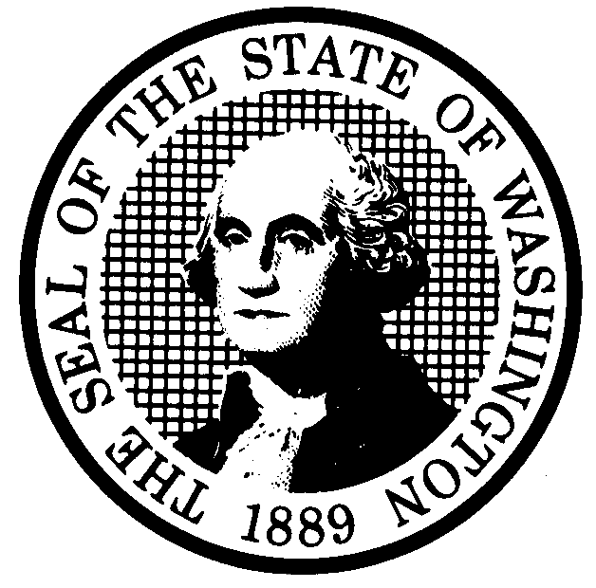
PREPROPOSAL STATEMENT OF INQUIRY  (RCW 34.05.310) |  | CR-101 (7/10/97)  Do NOT use for expedited repeal or adoption
Agency: WASHINGTON UTILITIES AND TRANSPORTATION COMMISSION
Subject of possible rule making:
SSB 5182 directs the agency to adopt rules that will establish the methodology for charging an annual pipeline safety fee to each intrastate and interstate natural gas and hazardous liquids pipeline company subject to inspection or enforcement by the Commission. This rulemaking will prepare the agency to comply with the legislative requirements of SSB 5182 if enacted. Docket No. UG-010522.
(a) Statutes authorizing the agency to adopt rules on this subject:
RCW 80.01.040, RCW 80.04.160 and SSB 5182
(b) Reasons why rules on this subject may be needed and what they might accomplish:
SSB 5182 requires the agency to establish by rule the methodology for collection of the appropriate fees from each pipeline operator subject to inspection and enforcement by the Commission. The methodology will provide for an equitable distribution of pipeline safety program costs among all pipeline companies subject to the fee.
(c) Identify other federal and state agencies that regulate this subject and the process coordinating
the rule with these agencies:
The Office of Pipeline Safety(OPS) is charged by Federal Law to regulate hazardous liquid pipeline operators. OPS has certified the WUTC to assume that responsibility for intrastate pipeline facilities. The Energy Facility Site Evaluation Council and the state Department of Ecology also have jurisdiction over some matters relating to pipeline safety and environmental effects. The Commission will invite participation by those agencies.
(d) Process for developing new rule (check all that apply):
□ Negotiated rule making
□ Pilot rule making
X Agency study
X Other (describe)

The Commission will ask for initial written comments, and will provide the opportunity for additional comments. The Commission has scheduled a workshop for May 17, 2001, beginning at 9:00 a.m. in the Commission’s hearing room in Olympia, Washington.
(e) How interested parties can participate in the decision to adopt the new rule and formulation of the proposed
rule before publication:
(List names, addresses, telephone, fax numbers of persons to contact;
describe meetings, other exchanges of information, etc.)

SEE ATTACHED.

CODE REVISER USE ONLY

Filed with the Code Reviser’s Office
April 26, 2001
2:35 p.m.
WSR # 01-10-047

NAME (TYPE OR PRINT)

CAROLE WASHBURN
SIGNATURE

TITLE  SECRETARY | DATE  April 25, 2001

WASHINGTON UTILITIES AND TRANSPORTATION COMMISSION
CR-101 - ATTACHMENT
DOCKET NO. UG-010522

(e) Interested persons may contact the Secretary, Washington Utilities and Transportation Commission, P. O. Box 47250, Olympia, Washington, 98504-7250, 360-664-1174 (Fax: 360-586-1150).

WRITTEN COMMENTS

Written comments may be submitted to the Commission at the address given above and should be filed with the Commission no later than Thursday May 10, 2001.
Electronic copies. The Commission also requests, but does not require, that comments be provided in electronic format to facilitate quotations from the comments, to enhance public access, and to reduce the need for additional paper copies. Please help us by sending an electronic copy with your paper filing on a 3-1/2 inch, IBM-formatted, high density disk, in .pdf Adobe Acrobat format, reflecting the pagination of your original. Also send us the text in your choice of .doc (Word 97 or later) or .wpd (Wordperfect 6.0 or later) and include all of the following information on the label of the diskette:
* The docket number of this proceeding (UG-010522)
* The commenting party's name
* The title and date of the comment or comments; and
* The type of software used
Please use the three-letter extension noted above for all electronic files. You may also send your comments by electronic mail to the Commission's Records Center at <records@wutc.wa.gov>; if you choose this means of submitting comments, include all of the information requested above for the diskette label. The Commission will post on the Commission's web site all comments that are provided in electronic format. The web site is located at <http://www.wutc.wa.gov/010522>.
Opportunity for further comment is anticipated. Information about the schedule and other aspects of the rulemaking, including comments, will be posted on the Commission’s web site as it becomes available. If you wish to receive further information on this rulemaking you may (1) call the Commission’s Records Center at 360-664-1234, (2) e-mail the Commission at <records@wutc.wa.gov>, or (3) mail written comments to the address above to the attention of Carole J. Washburn, Secretary. When contacting the Commission, please refer to Docket No. UG-010522 to ensure that you are placed on the appropriate service list.

WASHINGTON UTILITIES AND TRANSPORTATION COMMISSION
CR-101 - ATTACHMENT
DOCKET NO. UG-010522

NOTICE OF WORKSHOP

A workshop will be held on May 17, 2001, beginning at 9:00 a.m., in the Commission’s Hearing Room, Second Floor, Chandler Plaza, 1300 S. Evergreen Park Drive S.W., Olympia, Washington. The Commission’s teleconference bridge line will be available for this workshop. A limited number of teleconference ports are available and will be assigned one to an organization, first come first served. Persons wishing to attend via the teleconference bridge line must contact Kippi Walker at 360-664-1139 no later than 5:00 p.m., Tuesday, May 15, 2001. Questions may be addressed to Sondra Walsh at 360-664-1286 or e-mail at swalsh@wutc.wa.gov.

NOTICE

TO CONTINUE RECEIVING NOTICES AND INFORMATION ABOUT THIS RULEMAKING -- The Commission wants to ensure its mailings are sent to persons who are interested in the topic and want to receive that information. ANY PERSON WHO COMMENTS will continue to receive notices and information. If you do not submit comments but wish to remain on the mailing list for this rulemaking, please advise the Records Center by any one of the following methods: (1) send a note with your name, address (or a copy of your mailing label), and telephone and fax numbers referencing Docket No. UG-010522, and the words "Please keep me on the mailing list"; or (2) E-mail your name, address, telephone and fax numbers, referencing Docket No. UG-010522, and the words "Please keep me on the mailing list" to records@wutc.wa.gov. Please note that all information in the mailings will be accessible through the Commission's Internet web site at <http://www.wutc.wa.gov/>. THOSE PARTIES WHO DO NOT RESPOND MAY NOT RECEIVE FURTHER MAILINGS OR INFORMATION ON THE RULEMAKING.

