January 31, 2017

VIA ELECTRONIC FILING

Stephen V. King
Executive Director and Secretary
Washington Utilities and Transportation Commission
1300 S Evergreen Park Drive SW
Olympia, WA 98504-7250
Re: T-Mobile West LLC – Docket UT-170008
Dear Mr. King:
On behalf of T-Mobile West LLC, enclosed for filing is FCC Form 555 pursuant to 47 CFR § 54.416(b).
Very truly yours,
Davis Wright Tremaine LLP
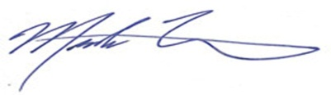
Mark P. Trinchero

MPT/jan

Enclosure

