January 14, 2013

Via Email and FEDEX

David W. Danner
Executive Director and Secretary
Washington Utilities and Transportation Commission
1300 S. Evergreen Park Dr. SW
PO Box 47250
Olympia, WA 98504-7250
Re: No. TG-121597
Application of Waste Management of Washington, Inc. d/b/a WM Healthcare Solutions of Washington

Dear Mr. Danner:
Enclosed please find an original and six (6) copies of Complainant Stericycle of Washington, Inc.’s Petition for Interlocutory Review.
Sincerely,
GARVEY SCHUBERT BARER
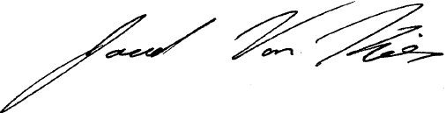
By
Jared Van Kirk

Enclosures

cc: Polly L. McNeill
Jessica Goldman
Adam Torem
Fronda Woods
James Sells

