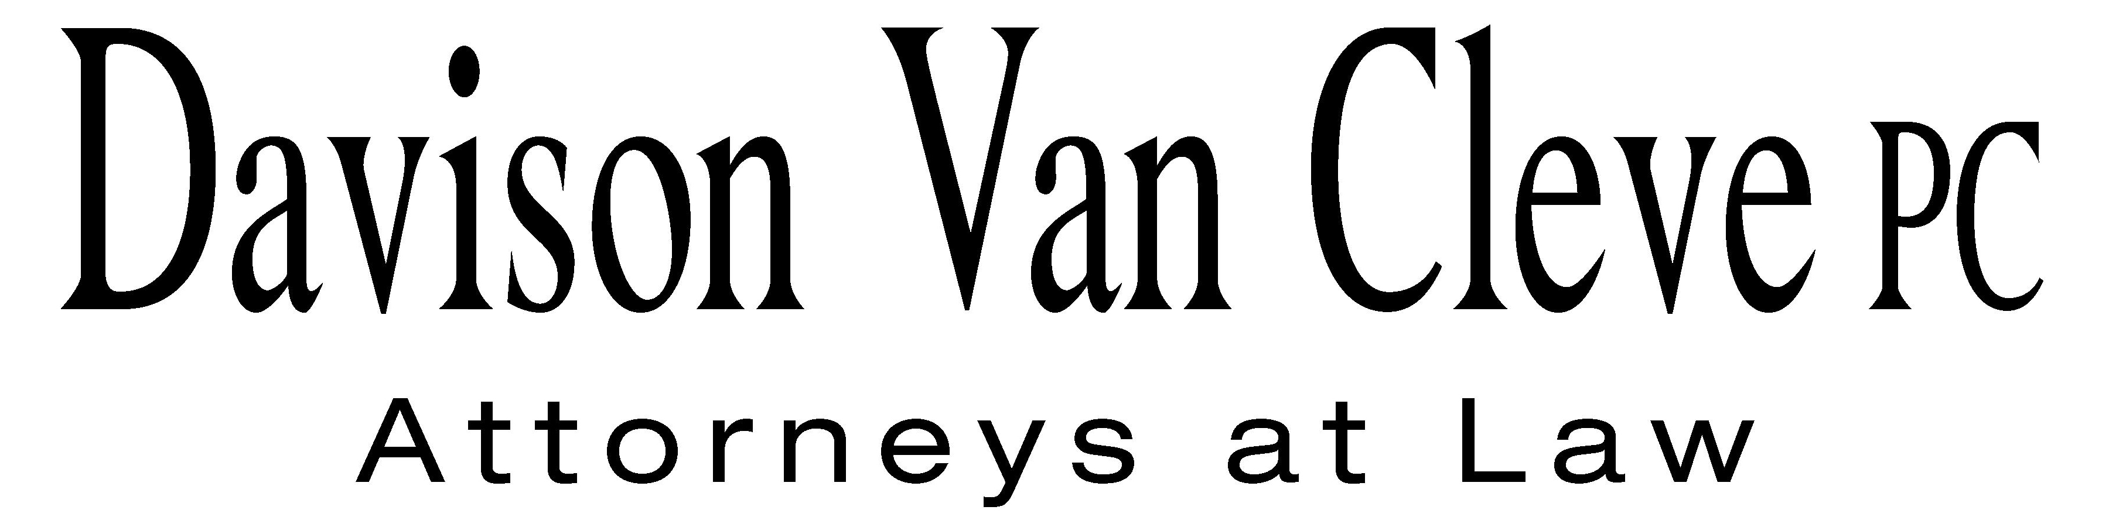
TEL (503) 241-7242 ● FAX (503) 241-8160 ● mail@dvclaw.com
Suite 400
333 SW Taylor
Portland, OR 97204

October 11, 2012

Via Federal Express and Electronic Mail

Mr. David E. Danner
Executive Director and Secretary
Washington Utilities & Transportation Commission
1300 S. Evergreen Park Drive S.W.
Olympia, WA 98504

Re: In the Matter of WUTC v. Avista Corporation

Docket Nos. UE-120436/UG-120437
Docket Nos. UE-110876/UG-110877

Dear Mr. Danner:

Enclosed please find an original and twenty (20) copies of the Confidentiality Agreement of Joshua D. Weber on behalf of the Industrial Customers of Northwest Utilities in the above-referenced dockets.

Thank you for your assistance. If you have any questions, please do not hesitate to give me a call.
Sincerely yours,

/s/ Sarah A. Kohler
Sarah A. Kohler

Enclosures
cc: Service List
CERTIFICATE OF SERVICE

I hereby certify that I have this day served a copy of the foregoing Confidentiality Agreement of Joshua D. Weber on behalf of the Industrial Customers of Northwest Utilities upon the parties, shown below, listed on the official service list in Docket Nos. UE-110886/UG-110877/UE-120436/UG-120437 by causing the same to be mailed, postage-prepaid, via U.S. Mail.
DATED at Portland, Oregon, this 11th day of October, 2012.
Davison Van Cleve, P.C.

/s/ Sarah A. Kohler
Sarah A. Kohler

Kelly Norwood, Vice President  Avista Corporation, d/b/a Avista Utilities  1411 E. Mission  Spokane, WA 99220  kelly.norwood@avistacorp.com | Don Trotter  Assistant Attorney General  WUTC  PO Box 40128  Olympia, WA 98504-0128  dtrotter@utc.wa.gov
Simon ffitch  Office of the Attorney General  800 5th Ave STE 2000  Seattle, WA 98104-3188  simonf@atg.wa.gov | David Meyer  Avista Corporation, d/b/a Avista Utilities  PO BOX 3727  Spokane, WA 99220-3727  dmeyer@avistacorp.com
Lisa Gafken  Assistant Attorney General  Office of the Attorney General  800 Fifth Avenue STE 2000  Seattle, WA 98104-3188  lisa.gafken@atg.wa.gov | Charles M. Eberdt  The Energy Project  3406 Redwood Ave  Bellingham, WA 98225  CHUCK_EBERDT@oppco.org
Ronald L. Roseman  Attorney At Law  2011 - 14th Avenue East  Seattle, WA 98112  ronaldroseman@comcast.net | Donald W. Schoenbeck  RCS, Inc.  900 Washington Street STE 780  Vancouver, WA 98660  dws@r-c-s-inc.com
Paula E. Pyron  Executive Director  NORTHWEST INDUSTRIAL GAS USERS  4113 Wolf Berry Court  Lake Oswego, OR 97035-1827  ppyron@nwigu.org | Michael Fassio  Assistant Attorney General  WUTC  PO Box 40128  Olympia, WA 98504-0128  MFassio@utc.wa.gov
Todd D. True  NW Energy Coalition  705 Second Avenue STE 203  Seattle, WA 98104  ttrue@earthjustice.org | Kristen Boyles  NW Energy Coalition  705 Second Ave. STE 203  Seattle, WA 98104  kboyles@earthjustice.org
Amanda Goodin  NW Energy Coalition  705 Second Avenue STE 203  Seattle, WA 98104  agoodin@earthjustice.org | Chad M. Stokes  Cable Huston Benedick Haagensen & Lloyd, LLP  1001 SW 5th Avenue STE 2000  Portland, OR 97204  cstokes@cablehuston.com
Tommy A. Brooks  Cable Huston Benedick Haagensen & Lloyd, LLP  1001 SW 5th Avenue STE 2000  Portland, OR 97204-1136  tbrooks@cablehuston.com | Nancy Hirsh  Policy Director  NORTHWEST ENERGY COALITION  811 1st Ave # 305  Seattle, WA 98104-2599  nancy@nwenergy.org

